普通高中教科书

第一册

英语

**ENGLISH**

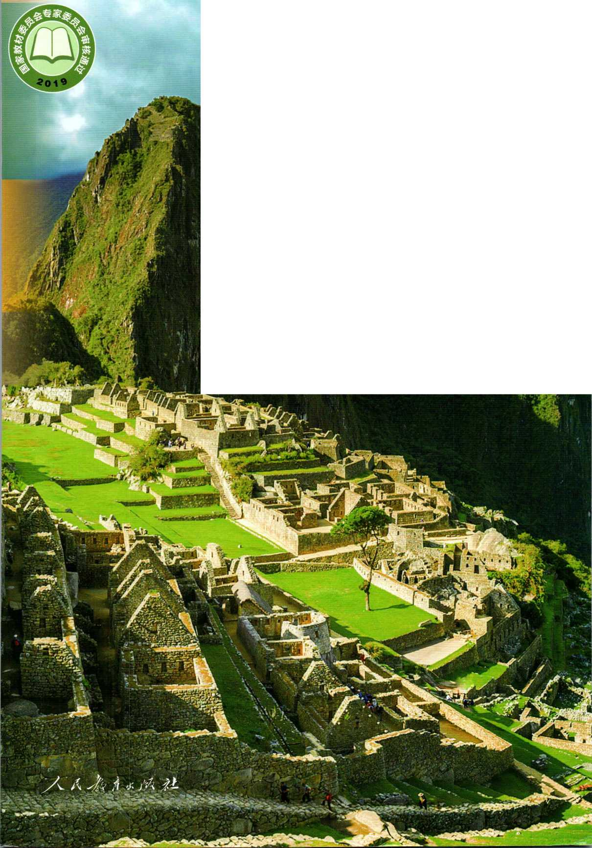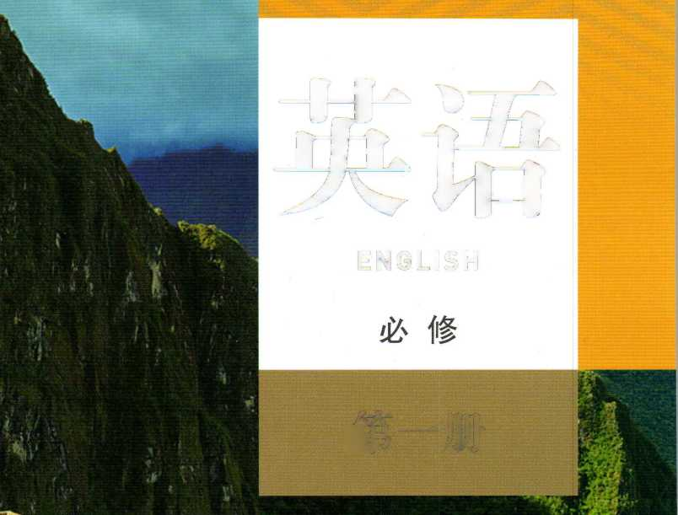

普通高中 教科书

ENGLISH

必修

第一册

人民教育出版社课程教材研究所 （中国）

英语课程教材研究开发中心编著

（美国）圣 智 学 习 集 团

*入*其球*疝承彩

.北京.

主 编：刘道义郑旺全 副主编：吴欣张献臣 编写人员：Sarah H. Miller Nils-Olov Fors Patrick Wallace

生平辜翔宇庄力葛炳芳贵丽萍

责任编辑：辜翔宇游晓霞 美术编辑：胡白珂

普通高中教科书英语必修第一册

人民教育出版社课程教材研究所

（中国）英语课程教材研究开发中心编著

（美国）圣 智 学 习 集 团

|  |  |  |
| --- | --- | --- |
| 出 | 版 | *人*周弟# 承"  （北京市海淀区中关村南大街17号院1号楼 邮编：100081） |
| 网 | 址 | http: // [www.pep.com.cn](http://www.pep.com.cn) |
| 重 | 印 | 北方联合出版传媒（集团）股份有限公司 |
| 发 | 行 | 辽宁省新华书店 |
| 印 | 刷 | 辽宁新华印务有限公司 |
| 版 | 次 | 2019年6月第1版 |
| 印 | 次 | 2019年8月第1次印刷 |
| 开 | 本 | 890毫米x 1240毫米 1/16 |
| 印 | 张 | 8. 5 |
| 字 | 数 | 225千字 |
| 书 | 号 | ISBN 978-7-107-33652-2 |
| 定 | 价 | 9. 40 元 |

含光盘定价14. 40元

版权所有•未经许可不得釆用任何方式擅自复制或使用本产品任何部分•违者必究 如发现内容质量问题，请登录中小学教材意见反馈平台：jcyjfk.pep.com.cn 如发现印、装质量问题，影响阅读，请与印厂联系调换。电话：024-31255233 监督电话：024-23284031

《普通高中教科书 英语》是为了适应新时代的发展需要，依据《普通高中英语课程标 准（2017年版）》的精神，充分征求广大师生的反馈意见，在《普通高中课程标准实验教科 书 英语》的基础上精心修订而成。此次教材修订的主要目的是：全面落实立德树人根本任 务，培育社会主义核心价值观，弘扬中华优秀文化，充分体现英语课程工具性和人文性的统 发展学生的语言能力、文化意识、思维品质和学习能力等英语学科核心素养，充分体现 英语学科特殊的育人价值，培养具有中国情怀、国际视野和跨文化沟通能力的社会主义建设 者和接班人。

修订后的教材主要具有以下特点：

注重思想引领教材融入了社会主义核心价值观的基本内容和要求，注重培养学生良好 的政治素质、道德品质和健全人格，弘扬中华优秀文化，增强文化自信，引导学生形成正确 的世界观、人生观和价值观。

反映时代要求 教材充分反映当代社会发展新变化、科技进步新成果，展示新时代中国 特色社会主义新成就，将先进的教育思想和理念融入到教材之中，同时紧密结合学生的学习 和生活实际，关注信息化环境下学生的发展需求。

强调语言实践教材以英语学习活动观为指导，以主题为引领，以语篇为依托，通过板 块式设计将语言知识与听、说、读、看、写等技能有机整合，强调学习过程和学习策略，突 出活动目标，让学生用语言做事情，在实践中培养语言运用能力和创新思维。

突出文化意识教材通过展示多姿多彩的中外文化来培养学生对中华文化的认同和传承， 加深对人类优秀文化的学习和鉴赏；通过让学生分析中外文化异同，发展其多元思维和批判 性思维，增强学生跨文化理解和跨文化沟通能力，构建人类命运共同体意识。

激发学习动机教材以真实性、趣味性、规范性和经典性作为内容选编原则，主题覆盖 面广，语篇题材和体裁丰富，活动呈现形式多样，版式设计生动活泼且富有美感，力求激发 学生的学习兴趣和动机，引发他们积极思考、主动参与语言实践活动，提升英语学习效率。

满足不同需求教材编排内容和活动设计既充分考虑学生的共同基础，又兼顾学生不同 的能力水平和学习需求，提供了拓展性的教学内容，为教师灵活使用教材进行教学提供了便利， 也切实促进学生的个性发展。

本套教材为高中英语教学提供了丰富的教学资源。希望教材能够帮助同学们打下坚实的 语言基础，提高英语水平，获得全面发展；同时也希望老师们能够充分利用教材，在实践中 不断完善教学，取得良好的教学效果。

编者

2019年4月

**CONTENTS**

|  |  |  |  |
| --- | --- | --- | --- |
|  | **Theme** | **Listening** | **Speaking** |
| 1 | **WELCOME** | Registering | Making introductions |
|  | **UNIT** | Learning styles | and greetings |
| I |  |  |  |
|  | UNIT1 | School clubs | Talking about future activities |
| Ip 1 | **TEENAGE** | *Predict content* |  |
| **LIFE** | Youth camps |  |
|  |  |  |  |
|  | UNIT 2 | Getting ready to travel | Making reservations |
| w p. 23 | **TRAVELLING** | *Focus on key words* |
| **AROUND** | Booking air tickets |  |

**Reading**

First Impressions

Student Profiles

The Freshman Challenge

*Skim*

A Letter of Advice

The Face-down Generation

Travel Peru

*Recognise text type*

A Travel Plan to Xi'an

Be a Good Tourist

|  |  |  |
| --- | --- | --- |
| p. 35 | UNIT 3  **SPORTS AND FITNESS** | Inviting a friend to a sports event  *Listen for main ideas*  Sportsmanship |
| p. 47 | UNIT 4  **NATURAL DISASTERS** | News about natural disasters  *Listen for details*  Preparing for a disaster |
| p. 59 | UNIT 5  **LANGUAGES AROUND THE WORLD** | Languages around the world  *Reference*  Different kinds of English |
| I | **WORKBOOK** | Unit 1 p- 71  Unit 2 p. *77* |
| 蔻 |  | Unit 3 p. 83 |
| 1  I |  | Unit 4 p- 89  Unit 5 p. 95 |

|  |  |
| --- | --- |
| Agreeing and disagreeing | Living Legends  *Make predictions*  Going Positive  Cool Cold Sports |
| Giving instructions | The Night the Earth Didn't Sleep  *Use context to understand*  *new words*  Tsunami Hits Asia: Over 6,500 Dead  The Story of an Eyewitness |
| Asking for clarification | The Chinese Writing System:  Connecting the Past and the Present |
|  | *Scan* |
|  | Learning English |
|  | Polyglots: What Are They and Who Can Be One? |

|  |  |  |  |  |
| --- | --- | --- | --- | --- |
| **Writing** | **Pronunciation** | **Structure** | **♦Project** | **\*Video Time** |
| A student profile | Vowel letters | Basic sentence structures | / | */*  */*  */* |
| A letter of | “Vowel + consonant” | Noun phrases, | Set up a | Learning Across |
| advice | combinations | adjective phrases, and adverb phrases | student club | Generations |
| A travel plan | Consonants and consonant combinations | The present continuous tense: expressing future plans | Design a travel brochure | Machu Picchu |
| A page in a wellness book | Intonation | Tag questions | Make a survey on sports interests and needs | The Karsts of China: A Vertical Journey |
| A summary | Voiceless and | Restrictive relative | Give a | Tsunami: |
| of a news report | voiced consonants  *-ed* endings | clauses ⑴*(that, which, who, whom, whose)* | presentation on natural disasters | Killer Wave |
| A blog about | Accents of English: | Restrictive relative | Create your own | Chinese |
| English study | American English and British English | clauses (2) *(yvhere, when, why, prep + which/whom)* | word bank | Characters |
| **APPENDICES** | | Notes Grammar |  | p. 101  p. 108 |

112

118

125

Words and Expressions in Each Unit p- Vocabulary **p.**

Irregular Verbs p



A thousand-mile journey begins with the first step. —Laozi

**In this unit, you will**

read about a students first day of school, hear and talk about choosing and registering for courses.

write a student profile.

learn about first-year senior high school students in different countries.

**Look and discuss**

Where do you think these students are? How do you think they feel?

How do you feel on the first day of school?

Get to know new people

1. Match the pictures with the sentences. Describe what the people in the pictures are doing.

A My name is Amy. I'd like to have a student ID card, please.

B Hi, I'm Max Jackson. I'm an exchange student from the UK.

C Hello, everyone! Welcome to our school!

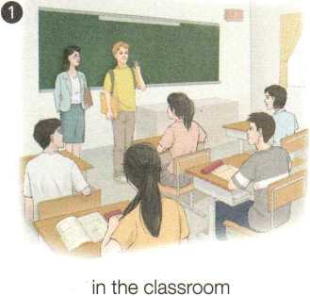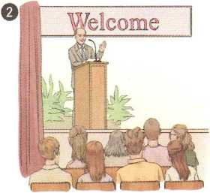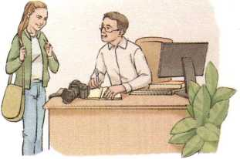

in the **lecture** hall

in the registration office

1. Amy is getting her student ID card. Listen to Conversation 1 and complete the table.

|  |  |  |  |  |  |  |
| --- | --- | --- | --- | --- | --- | --- |
| 1 | REGISTRATION | | | | | |
| 2 | Student No. | Name | Sex | Nationality | Grade | Email |
| **3** |  | Amy | | Female |  |  |  |
| 4 |  |  |  |  |  |  |
| ；— ； — | | | | | | |

1. Max meets Amy in the dining hall. Listen to Conversation 2 and tick Max's favourite subject and Amy's favourite subject.

Subject

Max's favourite

Amy,s favourite

1. Amy is talking to Ms Li, a school adviser, about which courses to choose. Listen to Conversation 3 and answer the questions.
2. What does Amy want to be in the future?

A An engineer. B A designer. C A writer.

1. What course will Amy probably choose?

A English. B IT. C Art.

1. Work in groups. Choose one of the situations and make a conversation. Try to use the introductions and greetings below.

* A boy meets a girl during a break.
* An exchange student is talking to a teacher on campus.
* 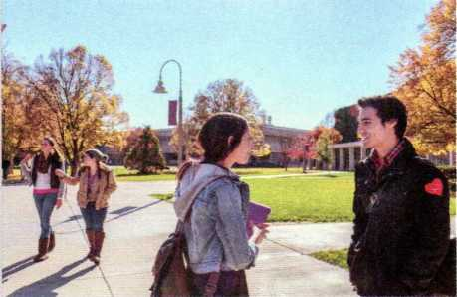A boy and a girl are at the airport to meet a visiting group of teachers and students from England.

Introductions

Greetings

Responses

|  |  |  |
| --- | --- | --- |
| My name is ... | Hi/Hello! | Hi/Hey! |
| I'm ... | Good morning! | Morning! |
| This is ... | Whatt up? | Not much. |
| Have you met ...? | Hows it going? | Great! |
| Do you know ...? | How are things going? | I'm fine, and you? |
| May I introduce ...? | How *are* you? | Very well, thank you. |
| 13 like you to meet ... | How *are* you doing? | How about you? |
| I dont believe you know | - Nice/Glad to meet you. | Nice/Glad to meet you, too. |
|  | People speak in a more polite way in **formal** situations. |  |

o Pronunciation

Listen and repeat. Notice the pronunciation of the vowels (A, E, 1,0, U). Then add a

|  |  |  |  |  |  |  |
| --- | --- | --- | --- | --- | --- | --- |
|  | word to each group. |  |  |  |  |  |
|  | /ei/ /as/ | grade | es*cape | map | cam«pus |  |
|  | - /i:/ /e/ | these | Chinese | met | fbr»get |  |
|  | /ai/ /i/ | write | a*live | quiz | lis*ten |  |
|  | 0 /su/ /d/ | hope | a«lone | frog | cof»fee |  |
|  | /ju:/ /a/ | use | fii*ture | up | dis・cuss |  |
|  |  |  |  |  |  | > |

Describe your first senior high school day

How did you feel on your first day of senior high school? Circle the pictures that describe how you felt.



happy

excited

annoyed

**frightened**

**anxious**

4)) 2

Read the text quickly and draw pictures to show Han Jing's feelings on her first school day.

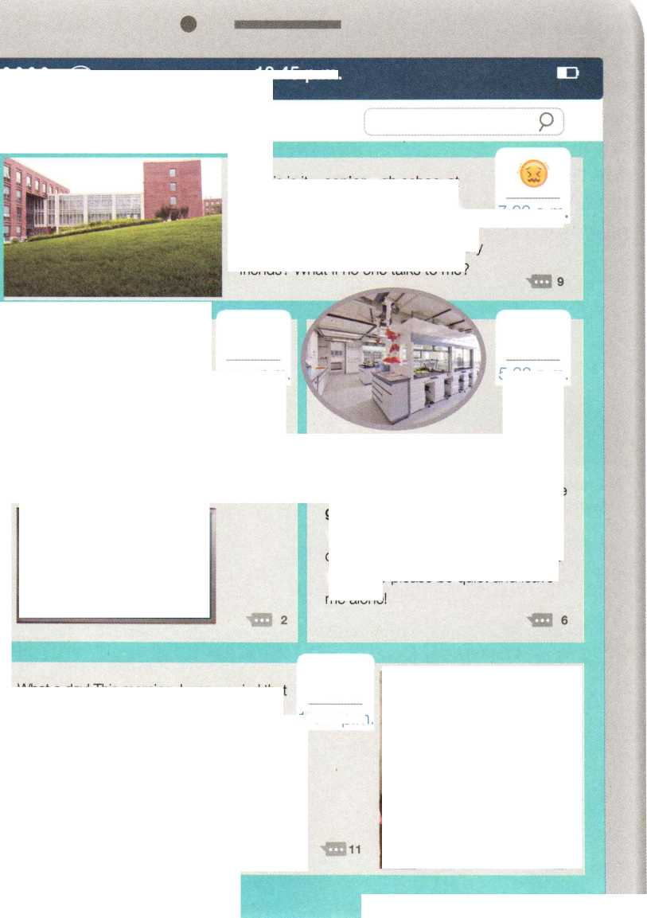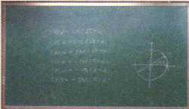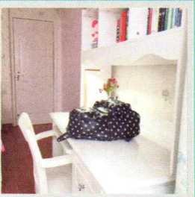**FIRST IMPRESSIONS**

Han Jing's World

10:45 p.m.

So this is it—**senior** high school at last! I'm not **outgoing** so I'm a little anxious right now. I want to make a good first **impression.** Will I make any friends? What if no one talks to me?

I just had my first maths class at senior high school! The 12:30 p.m. class was difficult, but the teacher was kind and friendly. He even told us a funny story, and everyone laughed so much! I found most of my classmates and teachers friendly and helpful.

7:00 a.m.

5:32 p.m.

This afternoon, we had our chemistry class in the science lab. The lab is new and the lesson was great, but the **guy** next to me tried to talk to me the whole time. I couldn*t **concentrate** on the **experiment.** I really wanted to tell him to please be quiet and leave me alone!

What a day! This morning, I was worried that no one would talk to me. But I was wrong. [0'29 p m I didn't feel **awkward** or frightened at all. I miss my friends from **junior** high school, but I believe I will make new friends here, and there's a lot to **explore** at senior high. I feel much more confident than I felt this morning.

I think that tomorrow will be a great day!

1. Read the text again and discuss the questions.
2. Why did Han Jing feel anxious before school?
3. How was her first maths class?
4. What happened in the chemistry class? What would you do if this happened to you?
5. What did Han Jing learn from her first day at senior high school?
6. Fill in the table with the words and phrases from the text, and tell a partner about Han Jings day. Then talk about your own first day of senior high school.

Time What was Han Jing texting about?

senior high school, a little anxious

12:30 p.m.

5:32 p.m.

*J*

10:29 p.m. /

Word Study

Complete the passage with the correct forms of the words and phrases below.

explore impression

senior experiment

Tian Hua is a new student at a school in America. She is studying at an American high school for one year. In China, Tian Hua was in Grade 1 at high school, but in America, she is in

Grade 10! She did not at all when she

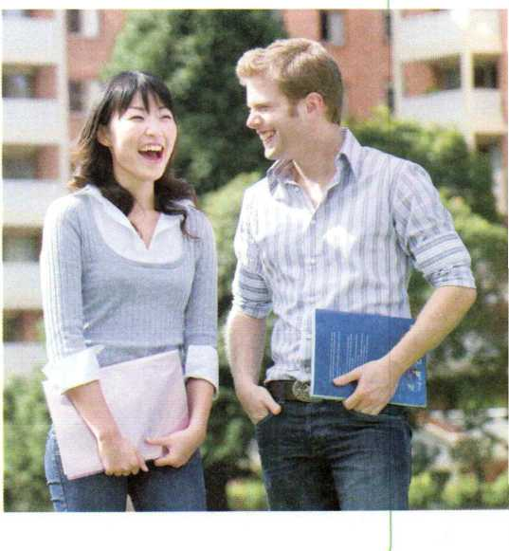arrived. Her first was that English was difficult and people spoke too quickly, but soon she found that if she the ideas, not the single words, she could understand! She also made friends and began to the city with them. Her new friends were happy to explain things to her after class. Her favourite class is chemistry because the teacher lets the students do cool ! Tian Hua is not sure how well she will do at school this year, but she is not nervous any more. She is excited!

feel confident concentrate on

Discovering Useful Structures

Analyse basic sentence structures

|  |  |
| --- | --- |
| **S** (subject)  **DO** (direct object) | **V** (verb) **0** (object) **P** (predicative) **A** (adverbial)  **IO** (indirect object) **C** (object complement) |

1. Study the sentence structures.

Sentence structure Sentence

|  |  |
| --- | --- |
| **SV** | All of us laughed! |
| svo  **SP** | I miss my grandma.  The teacher was kind and friendly. |
| **S V IO DO** | He told us a funny story. |
| svoc | I found most of my classmates and teachers friendly and helpful. |
| **SVA** | He talked too much. |
| **SVOA** | I had my first maths class at senior high school. |
| **There be ...** | There!s a lot to explore at senior high. |

1. Read the sentences and analyse the structures.

EXAMPLE： We laughed.

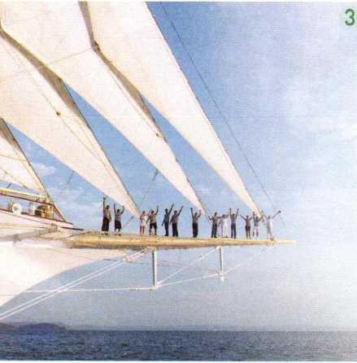S V

|  |  |  |  |
| --- | --- | --- | --- |
| 1 | The 100-year-old school lies in the | 5 | My mum bought me a new dictionary. |
|  | centre of the city. | 6 | Tom is looking forward to meeting the |
| 2 | We must act. |  | new exchange student. |
| 3 | The maths homework looks easy. | 7 | There is an English Corner at our school. |
| 4 | The teacher found the classroom empty. | 8 | We had chemistry in the newly built lab. |

Read the passage and analyse the structures of the underlined sentences.

How would you like to go to school and travel the world at the same time? For Tim, that dream has come true! This term, Tim and his classmates are living on a shi。! They take the same subjects as you do, like maths and English. They also learn about ships and the sea. Tim writes his parents an email every week and tells them what haDDened on the ship. Tim loves living on the ship. There's always something exciting to do. And, after a long day of study, he likes to watch the sun go down and wait for the stars to come out. Studying and doing homework seem much more fun when you are at sea!

Reflect on your learning styles and strategies

上 1 Li Ming and Amy are talking about learning strategies. Listen to their conversation and tick what Li Ming likes to do.

work in groups

listen to the teacher and take notes watch videos

use flash cards make mind maps keep a learning diary

*() 2* Listen again and answer the questions.

1. Why does Amy like group work?
2. How does Li Ming organise his thoughts?
3. Does Li Ming like to keep a learning diary? Why or why not?
4. How do you learn English? Rate the Learning methods below. You can add more of your own to the questionnaire.

|  |  |  |
| --- | --- | --- |
| 1 | I have learning goals and make plans for my English studies. | ☆☆☆☆☆ |
| 2 | I exchange learning experience with my classmates. | ☆☆☆☆☆ |
| 3 | I take notes while listening and reading. | ☆☆☆☆☆ |
| 4 | I read English newspapers and magazines. | ☆☆☆☆☆ |
| 5 | I write down new words in my notebook and review them often. | ☆☆☆☆☆ |
| 6 | I use dictionaries to check for new words. | ☆☆☆☆☆ |
| 7 | I like to write about what I read or hear in English. | ☆☆☆☆☆ |
| 8 | I like to watch movies in English. | ☆☆☆☆☆ |

1. Work in pairs. Share your ideas with your partner and discuss the questions.
2. What learning strategies do you and your partner share?
3. What is the best strategy for you to learn new words? How about grammar?
4. What is the best way for you to improve your reading skills? How about writing?

Reading for Writing

Write a student profile

1. Read the student profiles and discuss the questions.

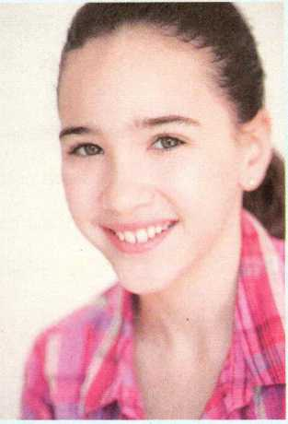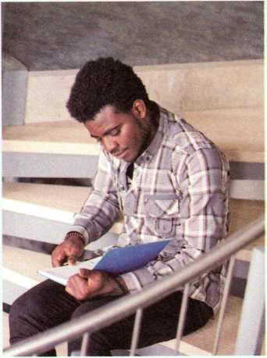

**Ann, 15**

**Lakeside High School**

**USA**

**Thando, 16**

**South Hill High School**

**South Africa**

My name is Ann Wells and I'm a Grade 10 student at Lakeside High School. I'm an active person and I love sports. I'm curious about everything. I often ask questions, but I learn best by doing. My favourite subject is physics. Dancing and skating are my hobbies, and I also like to read short stories. I plan to become an engineer in the future.

I'm Thando Gowon. I'm 16 this year. I come from South Africa. I'm a Grade 10 student at South Hill High School. I look good, think fast, and play hard. You'll never see me without a book or a pen. If I'm not in class, I'm either in the library or in the computer lab. At the weekends, I play computer games if I'm not busy studying. My dream is to start my own IT company!

1. What is Ann like? How do you know?
2. What does "You'll never see me without a book or a pen" mean?
3. Which profile do you like better? Why?

Study the organisation and language features.

1. A student profile can include the following parts. Fill in each part with the information from the student profiles.

**A** Name, age, grade, school

**D** Learning **style**

**B Personality**

**E** Hobbies

**C** Favourite subject

**F** Future plans and dreams

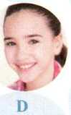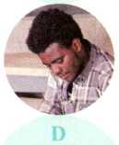

1. Circle the phrases that Ann and Thando use to describe their personalities and underline the sentences that they use to describe their learning styles.

3 Use what you have learnt to write your own student profile.

1 Complete the outline and use it to draft your student profile.

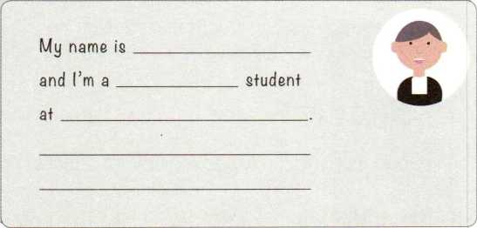~~伊―…、 一「……■…•…\~~

**Name： Age：**

**Grade： School：**

**Personality：**

**Favourite subject：**

**Learning style：**

**Hobbies：**

**Future plans and dreams：**

1. Exchange drafts. Use the checklist to give feedback on your partner's draft.

Does the profile give you a good impression of the student?

y Are all the parts in Activity 2 included and organised in a good order?

/ Are the sentence structures correct?

y Do all the sentences begin with capital letters?

*J* Are there any spelling mistakes?

1. Get your draft back and revise it.
2. Add a photo or drawing of yourself and show your student profile to your class.

4 Collect all the student profiles and create a class book.

Building Up Your Vocabulary

1. Match the pictures with the best adjectives. Then describe each picture in two or three sentences.

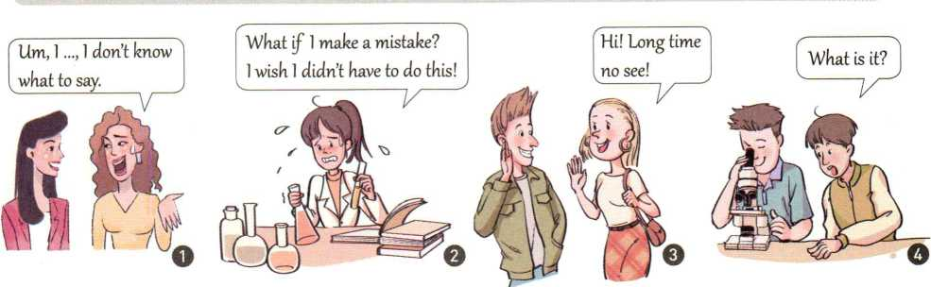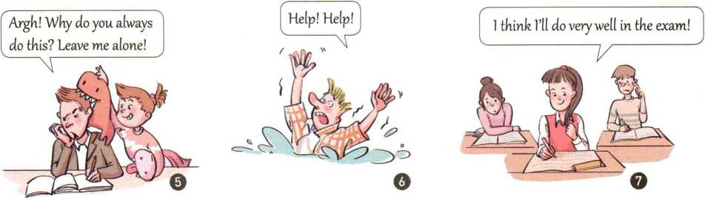

anxious awkward annoyed frightened confident curious excited

1. Match the verbs on the left with the nouns on the right. Then make sentences with your new phrases.

exchange

register (for)

design

explore

give

take

a class ideas

a dress the world

a lecture notes

EXAMPLE

Good morning. I'd like to register for a class. I'm interested in any classes on music!

1. Read the learning tips. Rewrite the underlined parts with the new words from this unit that have the similar meaning.

Know yourself.

How you like to learn depends on what kind of Derson you are. If you like to talk, then it may be best to study in groups. If you are quiet, you may concentrate best on your own.

Decide on what you want to leaon.

Do you want to learn spelling rules? Do you want to learn how to take notes during a talk by a teacher? No matter what you want to learn, it is important to decide on your goal before you make a plan.

Use the right strategy.

If you are learning new words, it is wise to use small cards with the words written on them. If you are organising your thoughts or notes, try a mind map.

■

UNIT

TEENAGE

1 LIFE

Good habits formed at youth make all the difference.

—Aristotle

In this unit, you will

life do you wish to live?

1

2

Look and discuss

What are the teenagers doing in the photo What do you do to relax outside of school?

*L*

read about school life in the USA.

hear and talk about extra-curricular activities 2 of senior high school students. 3

write about teenage problems and solutions.

**Iparn ahniit lifp in nthpr**

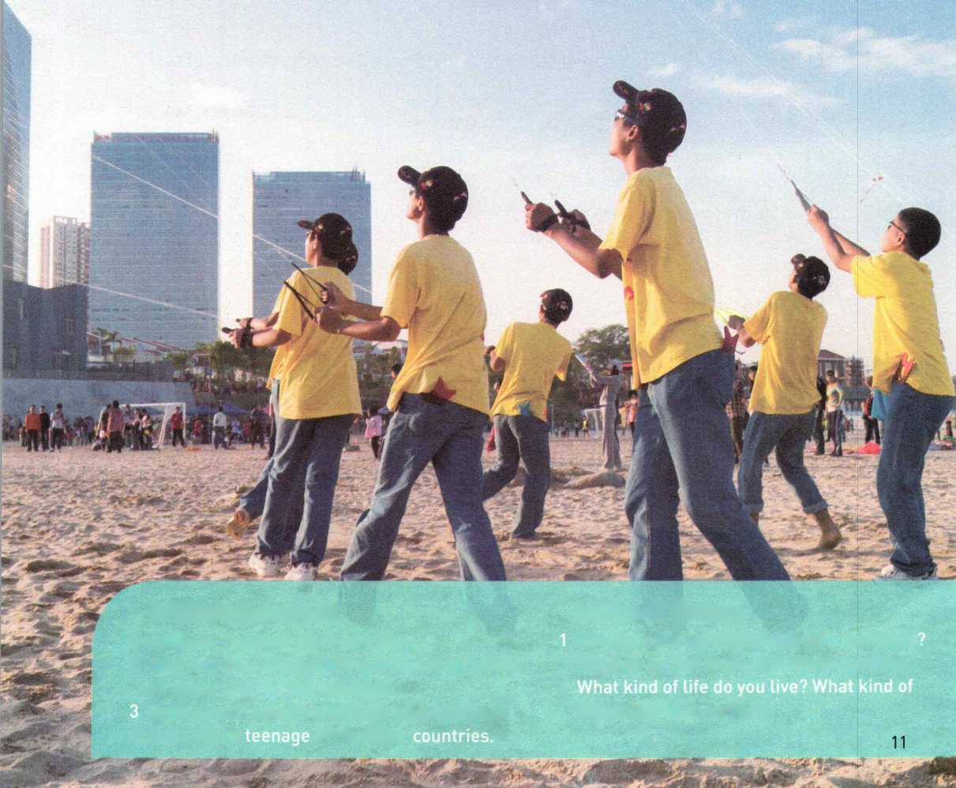

Choose a school club

1. Match the photos with the names of the clubs. What do you think students do in these clubs?

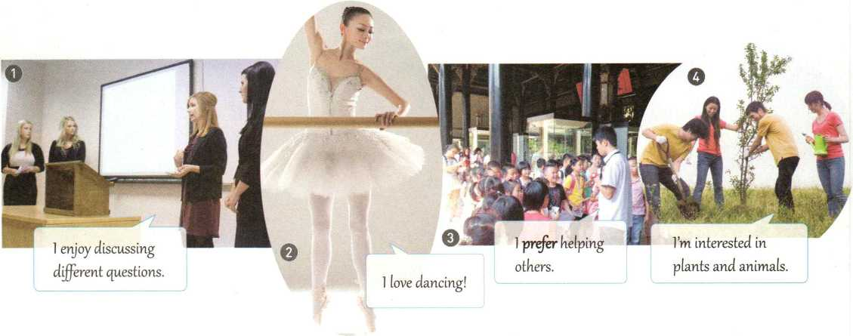

Ballet Club

Volunteer Club

Debate Club

Nature Club

1. Listen to the first two conversations and choose the correct answers.

1 What are they learning about in Conversation 1 ?

A Hearing. B Sounds. C Dogs.

**Predict content**

2 The students are discussing in Conversation 2. A schoolwork B relationships C dating

3 Circle the two clubs where these two conversations happened. A Science Club. B Ballet Club. C Nature Club.

Before you listen, you can read the questions and the choices. It will help you to predict what you will hear.

D Debate Club.

1. Listen to Conversation 3. Then help Adam choose a club.
2. Tick the activities that happen in each club.

|  |  |  |  |
| --- | --- | --- | --- |
| Ballet Club | Nature Club | Cartoon Club | Volunteer Club |
| learn new **movements** | listen to lectures | watch cartoons | help old people |
| watch dance programmes | grow plants | write stories | clean up parks |
| make ballet clothes | work in a **greenhouse** | draw cartoons | give directions |

1. Adam says that he likes but is not so interested in .

A stories, cartoons B animals, plants C making friends, cleaning up

1. Which club do you think is suitable for Adam? Why?
2. think Adam should join the Club because he says that he .
3. 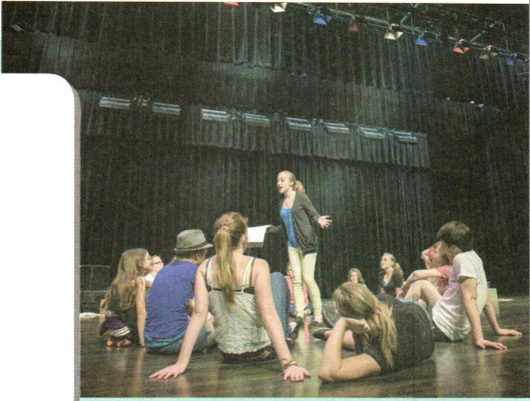Work in pairs. Help each other choose a school club.

EXAMPLE

A: Hi, Sam! Izve decided to join the Music Club.

B: Good decision!

A: How about you? Are you going to join a club?

B: Yes. I'm wondering which one I should choose: the Acting Club or the Ballet Club?

A: I guess the question is ... Do you like dancing better than acting?

B: Actually, I like acting better, but my friends go to the

Ballet Club and I want to be with them.

A: Hmm ... If you ask me, I think you should choose what

you like.

o Pronunciation

|  |  |  |  |  |  |  |  |  |  |
| --- | --- | --- | --- | --- | --- | --- | --- | --- | --- |
| al | ay | ai | are | ar | er | ir | or | or | ur |
| talk | pay | paint | care | bar | her | bird | horse | word | burn |
| wall | stay | daily | declare | hard | prefer | circus | absorb | work | hurt |
| ee | ea | ea | ear | ear | oa | ow | ow | **OU** | ore |
| keen | clean | head | clear | earn | boat | show | now | out | more |
| tree | eager | ready | appear | heard | coach | grow | shower | loud | bored |

*\* 2* Listen to the proverbs and repeat. Notice the pronunciation of the letters in bold.

The early bird catches the worm.

Always prepare for a rainy day.

Actions speak louder than words.

All work and no play makes Jack a dull boy.

Distance tests a horse's strength. Time reveals a person's character.

Compare school life in different places

1. Work in groups. Discuss the questions.
2. What do you want to know about school life in other countries?
3. What would you tell a teenager from another country about school life in China?

■》2 Read the text quickly to find the main idea of each paragraph.

Paragraph 1： Snior high school i& a challenge.

Paragraph 2:

Paragraph 3:

Paragraph 4: '

**Skim**

You can find main ideas by first taking a quick look at the **title,** picture(s), key words and phrases, and **topic** sentences.

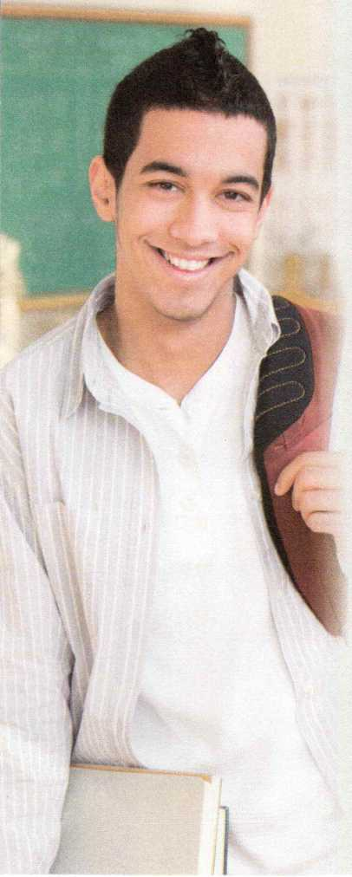

**THE FRESHMAN CHALLENGE**

Hi! My name is Adam and I'm a freshman at senior high school. Going from junior high school to senior high school is a really big challenge. The first week was a little confusing.

First, I had to think very carefully about which courses I wanted to take. The school adviser helped me choose the suitable ones: maths, English, chemistry, world history, and Chinese. I know that Chinese is a very difficult language, but I hope to be fluent when I graduate. My adviser recommended that I should sign up for advanced literature because I like English and I'm good at it.

1. had to choose extra-curricular activities, too. I tried to join the school football team, but the coach told me that I didn't play well enough. Obviously, I was unhappy, but I won't quit. I'll find a way to improve on my own so that I can make the team next year. I joined a volunteer club instead. Every Wednesday, we work at a soup kitchen and hand out food to homeless people in the community.
2. know Uli have to study harder as a senior high school student and get used to being responsible for a lot more. I'm a bit worried about keeping up with the other students in my advanced course, and ifll be quite difficult to get used to all the homework. Still, I'm happy to be here. Studying hard isn't always fun, but I'll be well prepared for university or whatever else comes in the future.
3. Read the text again and answer the questions.
4. What courses did Adam choose? Which one do you think would be his favourite? Why?
5. What does “make the team" in Paragraph 3 mean?
6. What is Adam worried about?
7. Is Adam confident that he will get used to senior high school life? How do you know?
8. Complete the outline. Then discuss the questions below with a partner.

**Paragraph Challenge How Adam feels Solution**

**1** Confused

|  |  |  |  |
| --- | --- | --- | --- |
| **2** | Choosing | courses | The school adviser |
| **3** |  |  | He will find a way to |
|  |  |  | He will |
| **4** |  |  |  |

1. What kind of person do you think Adam is? Why?
2. Do you face the same challenges as Adam? What other challenges are you facing? How do you deal with them?
3. What are some differences between Adam's school life and your school life?
4. Complete the sentences with the correct forms of the new words from the text.
5. I'm good at maths, so my teacher that I should choose advanced maths in my first year.
6. Finding time for both studies and extra-curricular activities is a big , so I need to make a workable schedule.
7. Ifs a little to choose suitable courses. I hope that my adviser can help me make a good decision.
8. We can try a course for two weeks after we up for it. After that, we cannot change it.
9. The main purpose of the course is to help each studenfs reading ability.
10. Some of the students want to become writers or editors after they , so the teacher advised them to start a writing club.
11. The school is for the safety of all the students.
12. Whenever I'm facing a difficulty, I always tell myself, “Don't let anything stop you. Don't ever

Discovering Useful Structures

Improve a draft

1. Find and mark the phrases in the sentences that fit the categories below. Then state their functions.

Noun Phrase (NP) word group with a noun as its head word

Adjective Phrase (AdjP) word group with an adjective as its head word

Adverb Phrase (AdvP) word group with an adverb as its head word

1. The first week was a little confusing.

NP AdjP

1. The building is so big that I'm completely lost.
2. The kids over there are putting something on a round paper plate.
3. Linda thinks and speaks quite quickly, and she can do well in the debate.
4. The new coach told me that I didn't play well enough.
5. My first French class was very confusing. The teacher spoke so fast!
6. Answer the questions using the phrases in brackets.
7. How soon do you think you,ll finish your homework? (pretty soon)
8. What do you think of your new teachers? (very nice and patient)
9. How many clubs have you joined this year? (two clubs)
10. How well does Rita play the violin? We need a new violinist in our music club, (quite well)
11. What did your adviser say about the advanced literature course?

(too difficult but very interesting)

1. Joyce has just written a draft. Help her improve it by using noun/adjective/ adverb phrases to add more information.

Cheerleader Try-outs

rve always wanted to be a cheerleader. Yesterday, I tried out for the team. It was hard. First, we had to dance. The teacher showed us how to move, and then we tried. Second, we practised singing a song about the school basketball team. Finally, some girls had to lift their partners. The other girls jumped and cheered. I think I did well, but the other girls were better. Tm not sure if 111 make the team or not.

「V。always wanted to be a high "hool cheerleader. Vesterday, I tried out for mg gehoolk eheQrleading team. It tuas real© hard. First, ...

Plan a camp for teenagers

1 Cao Jing and Max are talking about camps. Listen to the conversation and tick what they are going to do at the camps.

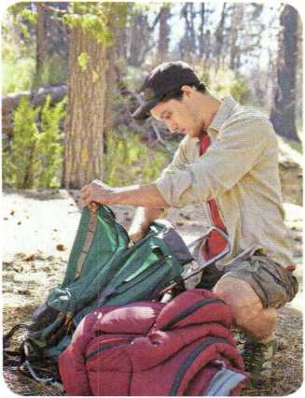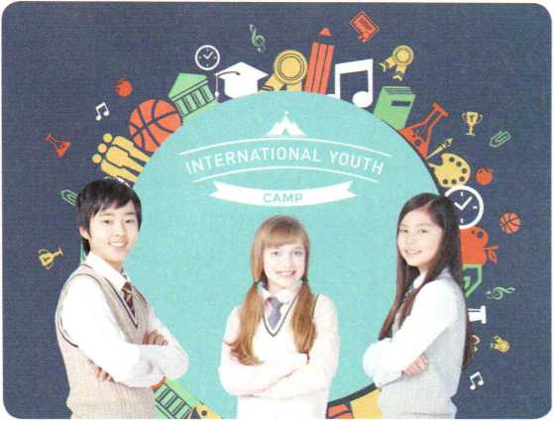

Adventure Camp

International Youth Camp

Well learn survival skills.

ril learn how to make *a* fire.

We'll learn how to live in the wild from some experts.

Were going to learn about wildlife.

I think its going to be fun.

*Q* 2

Talking about future activities

I plan to improve my spoken English. We'll talk about teenage life. There'll *be* students from different countries at the camp.

I'm going to give *a* speech.

I hope to make some friends.

Listen again. Underline the expressions in the sentences above that Cao Jing and Max use to talk about the future.

3 Work in groups. Plan a youth camp.

1. Think of ideas for the camp. You can use the questions below to get started.

* What kind of camp is it? • Who will be there?
* What will they do? • What will they learn?

1. Present your ideas for a youth camp to the class.

EXAMPLE

Camp

Do you want to have fun and learn at the same time? Then come to our camp. In our camp, you can learn about... Therell be many interesting activities. First, we are going to ... Then well ... We also plan to ... Finally, well ... Please come to our camp!

Write a letter of advice

<)》1 Susan Luo, an adviser for teenagers, has received a letter asking for some advice. Read her reply and discuss the questions.

10 September 2018

Date

Greeting

Body

Signature

Dear Worried Friend,

You wrote that you are very worried about your friend, Chen Lei. I understand quite well that you are anxious and feel terrible. You think that your friend plays computer games too often and spends too much time online.

I recommend that you talk to your friend about his behaviour. It is not unusual for teenagers of your generation to be attracted to computer games and the online world. But spending too much time online is unhealthy and makes it very difficult to focus on other things in life. Some students even become addicted to the Internet and cannot concentrate on school and family life. I think you should encourage your friend to try new hobbies. Why not discuss the problem together? I am sure he will listen to you, since you are his good friend.

All the best,



1. What is Worried Friend's problem?
2. Do you think Ms Luo's advice is useful? Why or why not?
3. What other kinds of advice would you give?
4. Study the organisation and language features,
5. Find and mark the parts of the letter that match the following points.

A I know what the problem is. B I understand how you feel.

C This is my advice and reason(s). D I think my advice will help.

1. What expressions does Ms Luo use to make suggestions? Circle them in the letter.
2. Use what you have learnt to write a letter of advice to one of the teenagers below.

1 Work in groups. Choose one of the teenagers and discuss his/her problem. List possible

suggestions and reasons.

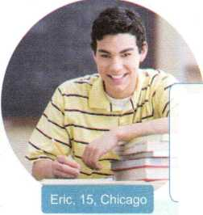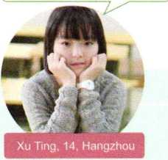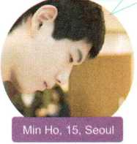*There is* a girl 1 like in my class, *but Vm too* sky *to* talk *to* her Please help me!

My parents won't listen when 1 tell tkem things. 1 guess its because they're adults and can't understand me. Do you kave any suggestions?

1 always Jeet lonely after school because my parents work in another city. What can 1 *do?*

Reason

2 Draft your letter according to the outline below.

Write the date and greet the reader.

Dear ,

*You* wrote that .

I understand that .

I think

because . I am sure that .

Close and sign the letter.

1. Exchange drafts. Use the checklist to give feedback on your partner's draft.

Are all the parts of a letter included and organised in a good order?

/ Does the writer give reasons for the advice?

v Does the writer use proper expressions to give suggestions? Does the writer use commas and stops correctly?

Is the handwriting easy to read?

1. Get your draft back and revise it.
2. Put up your Letter in the classroom or read it to the class.

Assessing Your Progress

1 Circle the correct word(s) in each sentence.

1. Today's teenagers seem to prefer/like the Internet more than TV.
2. Martin did not enjoy pop music until he became a generation/teenager.
3. Which course did your teacher recommend to/with you?
4. Don't quit trying/to try if there is still hope.
5. I think he is addicted/attracted to smoking. He just can't seem to quit.
6. The library project has already fallen behind schedule/plan.
7. The research has focused on/for the relationship between a teenager's sleep and health.
8. The instructions on the box made him confusing/confused, and he did not know what to do.
9. Find the noun/adjective/adverb phrases in the passage and state their functions.

If you have learnt some maths at school, you can quite quickly work out that one eleventh is about 9 percent. But did you know that 9 percent is also the number of children who are not at school? That's right—one in 11 children is not studying and probably even cannot do the simple maths you just did so very easily. They drop out of school because their families are too poor and they have to work like adults. In 2013, millions of children and teenagers were out of school. Most live

in poor countries, but there are also some boys and girls who cannot go to school in rich countries. If you are one of the lucky ones who can go to a senior high school, you should be grateful for the opportunity. So the next time you feel like you do not want to do boring, difficult homework or go to class, think about the children who don't have the chance to get a good education. Make the most of your education and make the world a better place.

Do you agree with the writers opinion? Give your reasons.

V REFLECTING

Which reading in this unit did you find the most interesting? Why?

What new things did you learn about teenage life from this unit?

What new vocabulary and structures did you learn in this unit? Did you use any of them in your language activities? How well could you use them?

Do you think skimming was useful for you to understand the texts?

What problems did you or your friends have with this unit? How did you solve the problems? What advice did you give each other?

* Project： Set up a student club

1 You are going to set up a student club. Work in groups and choose one of the clubs from below, or create a new club you think others would be interested in joining.

|  |  |  |  |
| --- | --- | --- | --- |
| Calligraphy Club | Basketball Club | Psychology Club | |
|  | Student |  |  |
|  | Club |  | Club |
| Club |  |  |
| Debate |  | Biology |  |
| Club | Chess Club | Club |  |

2 Decide on the following details of your club.

|  |  |
| --- | --- |
| **Club name** |  |
| **Slogan** |  |
| **Aim** | (Why form the club? What does it hope to achieve?) |
| **Activity** | (What will members usually do at the meetings? Any special events or outings?) |
| **Requirement** | (What should members prepare and bring?) |
| **Meeting time and place** |  |

1. Design an eye-catching logo for your club and make a poster including the club's name, slogan, and logo.
2. Prepare an introduction to recruit new members during a school assembly. Include some details that are not mentioned on your poster.

EXAMPLE

Hello, everyone! We're very pleased to introduce our club to you. It is called ... Our slogan isand our club aims to ...

* Video Time g

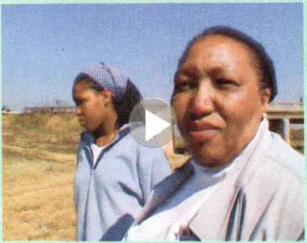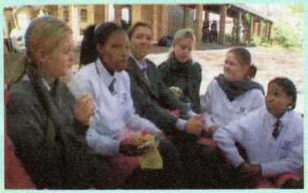Learning Across Generations

Mamorena Chaane is a teenage girl. She lives in the suburbs of Johannesburg, South Africa with her mother, landi.

BEFORE YOU WA C松

Look through the title, introduction, and photos. Then guess whether the statements are true (T) or false (F).

1. In South Africa, many teenagers graduate from university.

T F

tQ f

T F

T F

A shanty town is a poor area. People in a shanty town make their own houses, often from wood or materials that have been thrown away.

1. Mamorena's life is the same as Tandife when she was young.
2. landi had a difficult childhood.
3. Tandi is now a successful businesswoman.

WHILE YOU WATCH

1. Check your answers in Before You Watch.
2. Circle the correct word(s) in each sentence.
3. Mamorena is a student at an expensive/inexpensive private school.
4. Tandi grew up in a poor/wealthy area of Johannesburg.
5. Mamorena does not understand/understands about her mother's childhood.

AFTER YOU WATCH

Work in pairs. Discuss the questions.

1. In what ways is your life similar to or different from your parents' life when they were young?
2. Tandi said, "I don't think you become a person if you don't know where you come from." Do you agree or disagree with this statement? Why or why not?

TRAVELLING

AROUND

*二*

4

*5*

1

2

3

**In this unit, you will**

**Look and discuss**

write a travel plan.

learn about travelling at home and abroad.

Where do you think the travellers in the photo are?

Do you like travelling? Who do you like to travel with? What places have you travelled to? What words can you use to describe your trips?

**23**

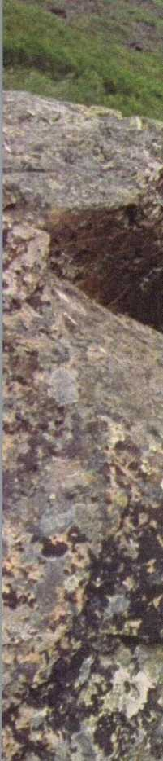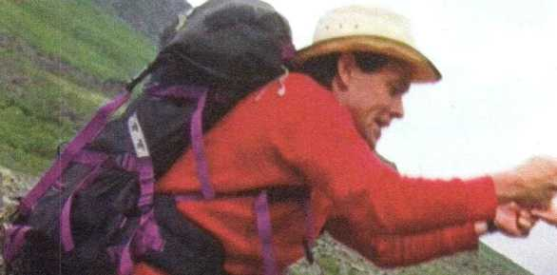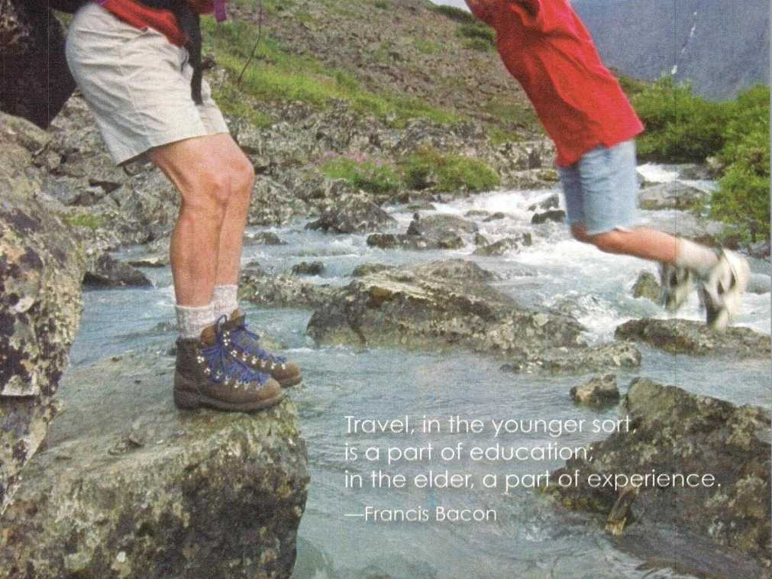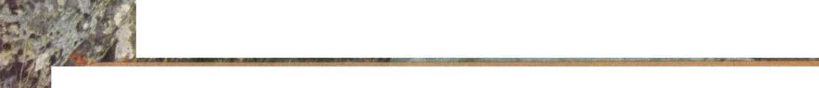

Listening and Speaking

Get ready to travel

1 Before you listen, discuss the questions in groups.

1 If you have the chance to travel anywhere in the world, where will you go?

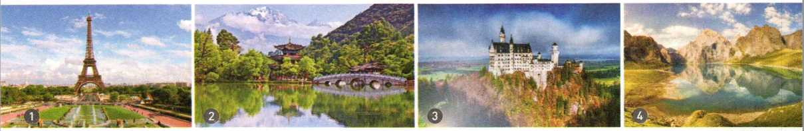

2 What do you need to do to prepare for the trip?

Tianshan, China

Lijiang, China

Neuschwanstein **Castle,** Germany

the Eiffel lower, France

get a passport rent a car

apply for a visa buy a guidebook

book tickets book a hotel room

pack some clothes research the local weather

Paul and Meilin are talking about the coming holiday. Listen to the first part of the conversation and choose the correct answers.

Circle the two places Meilin is going to for holiday.

A Germany. B England. C Iceland. D France.

**Focus on key words**

How is she going to get there?

A By sea. B By air. C By train.

How is she planning to get around after she arrives?

A By car. B By train. C On foot.

Do not try to catch every word in a conversation. Instead, listen for key words and phrases. You should focus on getting the main idea, not on single words or grammar.

Listen to the second part of the conversation and answer the questions.

1. Where is Paul's family going over the holiday?
2. Why are they going there?

Listen to the whole conversation again and fill in the table below.

**Travel**

**Preparations**

Meilin

Paul

a few light sweaters and a coat a guidebook

a car

* Get her passport
* for her visa

* air tickets online

1. Choose a travel destination and think about what you would do to prepare to travel there. Then share your travel plans with a partner.

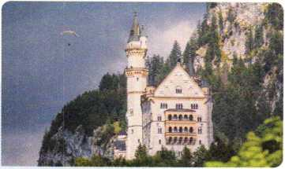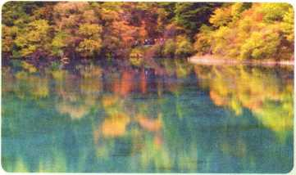

Where: Neuschwanstein Castle, Germany Why famous: the model for the castle in Disneyland

Where: Jiuzhaigou, China

Why famous: amazing waterfalls, colourful lakes, beautiful mountains

Best time to visit:

April/May or September/October

Best time to visit:

September/October (autumn)

EXAMPLE

A: Hi, Julie! Do you have any plans for the holiday?

B: Hi, Wang Lei! Yes, I'm planning to travel to Jiuzhaigou. Actually, I've just finished the travel arrangements!

A: Oh, good idea! Jiuzhaigou is an extremely beautiful place.

B: Yes, I'm looking forward to seeing the colourful lakes, amazing waterfalls ...

A: How are you getting ready for your trip?

B: I'm ...

o pronunciation

Listen and repeat. Then add more words to each group.

|  |  |  |  |  |  |  |  |  |  |  |
| --- | --- | --- | --- | --- | --- | --- | --- | --- | --- | --- |
| ck | ch | tch | ph | sh | th th |  | wh | wh | ng | qu |
| ticket | search | catch | photo | wish | thing weather | | when | who | song | quarter |
| pack | check | Dutch | graph | shock think neither | | | what | whose wing | | request |
| gu | igh | kn | mb | wr | c c | g | g |  | **X** | **X** |
| guest | high | know | climb | write | copy face | green large | | | text | exam |
| guide | night | knee | comb | wrist | local twice | blog general | | | except | exact |

Listen to the sentences below. Notice the pronunciation of the letters in bold.

A traveller without observation is a bird without wings. (Moslih Eddin Saadi) lb travel is to discover that everyone is wrong about other countries. (Aldous Huxley)

I see my path, but I don't know where it leads. Not knowing where I'm going is what inspires me to travel it. (Rosalia de Castro)

Explore Peru

1. Watch the video *Welcome to Peru* and answer the questions.
2. What did you see in the video?
3. What other sources of information can you find about Peru?
4. Below are two texts about Peru. Look through them quickly. What types of text are they： encyclopedia or brochure?

PERU is a country on the Pacific coast of South America with three main areas: **narrow,** dry, **flat** land running along the coast, the Andes Mountains, and the Amazon rainforest.

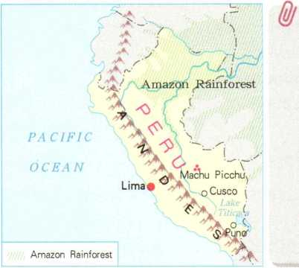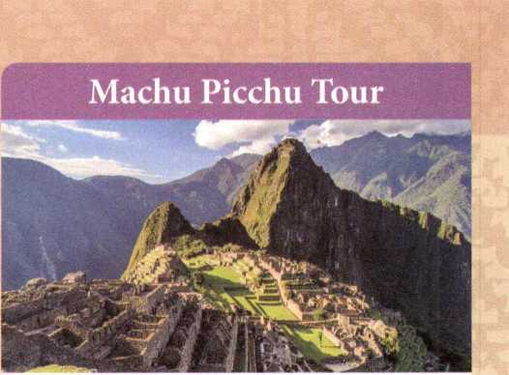In the 1400s and 1500s, Peru was the centre of the powerful ancient Inca Empire. The Inca **emperor** lived in the now-famous **site** Machu Picchu. Spain took control of Peru in the 16th century and ruled until 1821. It is for this reason that Spanish is the main **official** language of Peru.

**Recognise text type**

Before you read, look through the text quickly for titles, headers, pictures, charts, and any other information that might tell you what type of text it is.

**TRAVEL PERU**

A short **flight** from Cusco takes you from the Andes into the Amazon rainforest. From there, you'll spend one day travelling by boat to your **accommodation** in the middle of the forest. You can then spend three days exploring the rainforest with a local guide and enjoying the plants and animals **unique** to the rainforest.

This four-day walking tour will take you on amazing **paths** through the Andes Mountains on the way to the city of Machu Picchu. After reaching your **destination,** you will have a day to explore and be amazed by this ancient city. Especially amazing is the Incas dry stone method of building. Inca builders cut stones to exact sizes so that nothing was needed to hold walls together other than the perfect fit of the stones.

1. Complete the passage with the correct forms of the new words from the two texts.

Cusco is a popular d for tourists, because of its u place in the history of South America. Cusco was the capital city of the Inca E which was the most powerful in South America until the 1500s. There are two especially interesting things to a about the Inca civilisation. The first is the roads and p they built to connect their important cities. These Inca roads were made up of two north-south highways and many small roads crossing the mountains east to west. The roads were for Inca soldiers and their o . Second, the Incas built wonderful cities full of amazing architecture— but there were no markets in these cities. One of the interesting questions of history is how the Incas lived without shopping!

1. Read the text and fill in the table. Then discuss the question below with a partner



Spend four days enjoying the unique Spanish and local Indian culture high in the Andes at Cusco, the capital of the Inca Empire from the 13th until the 16th century. Stay in a local hotel, visit the museums, **admire** the architecture, enjoy the excellent local food, and go shopping at the local markets.

Enjoy the beautiful countryside as you spend a day driving along the new highway connecting Cusco to Lake Titicaca. There, a boat will take you to stay with a local Uros family on an island for three days. Both the island and the Uros homes are made of water plants from the lake.

|  |  |  |  |  |
| --- | --- | --- | --- | --- |
|  | **AMAZON RAINFOREST** |  | **CUSCO** |  |
| **Number of days** |  | 4 days |  |  |
| **Transport** |  |  |  |  |
| **Accommodation** |  |  |  | local home |
| **Activity** | boating, hiking, exploring nature |  |  |  |

Which tour(s) would you recommend for people who enjoy history and culture?

So come and experience what Peru has to offer: everything from the ancient Inca culture and centuries-old Spanish villages to deep rainforests, high mountains, and a beautiful coastline.

For more **brochures** about other **package** tours around Peru, **contact** us at [tourinfo@travelperu.org](mailto:tourinfo@travelperu.org).

Discovering Useful Structures

Talk about your future plans

1. Look at the sentences. What do you think the tense in the sentences expresses?

* I'm travelling around Europe for two weeks with my aunt and uncle.
* We're renting a car and driving!
* My parents are taking me to Hong Kong during the October holiday.

1. Read the conversation and underline verbs in the present continuous tense. Discuss with a partner when and how these verbs are used.

Amy: Hello, Jeremy! What are you doing this weekend?

Jeremy: Hi, Amy! Some friends and I are going to that new water park on Saturday. Do you want to join us?

Amy: Sure, Td love to! What time and where?

Jeremy: We're meeting at 10:00 a.m. at the bus stop near our school.

Amy: How about lunch? Are you eating at the water park?

Jeremy: Well, I'm bringing my own lunch. I think some of the others are eating at the park, but the food there is really expensive.

1. Read the sentences and tick those that express future plans. Rewrite them in the present continuous tense.
2. Pve just booked my air ticket! TH visit my grandparents in December.
3. Gary might visit China next year, but he's still not sure.
4. Kate has been invited to a meeting in Iceland. She will apply for a visa soon.
5. Could you help me with this box, please? I'm afraid I'm going to drop it.
6. A: Hey, are you free for dinner tonight?

B: I'm sorry, no. TH have dinner with my cousins tonight.

1. Discuss weekend plans with a partner, based on the weather report below.

|  |  |
| --- | --- |
| Saturday | Sunday |
| Morning Afternoon Evening | Morning Afternoon Evening |
| **200 25°C 19°c** | **21X： 20°C 17°C** |
| weather： sunny weather： sunny weather： clear c | weather： cloudy weather： rainy * weather： cloudy |
| **wind： light = wind： light = wind： strong W** | **wind： strong s wind： light = wind： none** |

EXAMPLE

A: What are you doing on Saturday morning?

B: Well, it's going to be sunny in the morning and not very windy, so I'm having a picnic with my friends.

Make reservations

1. Listen to the phone call and answer the questions.
2. What are the two speakers talking about?
3. What is the relationship between the two speakers?
4. Listen again and complete the table with the words you hear.

|  |  |
| --- | --- |
| Opening | **Making reservations**  *T .. 玲* to buy *a* plane  can I help you?,涂时... |
| Talking about time | are you On the 23rd of December travelling? |
| Talking about what you prefer | There are two flights ...  Which ? The 9:30 flight please.  Would travel to travel  business class or economy? business class.  book a return No, • Im taking flight this time? the train back. |
| Other information | your name, sir? Robert Williams. |
| Payment | to pay? By credit card. |

1. Imagine you are making plans for the holiday. Choose one of the situations below and role-play a phone call with a partner.

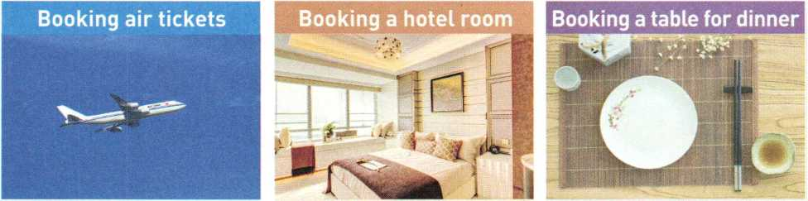

* Details

travel date(s) preferred time one-way or return

* Flight class
* first class
* business class
* economy class
* Other information

name

method of payment

Details

check in/check out breakfast

Internet

Kind of room

* 2 single beds
* double bed
* king bed

Special requests

* a view
* a non-smoking room
* a quiet room
* Details

date

time number of people

* Special requests
* non-smoking area
* high chair(s)
* other：

Write to a friend about a travel plan

W＞》1 Read Richard's email to his friend and the brochure that he found. Do you think his plan sounds interesting? Why?

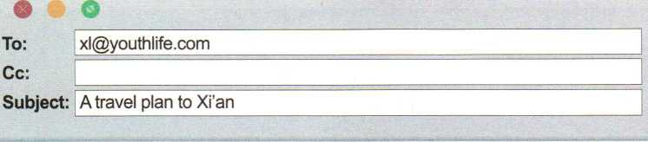

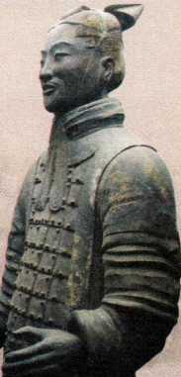

Dear Xiao Li,

My time here in China is going well. I love my new school and classmates. Over the October holiday, my parents and I are planning to go to Xi'an to see the Terracotta Army. I've heard that it is an amazing sight, and I can't wait to go. To me, the story of the Terracotta Army is almost unbelievable. It's amazing that there are more than 8,000 statues, and no one in modern times knew about them until the 1970s.

We're also planning to visit several other places in Xi'an. My dad and I are both looking forward to going to the Shaanxi History Museum, because my dad loves history and I have heard that this museum is known as a "Chinese treasure house"! We're also going to the Xi'an City Wall and a few other famous sights.

We're taking the train, leaving the day before the October holiday begins. We're arriving at 9:30 a.m. and will start sightseeing right away, so I hope we sleep well on the train!

1. guess that's all for now! I'll write again soon and send photos! Do you have any plans for the coming holiday? Hope to hear from you soon.

Your friend, Richard

Come and see the Terracotta Army: more than 8,000 statues were made in the third century BCE to guard the tomb of the Chinese Emperor Qinshihuang! Each statue has a different face, leading researchers to believe that each one is a copy of a real soldier. The statues fill only one part of the emperor's huge tomb, which still has not been completely unearthed. More than 700,000 people worked for nearly 40 years to build this tomb. However, no one in modern times knew about the tomb or the terracotta statues until 1974, when some farmers discovered the tomb while they were digging a well! 4

1. Study the organisation and language features.
2. Summarise the email in the table.

|  |  |  |
| --- | --- | --- |
| **Paragraph** | **Main idea** | **Detail** |
| **1** | main purpose for the trip |  |
| **2** | other plans for the trip | |
| **3** | transport |  |
| **4** | final thoughts |  |

1. Underline the words and phrases used to express emotion in the email. Then complete the sentences below.

|  |  |  |  |
| --- | --- | --- | --- |
| It is an amazing sight. |  | It is | |
| ► | I'm amazed. | |
| ... is almost unbelievable. | ► | I can't believe it.  It's hard |  |
|  |  | Ifs an ________ | story. |

1. Use the tables above to help you write a travel plan. Then follow the steps below.
2. Pretend you are Xiao Li and reply to Richard's email.
3. Exchange drafts. Assess each other's work according to the checklist.

/ Is there a clear purpose for the trip?

*J* Does each paragraph have a clear main idea?

/ Does the writer use the present continuous tense for future plans?

/ Does the writer use commas, stops, and question marks correctly?

/ Are all the words spelt correctly?

/ Are all the proper nouns capitalised?

1. Revise your draft according to your partner's comments.
2. Put up your email in the classroom or read it to the class.

Assessing Your Progress

1. Complete the postcard with the correct forms of the words below.

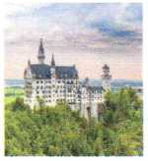destination sight pack credit detail amazing rent

admire

200

Deutschland

Hi Paul,

Kello from our final —Meuschwanstein Castle! We arrived in Europe about six days ago. Pm so glad that a car. The highways here are uuonderful, and driving lets you see lots of amazing . Pm also pleased I good walking

shoes, because we'u。walked A LOT in the last few days. I feel like we drive for only a short time and then walk and walk and walk! I think what I most so far is the architecture. The

on the buildings hero are so unusual, so different from China. Of course, also enjoying the shopping! I bought gifts for all of my family and friends. Pm vory glad my card works here, so I don't have to carry a lot of money. I hope I can oome back here some day and see all of these places again.

Your friend,

Meilin

1. Read the conversation and mark the phrases expressing future plans.

Paul: Hey Meilin. This is Paul, calling from the Old Town of Lijiang!

Meilin: Hi Paul! You are already in Lijiang?! Great to hear you! So what do you think of the Old Town there?

Paul: Oh, we love it. You know, it is so different from big cities.

Meilin: Really? How long are you staying there?

Paul: About four days, since my dad has to go back to work next Monday. We arrived yesterday and visited the Old Town. Tomorrow we're going to Yulong Snow Mountain. In order to save time, we're taking the cable car up there. If we still have time, we're planning to see Blue Moon Valley and Yak Meadow.

Meilin: Sounds great! Oh, don't forget ifs much colder on Snow Mountain. Be sure to keep warm!

Paul: Thanks! We're bringing sweaters and coats with us, so I hope we'll be OK. Til see you in a few days! Talk to you soon.

Role-play the conversation with a partner; Pay attention to your stress and intonation.

C REFLECTING

My favourite part of this unit was because . In this unit, I had a hard time with because . I wish I could learn more about because . Overall, I thought this unit was cool useful just OK difficult.

* Project： Design a travel brochure

1. 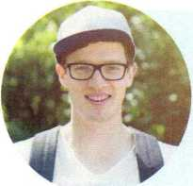Read the posts and find out what each students reason is for travelling.

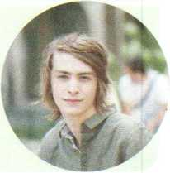Hi everybody! Tm Fraser, and I'm from the UK. I'm going to visit China this year because I'm very interested in China's history and culture. I'm going to see the Great Wall, but other than that, I'm not sure where to go. Any ideas?

Hello! My name is Anthony. Tm from France. I want to go hiking in China over the summer holiday. I love nature, and I really want to see the beautiful sights there. The mountains, the sky, the lakes一 the photos I've seen of Chinas countryside are wonderful.

Hi! My name is Anna, and I'm from Russia. I've just started my last year of high school, and I want to visit a few universities or colleges in China, since I hope to study there next year. I want to experience some Chinese culture and see the natural beauty there, but my main goal is to find out which university is the best for me to attend.

1. Work in groups. Research, plan, and design a tour.
2. Brainstorm different types of tours and add them to the list below.

• Education • History •Adventure • Culture • Cuisine

1. Choose one person and a tour he/she might like. Work out a week-long travel plan for the tour.

Time Place Activity

Day 1

Day 2

Day 3

Day 4

Day 5

Day 6

Day 7

1. Design a travel brochure for the tour Make your brochure as attractive as possible.

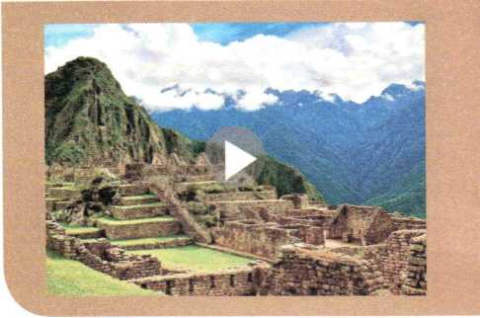* Video Time &(

Machu Picchu

Machu Picchu is an ancient city high up in the Andes Mountains of Peru in South America. It is very popular with tourists and brings money into Peru.

BEFORE YOU WATCH

Complete the sentences with the words and phrases below. You may use a dictionary to help you.

magnetic centre Inca civilisation outside world stalls business and money ruins

1. Machu Picchu was once part of the .
2. For many years, Machu Picchu was lost to the .
3. Machu Picchu is now made up of .
4. People believe that Machu Picchu is a(n) , attracting many tourists each year.
5. Apart from being a magical place, Machu Picchu also brings a lot of to Peru.
6. Local people sell things at to tourists.

WHILE YOU WATCH

Choose the correct answers.

1. Another name for Machu Picchu is .

A Aguas Calientes B one of the magnetic centres of the ancient world

C the Lost City of the Inca

1. Machu Picchu was built .

A in 1911 B more than 500 years ago C 500 years ago

1. Some people worry that too many tourists going to Machu Picchu , A will be bad for the environment B will be bad for business

C will be too noisy

1. The people in the town live completely .

A on the money from tourism B by selling art C by driving buses

1. Machu Picchu may be changed forever by .

A the weather B poverty C tourism

AFTER YOU WATCH

Work in groups. Discuss the questions.

1. Are there any places like Machu Picchu in China? In what ways are they alike?
2. Should tourism be stopped in places like Machu Picchu? Why or why not?

UNIT

SPORTS AND

FITNESS

3

1

2

**In this unit, you will**

read about famous athletes at home and abroad, hear and talk about sports events and sportsmanship.

write about health and fitness.

1. Do you jog often? What sports and exercise do you like?
2. What do you think sports and exercise can do for you?



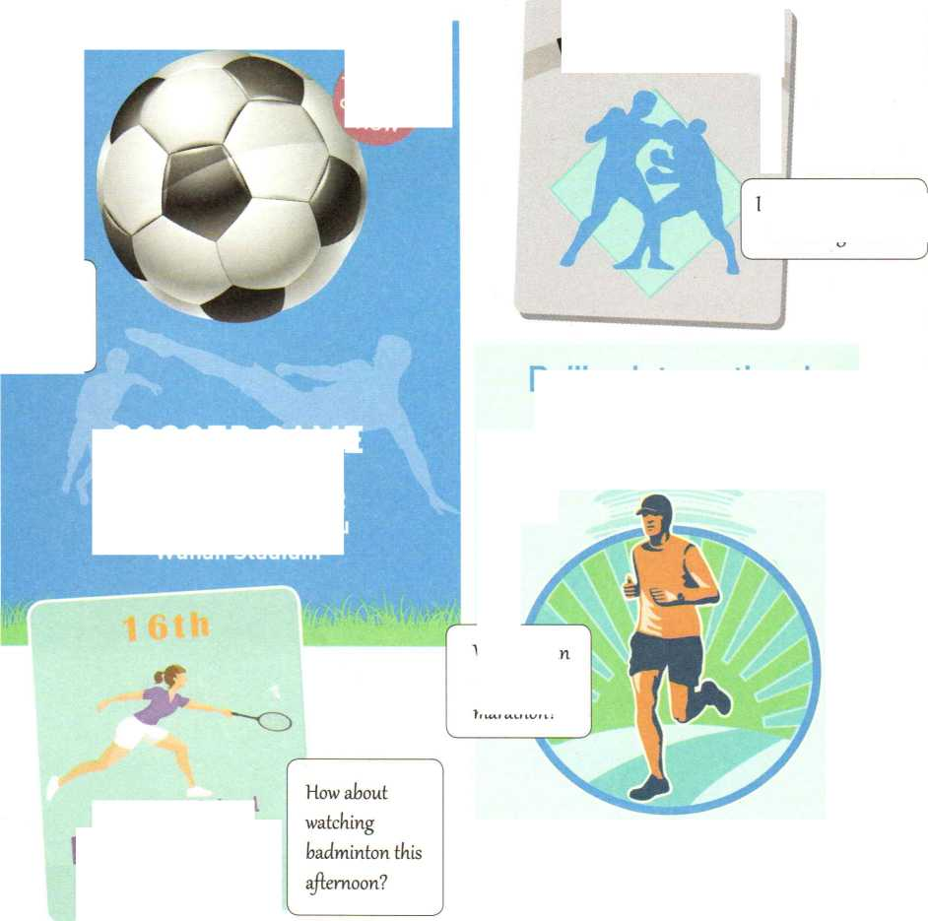

Sunday, 30 October

Olympic Park, Beijing

Full Marathon and Half Marathon

Would you like to *go to the* soccer game?

BOX/'g

Tickets °n sale

*NOW*

Do you want to watch  
tke boxing match?

**SOCCER GAME**

C 2 Listen to Conversation 1. What is Shen Qi's

lb invite Amy to an e-sports event, lb invite Amy to a soccer match.

To explain an e-sports event.

Invite a friend to a sports event

1. Look at the posters. What sports events do you like to watch? Which sport would you like to try?

Beijing International  
Marathon Day

3：00 p.m. October 22  
Wuhan vs Guangzhou  
Wuhan Stadium

Why not rui an exciting marathon?

**No. 8 High School**badminton  
**MATCH**

main purpose for talking to Amy?

*&*

**Listen for main ideas**

Try to catch the main ideas instead of trying to remember and translate each word you hear.

C 3 Listen to Conversation 1 again and circle the words that the speaker stresses.

1. Did you hear that there's an e-sports event this weekend?
2. Would you like to come along?
3. Really? I'd love to!
4. Why don't you join us this Saturday afternoon?
5. Oh, sorry. I can't.
6. Adam is inviting Julie to a sports event. Listen to Conversation 2 and answer the questions.
7. When will the event happen?

The event will happen .

1. What's a "Blue Paint" run?

A “Blue Paint" run is a fun run that .

1. Why is it called a "Blue Paint" run?

Because people can buy water balloons filled with and the runners.

1. If 200 people take part in the run and 400 balloons are sold, how much money will

they collect?

1. What event or activity would you like to invite your friend to? Make a conversation with a partner.

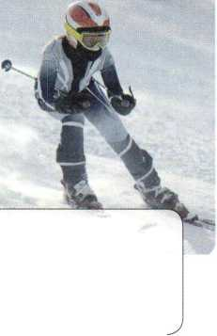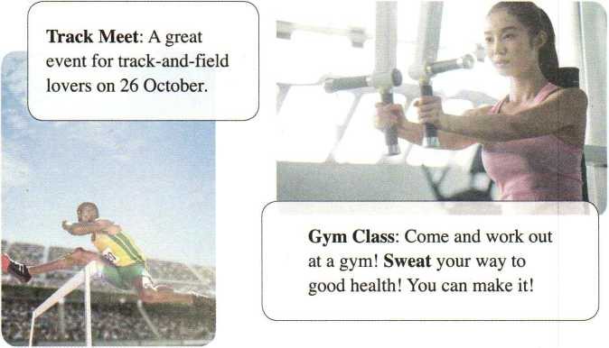

**Ski Race:** Zhangjiakou, a beautiful city in northern China, will **host** the Youth Ski Race in December.

**k**

O Pronunciation I

1. Read the conversation. Decide whether the intonation of the tag questions is rising or falling.

Dave: Wonderful gym, isn't it?

Jack: Er... yes. Ifs great.

Dave: This isn't your first time here, is it?

Jack: Actually, it is. Ydu come here often, don't you?

Dave: *Yep.* At least three times a week.

Jack: You've lost some weight, haven't you?

Dave: Yes. All that fat has become muscle now. If you want to lose weight, too, I recommend using the spin bike.

Jack: OK, but it won't make me too tired, will it?

Dave: Maybe at first, but you'll get used to it. I used to come here every day when I first started.

Jack: Oh, I don*t have to come here every day, do I?

Dave: No. Of course not. Ifs up to you, isn't it?

O 2 Listen and check your answers. Then practise it with a partner.

Choose your favourite athlete

1. Look at the titles and pictures below. What do you think the text is about?

**Make predictions**



Help us choose some “Living Legends of Sports”. They must be **athletes** who are **masters** in their sports and also set good examples for others. Here are our first two choices.

Look at the pictures and think about the content before reading. This helps you to relate what you read to what

**Lang Ping**

**Michael Jordan**

As a player, Lang Ping brought **honour** and glory to her country. As a coach, she led the China women's volleyball team to **medals** at world championships and the Olympics. As a person, Lang Ping is loved by fans at home and abroad. When the Chinese team was preparing fbr the 2015 World Cup, her determination was tested. The team that Lang Ping had built was falling **apart.** One of the best players had been injured, and the team **captain** had to leave because of heart problems. Losing two important players was a big challenge, but Lang Ping did not lose heart. She had faced difficulties before, and she knew that her young players could win if they worked together as a team. Two weeks later, they were world **champions!** Then in 2016, Lang Ping led her volleyball team to Olympic gold in Brazil.

When Michael Jordan's feet left the ground, time seemed to stand still. The player who became known as "Air Jordan,, changed basketball with his graceful moves and jumps. Jordan's skills were impressive, but the mental **strength** that he showed made him unique. In the final seconds of a game, Jordan always seemed to find a way to win. Jordan says that the secret to his success is learning from his **failures.** UI can accept failure; everyone fails at something. But I can't accept not trying.Losing games taught him to practise harder and never give up. In life, Jordan has learnt to share his success with others. The Boys and Girls Club which he started in Chicago has been helping young people since 1996.

Send your suggestions for uLiving Legends of Sports” to [LLS@sports.net](mailto:LLS@sports.net).

1. Read the text and decide what is stated in the text (S), what can be inferred (I), and what you know to be true from experience (E).

Lang Ping won several championships before she became a coach.

Lang Ping believed that her young players could win.

—Many people in China and the US love Coach Lang.

Michael Jordan is loved by basketball fans around the world.

—Before people saw Michael Jordan play, they did not know that basketball could be played that way.

Michael Jordan believes that it is important to help others.

1. Read the text again and answer the questions.
2. How was Lang Ping's determination tested in the 2015 World Cup?
3. What examples does the writer use to describe Lang Ping?
4. What does the first sentence in the paragraph introducing Michael Jordan mean?
5. Why does the writer mention "the final seconds of a game"?
6. Work in groups. Discuss the questions.
7. What reasons does the writer give for choosing Lang Ping and Michael Jordan? Who would you choose as another "living legend"? Give your reasons.

**Vao Ming**

**Chinese**

**Basketball**

**2.26 m**

**Care for wildlife**

1. What can we learn from successful athletes?
2. Use the words and phrases below to talk about Lang Ping, Michael Jordan, and the athlete that you admire.

|  |  |  |  |  |
| --- | --- | --- | --- | --- |
| athlete | champion | determination | captain | bring glory and honour |
| injured | impressive | medal | unique | set a good example |
| give up | strength | graceful | failure | lose heart |

Lang Ping：

Michael Jordan：

The athlete I admire：

Discovering Useful Structures

Make small conversations

1. Read the conversations below and underline the tag questions and their answers. What functions do the tag questions have?
2. Amy: It's not a real sport, is it?

Shen Qi: Yes, it is.

1. Adam: That sounds interesting, doesn't it?

Julie: Sure, it does.

1. Lin Tao: Hi! It's a beautiful day, isn't it?

Han Jing: Yes, it is. I'm going to play soccer. Can you come along and join us?

Lin Tao: Sorry, I can't. I've got to meet my adviser. By the way, our school soccer team won at last, didn't they?

Han Jing: No, they didn't. It's too bad.

1. Complete the conversations with appropriate tag questions or correct answers. Then act them out.
2. A: It's not going to rain, is it?

B: . It's a good day for sports.

A: Then we can play football, ?

B: . We don't have a ball.

1. A: It's Sports Day next Thursday, ?

B: You're right, it is. Let's ask Xia Lei if she wants to join a team.

A: She likes soccer, ?

B: . But she loves volleyball. She could be in the volleyball team.

1. A: It's time for badminton class. Where is the coach? He's late, ?

B: It's been 10 minutes already. He isn't coming, ?

A: Cool! We can have a good time. That's great!

B: Shh!

A: Oh no, he's right behind me, ?

C: Yes, I am!

1. 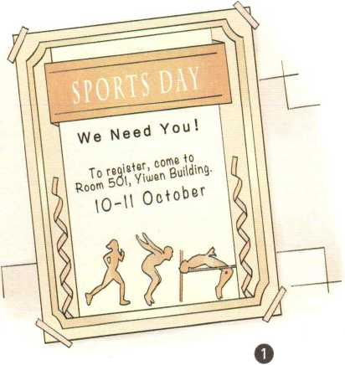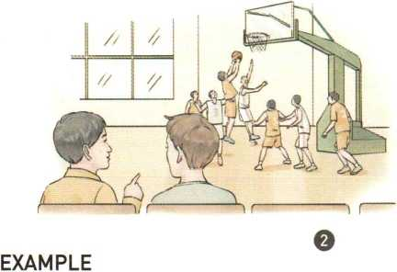Work in pairs. Use tag questions to role-play one of the situations below.

A: The Sports Day is coming soon, isn't it?

B: Yes, it is. They need some volunteers, don't they?

A: Yesz they do. ...

Voice your opinion on sportsmanship

C 1 Three students are talking about sportsmanship. Listen to the conversation and match each opinion with the right speaker. Who do you agree with? Why?

**Cao Jing Lily Max**

A An athlete should do his/her best to win.

B The girl should stop and help the other girl. Good sportsmanship is more important than winning!

C An athlete should think about honour and his/her fans if he/she is competing for his/her country.

C 2 Listen again and circle the expressions that you hear in the conversation.

I agree. So do I. Exactly! All right. Good idea.

| Agreeing | Disagreeing |
| --- | --- |
| Yes, I think so.  Me too. | I'm sorry, but I disagreeZdont agree. I dont think so. |

Sure./Certainly./Of course. not right

Youre right/correct. That doesn't make any sense!

I guess so. That& not how I *see* it.

I see what you mean, but ...

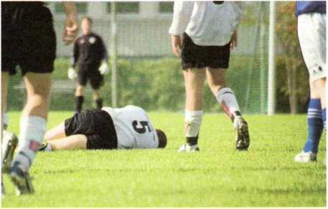

1. Work in groups. Choose one of the situations below and make a conversation.

A soccer player should not pretend to fall down even if it helps his/her team.

* In school teams, everyone should get a chance to play, not only the best players.
* It is wrong to pay people millions of yuan to play sports.
* Athletes should play only for their own country.

EXAMPLE

A: I agree with the idea that a soccer player should never pretend to fall down even if it helps his or her team. You should never cheat.

B: Exactly! It's important to do the right thing.

C: Well, I don't think so. Many players do it, and they think it helps their team to win.

A: That doesn't make any sense!

B: I see what you mean, but the audience wants fair play.

Write a page in a wellness book

♦》1 A high school class has a wellness book in which they exchange ideas about health and f代ness. Read what Kayla wrote and answer the questions.

**GOING POSITIVE**

o

o

o

o

o

o

o

o

o

o

o

o

o

o

o

I always wanted to look like the slim girls on TV even though I knew that it was impossible. I worried about my weight and tried every new diet I read about online. I tried no­fat, low-fat, 5:2, only bananas, no bananas—I almost went bananas, too.

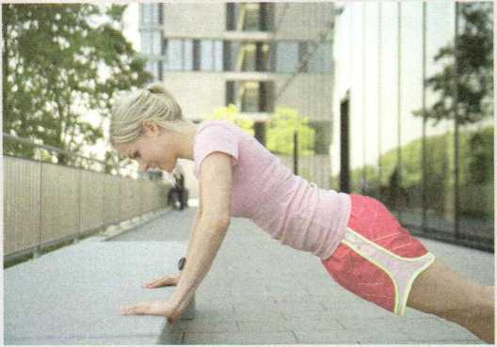Then I read an article that said instead of asking /zAm I fat?” I

should be asking z<Am I fit?” I had no idea a letter could make such a difference! Once I started thinking about fitness rather than weight, things began to change. Instead of saying "I want to lose three kilos", I would say "I want to run two kilometres in eight minutes" or "I want to be able to do 30 push-ups”. Rather than cutting out the foods I enjoyed, I added healthy foods to my meals. I could still have a burger now and then, but I would add a salad or an apple.

Finally, I stopped comparing myself with actresses and models and looking for things that were wrong with my face or body. Instead, I made a list of the things I liked about myself. By being positive about myself and my body, I became both happier and healthier.

1. What problem did Kayla have in the past?
2. What does the sentence “I almost went bananas” mean?
3. What made her change her thinking?
4. Study the organisation and language features.
5. Complete the outline with the words and phrases from the text.

**The past The present**

worried about and tried think about

compared myself with

1. Underline the words and phrases used in the text to show similarities and differences.
2. Write a page for a class wellness book.

1 Work in groups. Discuss the questions below.

**Exercise**

What can you do to make exercise like jogging more enjoyable?

**Stress**

How can you plan your work and make sure that you also have time to rest and relax?

**Self-confidence**

What can you do to become more confident and feel better about yourself?

**Food**

How can you make your meals healthier?

2 Use the ideas from your discussion to list some positive changes.

**• What you used to do/do now and results：**

**• Useful expressions to show similarities and differences**

like so too still similarly similar to the same (... as ...) in common (with) both ... and ...

**• What you do now/will do in the future and possible results：**

instead than however/but/though different from rather than

instead of the difference is ...

1. Write a short paragraph to describe and explain your changes.

*/*

* Start with a general statement about the topic and your situation.
* Tell the reader about how and why you changed or want to change.
* Describe the changes and compare the (possible) results.
* Tell the reader how the changes have improved or will improve your life.

1. Exchange drafts. Use the checklist to give feedback on your partner's draft.

/ Does the writer explain why he/she changed/wants to change?

/ Does the writer tell how the changes have improved or will improve his/her life?

/ Is the text well-organised?

*V* Does the writer use words and expressions to show similarities and differences? / Are there any grammar or spelling errors?

Does the writer use correct punctuation?

1. Get your draft back and revise it.
2. Collect the entries for a class wellness book.
3. Read the passage and find suitable words for the blanks.

compete cheating master pretending events failure audience stress

Sports play a very valuable role in children's lives. Children who in a sport will learn how to deal with , because even though they work hard to the skills needed for a sport, it does not mean they will always win. Sports also help children see that is foolish. In sports, there is no use to fall down or be hurt, because in the end, the will see through it. Taking part in sports is fun but not always easy, so it helps children learn how to deal with , something that everyone must learn to face in life.

1. Complete the conversation with appropriate tag questions or answers.

A: There's a basketball game at our school this Saturday, ?

B: Yeah, our school is playing against No. 2 Senior High School.

A: Oh, good! I really want to see our team play. I missed the last game. You went, didn't you?

B: Oh, yes, ! It was a great game. So you're planning to go this Saturday, ? Do you want to go together?

A: Sure! I'd love to. What time shall we meet?

B: Well, the game starts at 1:00 p.m., so I can come to your home at 12:30 and we can walk to school together. You'll be coming from home, won't you?

A: No, . I'll be at the library all morning studying for that big test on Monday.

B: Oh, then why don't we meet outside the library at 12:15?

A: I'll need to stop at the noodle restaurant and get something to eat before the game. You wouldn't mind, ?

B: Not at all. I've never said no to food, ? How about meeting at 12:00, going there for lunch together, and then heading to the game?

A: Sounds great!

Act out the conversation with a partner

9REFLECTING

◎ In your opinion, what are the most useful words and expressions you learnt in this unit?

Do you think the grammar in this unit is more useful in spoken or written English?

粉 Do you think sports are a valuable part of life? Why or why not?

© Overall, I thought this unit was C cool O useful O just OK difficult.

* Project： Make a survey on sports interests and needs

Your school wants to start some new sports clubs. Which clubs would best fit students' interests and needs? Do a survey and write up the survey results.

1. Work in groups of five. Read the questions below and then add one more that you would like to ask your classmates.
2. What is your favourite sport?
3. At what time of day do you like to do sports?
4. How often do you every week?
5. How long ?
6. ?
7. Each group member chooses three classmates and asks the questions from the list above. Write down their answers in the table.

Question 1 Question 2 Question 3 Question 4 Question 5

Student 1

Student 2

Student 3

1. Use the data to write up the survey results. Be sure to include the following points.

* The questions you asked
* The results of the survey
* Your suggestions to the school, based on the survey results

1. Work in groups. Complete your report.

EXAMPLE

This week, our group of five students did a survey of our classmates to find out what sports interests and needs our students have. We hope that the results of our survey will be useful to the school in deciding what new sports clubs should be set up.

The first question we asked was, ''What is your favourite sport?M Eight out of 15 students said that playing one-on-one sports is their favourite way to get exercise, like ping-pong or badminton. Five out of 15 said that they prefer team sports, such as football. Only two said that they like to exercise alone, such as jogging or walking.

Our second question was ...

* Video Time 昼

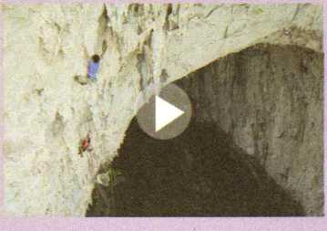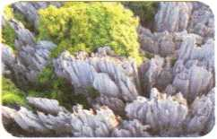

The Karsts of China: A Vertical Journey

Karsts are found in many places in southwestern China. Rock climbers like to go there to enjoy climbing and challenge themselves.

BEFO

Read the introduction of karsts and discuss the questions below.

Karsts are rock formations made of limestone. They have been sculpted by wind and water and millions of years of erosion into these beautiful natural sculptures. One of the most famous places in the world for karsts is Guilin. The karsts there provide a lot of exciting opportunities to rock climbers.

1. Would you like to have a go at karst climbing? Why or why not?
2. What can rock climbing bring to climbers?

WHILE YOU WATCH

Complete the sentences below with the adjectives in the box.

Z ~~ ■

amazing natural adventurous spectacular unexplored gymnastic

1. For me, ifs important not just to go and see these landscapes but to interact with them, too.
2. The stone here offers up , athletic movement, but it can also be very , sometimes dangerous, but always beautiful.
3. This is what we love to do—to come to these beautiful areas and climb and explore and push ourselves mentally and physically.
4. China is relatively and new to climbers and to adventurers who want to go out and see something new and .

AFTER YOU WATCH

Work in groups. Discuss the questions.

1. Describe your feelings after watching the video. How are they the same as or different from the feelings the climber describes when he talks about climbing the karsts?
2. What is your opinion of extreme sports such as rock climbing? Is it something worthwhile to do? Why or why not?

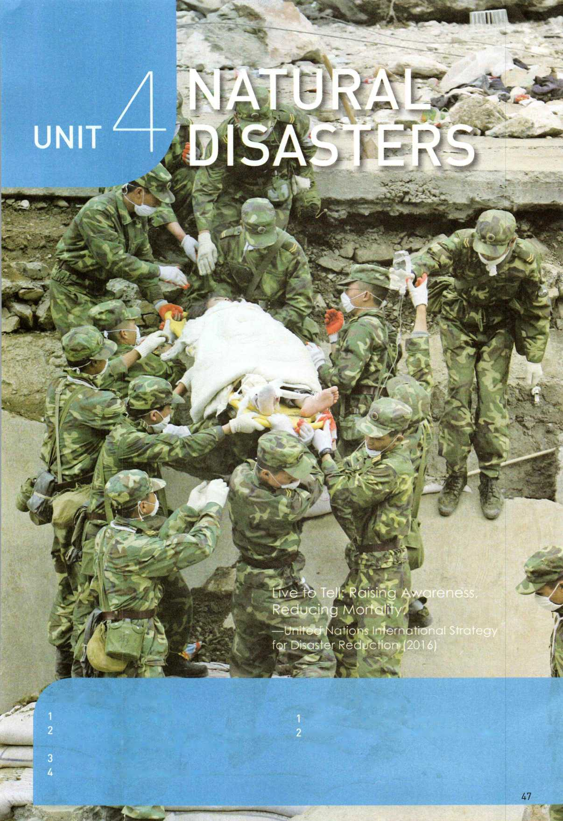

**Look and discuss**

What s going on in this photo?

What kinds of natural disasters can you think of?

**In this unit, you will**

read about natural disasters.

listen to news reports about natural disasters and discuss disaster safety measures.

write a summary.

learn about disaster relief work.

Listening and Speaking

Report natural disasters

1. Watch the video *Natural Disasters* and look at the photos. Do you know what these disasters are? Write down their names.

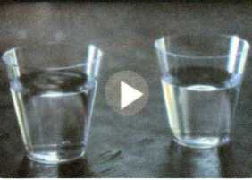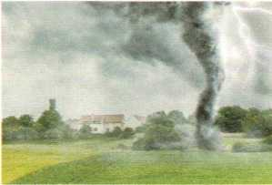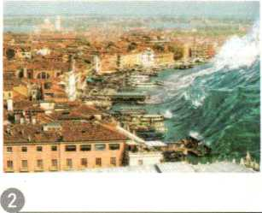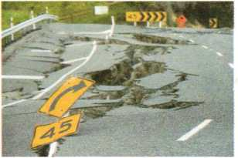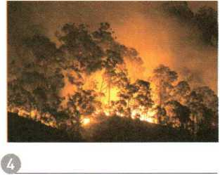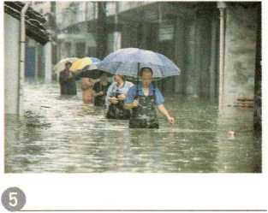

o

O 2 Listen to the news reports and tick the disasters that you hear.

earthquake

tornado

wildfire

**drought**

landslide

Q tsunami

**flood**

volcanic eruption

*&*

**Listen for details**

Think about what you are listening for before you listen: numbers, dates, times, addresses, activities, people or places, reasons, etc.

Question

1 What was the magnitude of the earthquake in Ecuador?

1. ； 3 Circle the key word(s) in the questions below and write the kind of information they refer to. Then listen again and answer the questions.

Type of information Answer number

1. How many people were killed or injured in Ecuador?
2. Where are the floods?
3. What are the rescue workers and soldiers doing in the flood-hit area?
4. When did people see the tornado in Memphis?
5. Which buildings were damaged in Seoul?
6. What caused the landslide in Seoul?

Read about the disasters below and prepare a short news report on one of them. Then present your news report to a partner.

**Earthquake**

Wenchuan, China

14:28 Monday, 12 May

Magnitude 7.8 (8.0)

At least 8,500 killed (by 13

May)

Rescue workers (medical teams, troops, volunteers, etc.) organised quickly

**Wildfire**

Alberta, Canada

Began on 1 May

2,400 homes **destroyed** Almost 88,000 people evacuated

Hundreds of firefighters arrived Planes, helicopters used to fight the fire

No **deaths,** no injuries

**Flood**

Colombo, Sri Lanka

* Began in May
* 82 killed, 500,000 **affected**

*爭* Rescue teams provided food and water

蚩 **Shelters** set up by the government

EXAMPLE

Good morning. Today is 13 May. A huge earthquake hit Wenchuan, China yesterday afternoon ...

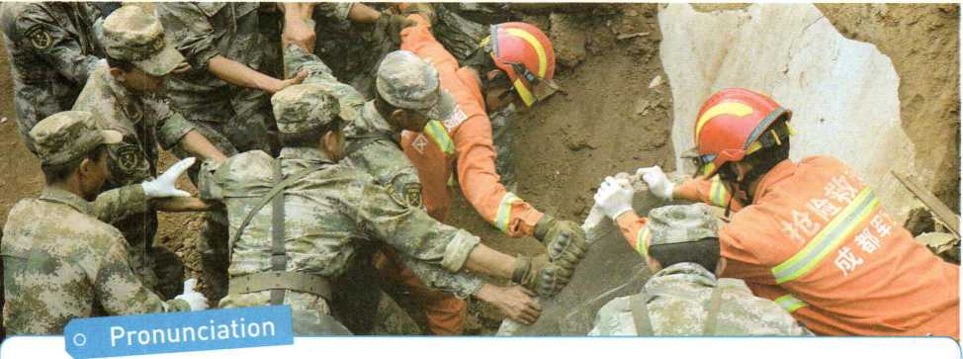

1. Listen and repeat. Pay attention to the letters in bold.

* pipe brick .tend death .keen glory
* fond view
* French bridge
* think they • campus amaze •flash garage
* truly draw • events friends

2 Read the words aloud. Pay attention to the pronunciation of the *-ed* endings. Then wHte the words in the boxes.

|  |  |  |  |  |  |
| --- | --- | --- | --- | --- | --- |
| begged | breathed | described | concentrated | confused | debated |
| exchanged | helped | laughed | learned | depended | embarrassed |
| pretended | reserved | shocked | viewed | watched | wished |
|  | /t/ |  | /d/ |  | /id/ |

1. Listen to the words in each box and repeat.

Describe a natural disaster

1. Work in pairs. Discuss what can happen to a city during a big earthquake.

W＞》2 Look at the title and photo below and guess what the text is about. Then read and check if you are right.

THE NIGHT THE EARTH DIDN'T SLEEP

Strange things were happening in the countryside of northeastern Hebei. For several days, the water in the village wells rose and fell, rose and fell. There were deep cracks that appeared in the well walls. At least one well had some smelly gas coming out of it. Chickens and even pigs were too nervous to eat, and dogs refused to go inside buildings. Mice ran out of the fields looking for places to hide, and fish jumped out of the water. At about 3:00 a.m., on 28 July 1976, bright lights were seen in the sky outside the city of Tangshan and loud noises were heard. But the city's one million people were asleep as usual that night.

At 3：42 a.m., everything began to shake. It seemed as if the world were coming to an end! Eleven kilometres directly below the city, one of the most deadly earthquakes of the 20th century had begun, a quake that even caused damage more than 150 kilometres away in Beijing. Nearly one third of the whole nation felt it! A huge crack, eight kilometres long and 30 metres wide, cut across houses, roads, and waterways. Hard hills of rock became rivers of dirt. In less than one minute, a large city lay in ruins. Two thirds of the people who lived there were dead or injured. Thousands of children were left without parents. The number of people who were killed or badly injured in the quake was more than 400,000.

Everywhere survivors looked, there was nothing but ruins. Nearly everything in the city was destroyed. About 75 percent of the citys factories and buildings, 90 percent of its homes, and all of its hospitals were gone. Bricks covered the ground like red autumn leaves, but no wind could blow them away. Most bridges had fallen or were not safe to cross. The railway tracks were now useless pieces of metal. Tens of thousands of cows, hundreds of thousands of pigs, and millions of chickens were dead. Sand now filled the wells instead of water. People were in shock—and then, later that afternoon, another big quake shook Tangshan again. Even more buildings fell down. Water, food, and electricity were hard to get. People began to wonder how long the disaster would last.

But hope was not lost. Soon after the quakes, the army sent 150,000 soldiers to Tangshan to dig out those who were trapped and to bury the dead. More than 10,000 doctors and nurses came to provide medical care. Workers built shelters for survivors whose homes had been destroyed. Hundreds of thousands of people were helped. Water and food were brought into the city by train, truck, and plane. Slowly, the city began to breathe again.

Tangshan started to revive itself and get back up on its feet. With strong support from the government and the tireless efforts of the citys people, a new Tangshan was built upon the earthquake ruins. The new city has become a home to more than seven million people, with great improvements in transportation, industry, and environment. Tangshan city has proved to China and the rest of the world that in times of disaster, people must unify and show the wisdom to stay positive and rebuild for a brighter future.

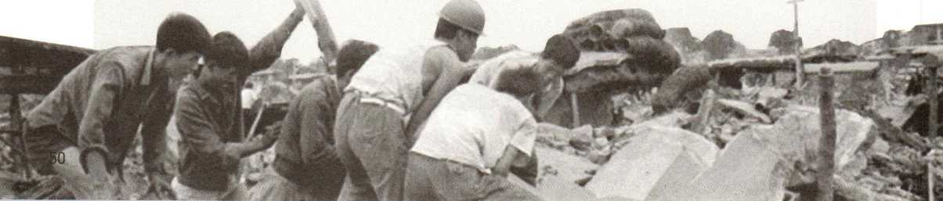

Read the text carefully and then write down the main idea of each paragraph. Warning signs before the earthquake.

Paragraph 1:

Paragraph 2:

Paragraph 3:

Paragraph 4:

Paragraph 5:

**Use context to understand new words**

Scan the text and find the words below. Guess what they mean from the context.

When you see a word you do not know, do not stop and look it up in a dictionary. If you continue reading, the context will probably help you understand what it means.

ruin brick trap bury

Read the sentences describing what happened after a huge earthquake, Complete the sentences with the correct forms of the new words and phrases from the text.

The huge earthquake left nearly the whole city .

Everyone was , thinking the world must be coming to an end.

Millions of people were left without water, food, or .

Soldiers and volunteers worked as hard as they could to pull away rocks, and rescue those who were under the ruins.

and

Some were found alive, though they were suffering from terrible injuries, but others had already stopped when they were discovered.

A few buildings were still standing, but people were afraid to use them as shelters, worrying they would be if the buildings fell.

Read the text again and answer the questions.

1. What were some of the strange things happening before the earthquake? Do you think they were warning signs? Why or why not?
2. What does the writer mean by "Slowly, the city began to breathe again"?
3. What kind of help do you think people who have suffered an earthquake need?

Work in groups. Discuss the questions.

1. What do you think helped in the revival of Tangshan city?
2. What other cities or towns have gone through similar changes? What lessons can we learn from these events?

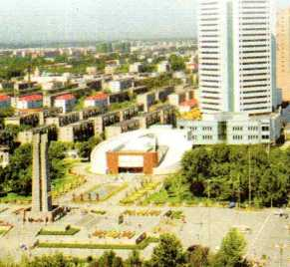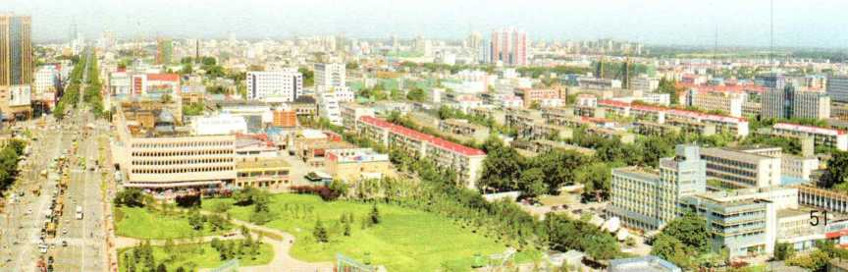

Discovering Useful Structures

Describe pictures of disasters

1. Find and underline the restrictive relative clauses in the sentences below. What function do the restrictive relative clauses have?

The Tangshan earthquake was a terrible experience that my great-grandma cannot forget.

The couple who live next to us volunteered to help after the volcano erupted.

The supplies which were provided to the disaster area were collected from around the country.

Mr Li is an architect whose designs for the new town have won praise.

A doctor with whom James used to work died in the 2016 earthquake in Ecuador.

Find more sentences with restrictive relative clauses from the text on page 50.

1. Complete each sentence with *that, which, who, whose, whom,* or Then translate the sentences into Chinese.
2. Here are some of the people homes were destroyed by the typhoon.
3. The terrible shaking of the building woke up all the people were asleep.
4. The next day, people put up shelters in the open air using anything they could find.
5. Several days later, most of the buildings had been damaged by the hurricane were repaired.
6. The injured boy mother was lost in the disaster was taken to the hospital.
7. The woman wrote a thank-you letter to the soldier by she was rescued.
8. Is this the young boy saved several other students trapped under buildings?
9. Work with a partner. Take turns to ask each other about the pictures. Make sentences with restrictive relative clauses using *that, which, who, whose,* or *whom.*

EXAMPLE

A: What's the rescue worker doing?

B: She's feeding the baby who survived the earthquake.

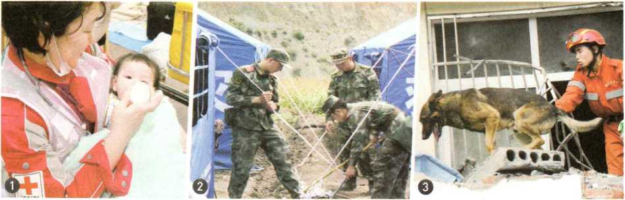

Prepare for a disaster

1 Mrs Fors is a rescue worker. She and her dog, Lucky, are visiting a senior high school. Listen to the conversation and complete the table below.

|  |  |
| --- | --- |
| **Before an earthquake** | Make a safety list of , , and . |
| **During an earthquake (in a building)** | Remember to " , , and ”. |
| **During an earthquake (outdoors)** | Go to a(n) space away from ,  , or power lines. |
| **After an earthquake (if you're trapped)** | Use a(n) to get help.  lap on a pipe or or whistle for help. |

1. Work in pairs. Choose a disaster and prepare a list of safety instructions. The expressions below may help you.

**Givina instructions**

First/First of all, you should ... Cover your ... Call an emergency number.

|  |  |
| --- | --- |
| Stay calm. | Listen to the news. Stay away from ... |

Dont drive or walk outside. Move to a safe place. Make sure ...

Collect water and food if you can. Finally, ... Stay indoors.

1. Having an emergency kit prepared is also very important. Look at the emergency supplies below. Discuss with a partner what else you would add.

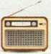

**EMERGENCY**

**SUPPLIES**

radio

first aid kit

water and food for three days

flashlight

1. Report to the class the safety instructions you listed and then explain what emergency supplies people should keep on hand.

EXAMPLE

If you find yourself in danger from a forest fire, first of all, stay calm. Cover your face with ... Then go to a safer place if you can. ...

Now for our emergency supplies, we would suggest always having on hand enough water and food for three days, a radio,...

Write a summary

＜）》1 Read the news report released the day after a tsunami and answer the questions.

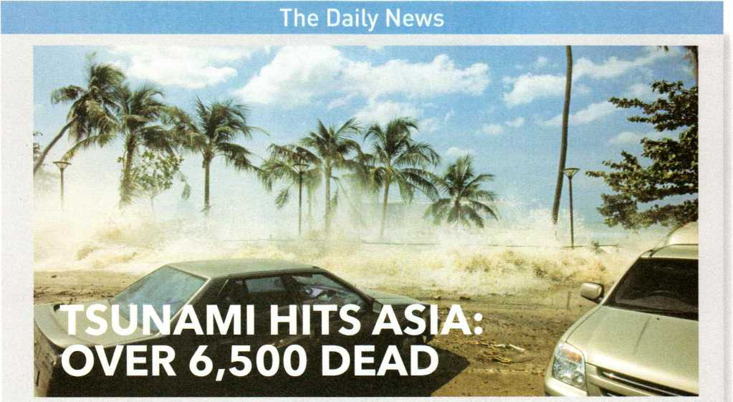

By Robert Woodhouse Monday, 27 December 2004

The most powerful earth­quake in the past 40 years caused a tsunami that **crashed** into coastlines across Asia yesterday, killing more than 6,500 people in Indonesia, India, Thailand, Malaysia, and at least four other countries. Fishermen, tourists, hotels, homes, and cars were **swept** away by huge **waves** caused by the strong earthquake that reached a magnitude of 9.0. The undersea quake **struck** around 7:00 a.m., Sunday off the west coast of Indonesia's Sumatra Island. In that area

alone, at least 1,870 people were killed.

In Sri Lanka, some 1,600 kilometres west of the quake centre, the number of deaths stood at 2,498, and one million more were affected by the tsunami, government officials said. Indian officials said as many as 1,900 had been killed along the southern coast. Another 254 were found dead in Thailand and 54 in three other countries. In southern Thailand, 1,900 people were hurt and many more were missing, local officials said.

“I was having breakfast with my three children when water started filling my home. We had to leave everything and run to safety," said Chandra Theeravit, a local Thai woman.

Thousands of people are still missing, and the number of deaths is expected to grow even higher over the next few days. Foreign aid is being organised for the tsunami-hit countries. However, dangerous conditions and damaged roads will make it difficult to **deliver** food and supplies.

1. When did the tsunami happen?
2. What caused the tsunami?
3. Why would it be difficult to deliver food and supplies?
4. Read the summary of the news report. Check the main points it includes.

Summary: On 26 December 2004, a tsunami killed more than 6,500 tourists, fishermen, and other locals in Southeast Asia. Thousands of people are missing and the number of deaths is expected to grow. The damage caused by the tsunami is making it difficult for rescue workers to help the survivors.

date time place event sta™7Jf mam points,

cause effect following events 籍*囂鷲;摞鷲:普st

important information of a longer passage.

1. Follow the steps below to write a summary for the text on page 50.

1 Read the text and write a list of the main details.

* Strange things happened in the countryside before the earthquake.
* An earthquake hit China on 28 July 1976.

.

1. Write down the main idea of each paragraph based on the details above.
2. Organise the ideas and draft your summary. Pay attention to the following:

*/*

* A summary should be around one third the length of the original text.
* Write down the key supporting points for the topic.
* Do not include unimportant details or examples.

1. Exchange drafts. Use the checklist to give feedback on your partners draft.

Does the summary give you a clear idea of what the text is about?

/ Does the summary include only the most important information of the text?

• Is the summary the proper length?

/ Are there any spelling or punctuation errors?

/ Does the writer use correct tenses?

1. Get your draft back and revise it.
2. Put up your summary in the classroom or read it to the class.

1 Circle the correct word in each sentence.

1. The tornado that hit Mississippi last week caused a lot of damage/destroy.
2. The mother thanked the rescue/save worker who found her baby.
3. According to experts, the volcano could crash/erupt this week.
4. Thousands of people are suffermg/trapping from illnesses after the disaster.
5. An emergency delivery/supply of food was transported to the area by the army.
6. The earthquake affected/effected an area of several hundred square kilometres.
7. During a natural disaster, the most important thing is to keep calm/quiet.
8. "She's still breathing./survivmg! Come and help me dig her out!" shouted the soldier.

2 Read the passage and fill in the blanks with relative pronouns.

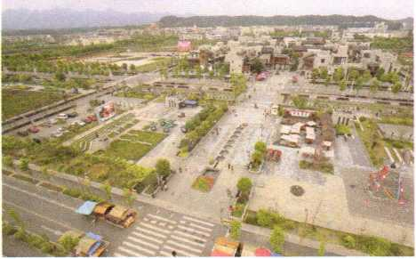The people live in Wenchuan county will never forget the day 12 May, 2008. The 8.0-magnitude earthquake killed over 80,000 people and left many more injured turned many towns and counties into ruins. The rescue work followed was carried out by people from all over the country, and even abroad.

Now, more than 10 years on, the people suffered the earthquake are living a new life. Many live in new towns are earthquake-safe, in local communities have been beautifully rebuilt by the government. The people will never forget those rescued them and helped them rebuild their home. Out of gratitude, many young adults were students during the earthquake have chosen to study medicine or join the army in a wish to help more people. Wenchuan, the county was completely destroyed and then completely rebuilt, has become a symbol of the Chinese spirit of never giving up.

□reflecting

© What did you learn about natural disasters in this unit that you did not know before? © What else do you want to know about natural disasters?

© What did you find the most difficult in this unit?

© What in this unit motivated you most?

⑥ Overall, I thought this unit was interesting useful so-so difficult.

* Project： Give a presentation on natural disasters

1 **BRAINSTORM：** Work in groups of three or four. Choose one of the natural disasters below and brainstorm answers to the questions.

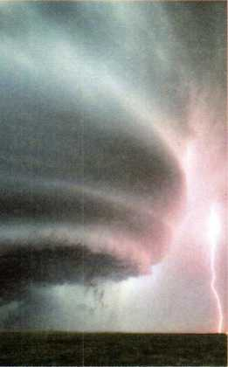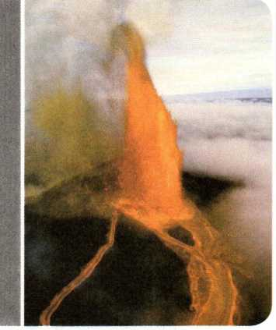

earthquake

typhoon/hurricane

tornado

landslide/snowslide

wildfire

tsunami

volcanic eruption

drought

flood

Understanding the disaster

Are there any known causes of the disaster? What can be done to prevent it?

Preparing for the disaster

What are the possible effects of the disaster? What can be done to prepare for it?

In the event of a disaster

What can you do to stay safe during the disaster? What kind of help do survivors need?

1. **RESEARCH：** Which questions do you not know the answers to? Which ones do you need more information on? Use the Internet or your school library to find out more.
2. **ORGANISE：** Put together a presentation using the information you have gathered. Use the tips below to help you.

, Start your presentation with a "hook" (a story or fact to catch the attention of your listeners).

*On Monday, 5 September 20XX, 600 people disappeared when ...*

* Reduce your ideas to three main points to help listeners remember what you say.

So *always remember to drop, cover, and hold on. ...*

* Prepare visual aids for your presentation (photos, charts, tables, etc.).

1. **PRESENT：** Give a group presentation to your class.

* Video Time 昼

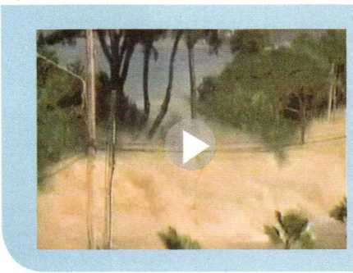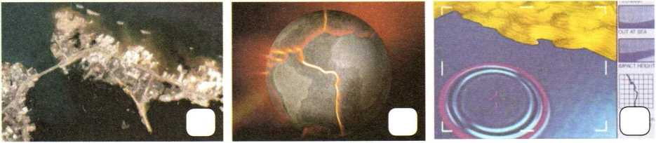

Tsunami: Killer Wave

Tsunami waves can strike out of nowhere and cause a lot of destruction. Scientists study and track tsunamis in order to warn people and minimise deaths.

**BEFORE**

Read the sentences about the formation and effects of tsunamis. Then match each sentence with the correct picture.

A Tectonic plates push together.

B A series of waves expands in all directions.

C Whole sections of cities are destroyed.

**WHILE YOU WATCH**

1. Decide whether the statements are true (T) or false (F).
2. There are few warning signs just before a tsunami hits.

丁 FC

T口 FO

tD fD

1. A tsunami breaks just like an ordinary wave but is bigger.
2. Scientists at the Pacific Tsunami Warning Center monitor the earth's movements 24 hours a day in order to track tsunamis.
3. Circle the correct word(s) in each sentence.
4. An earthquake occurs when plates below the earth's surface push together/pull apart.
5. Tsunami waves deep at sea move fast and rise only a few/hundreds of feet.
6. As these killer waves enter shallow waters, their speed is reduced/raised.
7. Most tsunami damage is caused when the waves come in from/move back out t< the sea.

**AFTER YOU WATCH**

Work in pairs. Discuss the questions.

1. What have you learnt about tsunamis?
2. What kind of help do you think people who have suffered from a tsunami need?

■ LANGUAGES ■AROUND "THE WORLD

UNIT

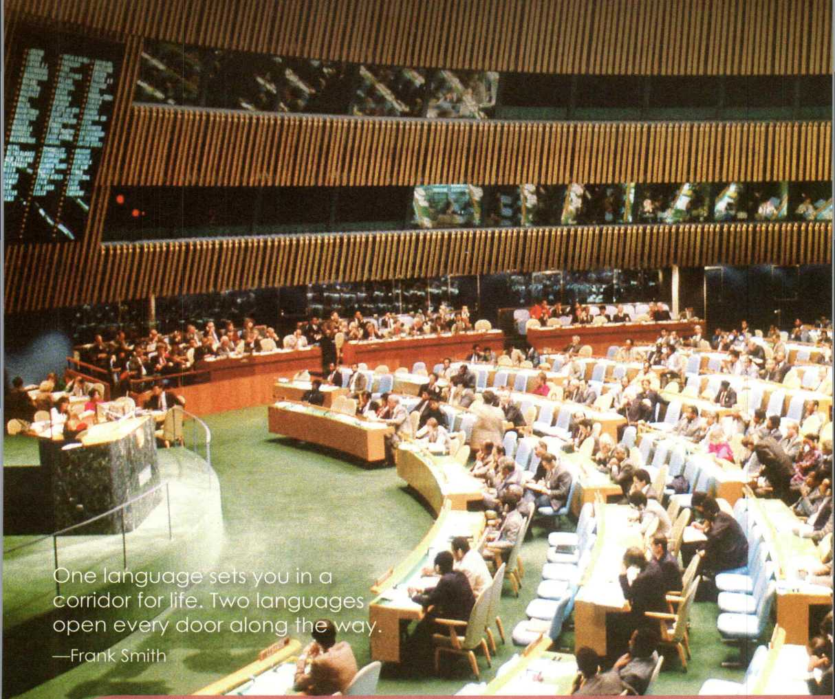

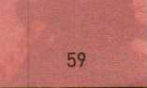**In this unit, you will**

**Look and discuss**

Do you know where the photo was taken? Which languages do you think are officially used here?

1. read about the development of Chinese characters 1

and students difficulties in learning English. 2

1. listen to a speech about learning foreign languages and talk about reasons why people study a foreign language.
2. write a blog about language study.
3. learn about the history of the *Oxford English Dictionary.*

**Explore languages around the world**

1. Before you listen, match each photo with the correct country name. Then discuss which languages are spoken in these countries.

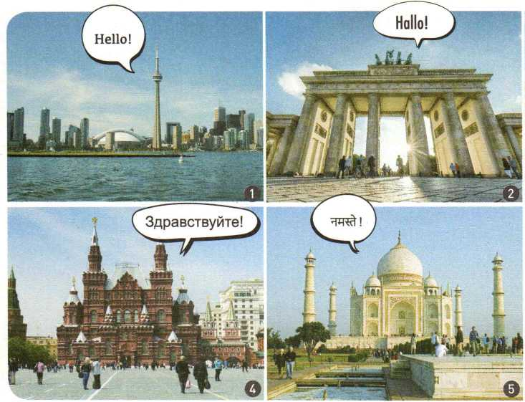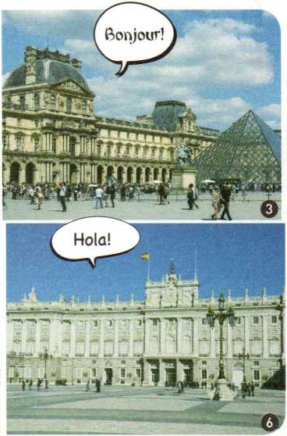

France

Russia Germany Spain Canada

India

Listen to a speech and tick the two languages with the most native speakers. Circle the official languages of the United Nations (UN).

O Korean

O English

©Japanese

C French

C Russian

Spanish

O Chinese

O Arabic

4 3 Listen to the speech again and answer the questions.

1. What is the main topic of this speech?
2. How many languages are there in the world?
3. How many billion people speak the UN's official languages as their native or second language?
4. What is the attitude of the speaker towards foreign language learning?

Q 4 Listen to the speech again. What do the italicised words refer to in the sentences?

1. *They* think *it* means better job chances in the future.
2. *They* are spoken by around 2.8 billion people ...

**Reference**

Pronouns (it, they, she, etc.) refer to something or somebody mentioned earlier. Pay attention to the context of words to help you understand what the pronouns refer to.

5 Work in pairs or groups. Discuss which other Language(s) you want to learn and why.

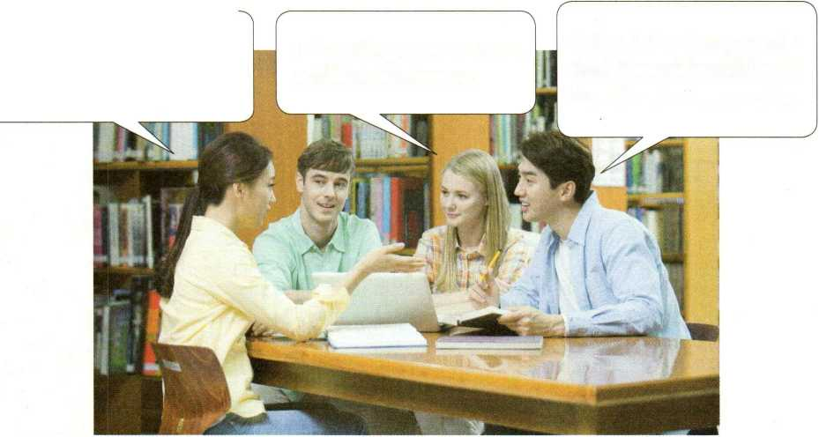

Perkaps 1 should study French.. 1 tkink it sounds beautiful, and 1 know it's used in many countries.

Myjatker is doing business with Russians. *Vd.* like to learn Russian so 1 can kelp kim in thejuture.

1 like watckingjapanese cartoons, so *Vd* like *to* team Japanese.

EXAMPLE

A: What language do you want to study?

B: I really want to study French. I think that the French language sounds beautiful.

A: Why? Do you want to go to France some day?

B: Yes, I'd love to. Also, French is used by many international organisations around the world. Do you know that FIFA's full name is in French?

A: Oh, I remember that. But I don't know how to pronounce it.



Pronunciatic^

1. Work in pairs. Read the words to each other and see if you pronounce them differently.

□ schedule □ hostile □ either □ address

□ direct □ laboratory □ advertisement □ shone

O Listen and pay attention to how the speakers pronounce them.

C*2 Listen to the paragraph read by two different speakers. Which speaker has a British accent and which has an American accent?

English is a crazy language. There is no egg in eggplant nor ham in hamburger; neither apple nor pine in pineapple. English muffins weren't invented in England or French fries in France. Sweetmeats are candies while sweetbreads, which aren't sweet, are meat. ... We find that quicksand can work slowly, boxing rings are square, and a guinea pig is neither from Guinea nor is it a pig. And why is it that writers write but... hammers don't ham? (Richard Lederer)

\ >

**Explore the Chinese writing system**

1. Look at the title and picture below. Predict what the text will be about.

■4》2 Read the text quickly to find the main idea of each paragraph.

THE CHINESE WRITING SYSTEM:

CONNECTING THE PAST AND THE PRESENT

China is widely known for its ancient civilisation which has continued all the way through into modem times, **despite** the many ups and downs in its history. There are many reasons why this has been possible, but one of the main **factors** has been the Chinese writing system.

At the beginning, written Chinese was a picture-based language. It dates back several thousand years to the use of *longgu*—animal **bones**

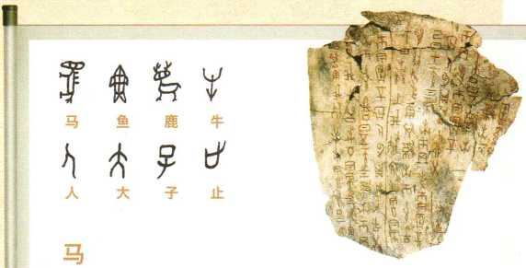and shells on which **symbols** were **carved** by ancient Chinese people. Some of the ancient symbols can still be seen in today's *hanzi.*

3來©查洼矣覆

韩 楚 秦 秦统一后

的文字

By the Shang **Dynasty** (around 1600- 1046 BCE), these symbols had become a well-developed writing system. Over the years, the system developed into different forms, as it was a time when people were divided geographically, leading to many **varieties** of dialects and characters. This, however, changed under Emperor Qinshihuang of the Qin Dynasty (221-207 BCE).

Emperor Qinshihuang united the seven **major** states into one unified country where the Chinese writing system began to develop in one direction. That writing system was of great importance in uniting the Chinese people and culture. Even today, no matter where Chinese people live or what dialect they speak, they can all still communicate in writing.

Written Chinese has also become an important **means** by which China's present is connected with its past. People in modem times can read the **classic** works which were written by Chinese in ancient times. The high **regard** for the Chinese writing system can be seen in the development of Chinese **characters** as an art form, known as Chinese **calligraphy,** which has become an important part of Chinese culture.

Today, the Chinese writing system is still an important part of Chinese culture. As China plays a greater role in **global affairs,** an increasing number of international students are beginning to **appreciate** China's culture and history through this amazing language.

1. Scan the text to find the words and phrases that describe a time. Then write down what happened at each of those important times.
2. Read the text again and discuss the questions.

Scan

Scanning is Looking at the text quickly to find specific information, such as dates or numbers.

1. How did written Chinese unify Chinese people divided by geography and dialects?
2. How does written Chinese connect Chinese people today with those of the past?
3. According to the writer, the Chinese writing system is one factor that has helped the Chinese language and culture survive. What do you think are some of the other factors?
4. Complete the passage with the correct words and phrase below.

system carving means dates back classic civilisation

Chinese calligraphy has developed along with China's . It is difficult to say when exactly calligraphy started. Chinese writing was first done by symbols onto bones and shells, but as it developed into a writing , it also developed as a form of art done with a brush. It is believed that Chinese calligraphy to at least the Han Dynasty (202 BCE-220 CE). Soon after that, the idea developed that calligraphy was not only a beautiful art form but also a of showing the character of the "man behind the brush". Today, anyone from small children to old people can enjoy practising the art of Chinese calligraphy.

1. 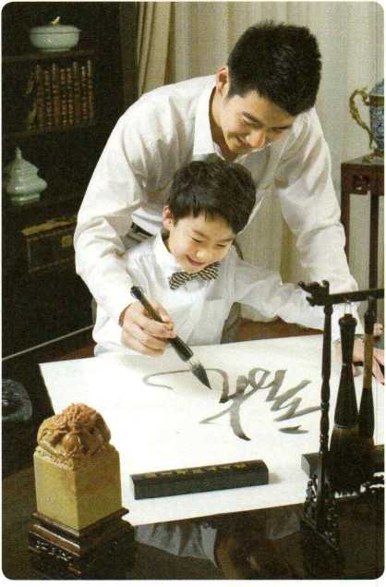Guess the meaning of the underlined words in the sentences. Then look in the text for the words they are related to.
2. Many Chinese characters symbolise their meanings, unlike English words which are spelt out according to how they sound.
3. The basic forms of the English writing system are known as letters.
4. A unified writing system is considered to be an important part of civilised society.
5. Learning Chinese calligraphy will increase your aDDreciation of Chinese culture.

Discovering Useful Structures

**Describe your favourite things**

1. Look at these sentences and underline the restrictive relative clauses. What kind of information does each clause communicate?

* It was a time when people were divided geographically.
* Emperor Qinshihuang united the seven major states into one unified country where the Chinese writing system began to develop in one direction.
* There are many reasons why people learn a foreign language.
* These were animal bones and shells on which symbols were carved by ancient Chinese people.

1. Fill in the table to complete each phrase with a restrictive relative clause. Then use the phrases to make complete sentences.

the *day* when the *reason* why

the *place* where the *place/time* in/at which

1. Complete the passage with the correct relative adverbs or pronouns. Add a preposition where necessary.

When I started studying German, it was a struggle. The words felt strange on my tongue, and the grammar would not stay in my head. I told my mum that I wanted to give up, and that I would never live in a country German was spoken. My mum told me that studying a language was not just for my future. It was exercise for the brain; the more I learnt of a language, the more my brain would grow. And I remember that day I suddenly felt like German was no longer a foreign language. It felt like my brain had doubled in size. I had finally come to a place I could think in this foreign language, and I could see the world from a different point of view. I felt as if I had reached the goal I had been fighting for. I could open a book and see meanings, not just a sea of words. I finally understood the reason my mum had encouraged me not to give up. Thanks, Mum!

1. Work in pairs. Ask and answer the questions.

A: What kind of day makes you happy?

**A:** What's your favourite place at school?

B: It's a day when ...

**B:** It's ..because it is a place where ...



A: What kind of teachers do you like best?

A: Who do you admire most? Why?

B: I like teachers who ...

B: I admire ... That's the reason why...

**Explore different kinds of English**

Q 1 Listen to the first part of the talk. What are the different kinds of English mentioned?

C 2 Listen to the second part of the talk. What are the two pairs of words that the student is confused by? Tick them in the boxes.

□ semester/term □ restroom/toilet □ gas/petrol □ subway/underground

1. Look at the pairs of words below. Which words are British English and which are American English? Try to think of more pairs of words like these.

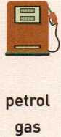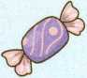

sweet candy

t中

toilet  
restroom

honour honor

mum mom

**id—**

**WITSHlTw**

flat

apartment

1. Read and role-play the conversation. What misunderstanding has happened?

Martin: Hey, Zhou Wei, do you want to go shopping ? There's a sale at my favourite store.

Zhou Wei: Oh, yes! I really need to buy some pants.

Martin: Pants? That's funny. I don't usually go shopping with my friends for pants.

Zhou Wei: You don't? Don't you like to have somebody tell you if the pants look good or not?

Martin: Er... Not really ... Hey, wait, do you mean trousers一what you and I are

wearing on our legs right now?

Zhou Wei: Oh, yes. That's what I mean by pants! That's American English, isn't it?

Martin: Yes, it is! I knew what you meant, by the way. I was just joking with you. Did you

know that in British English,''pants,/ means something very different?

Zhou Wei: Really? So what does it mean?

Martin: In British English, the word ''pants" means underwear....

1. Choose one or two pairs of words in Activity 3 and make a conversation. The expressions below may help you.

Asking for clarification

Do you mean ...？ Does that mean ...? I'm sorry. What does ... mean?

I'm sorry. Would you mind repeating ・・・? I beg your pardon.

So am I right in saying ...？ So what youre really saying is ...

**Write a blog about English study**

♦》1 Read these posts from an online forum for Chinese students who are learning English and fill in the table on page 67.

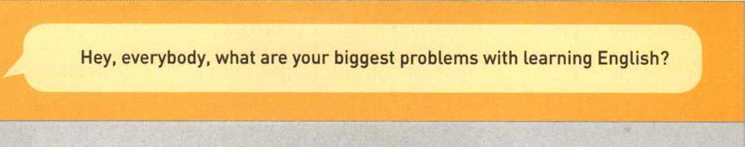

**Learning English**

Wang Le

login sign up



Liu Wen

Jia Xin

Hi! I've been studying English since primary school. I used to get high marks in English, but now I'm having a lot of trouble with my listening. When I listen to native English speakers talking in a video, I can catch only a few words. I can never quite get the main idea. Any advice?

Listening to English radio programmes helps me get used to how fast native speakers talk. I also repeat what I hear to help myself to experience the feeling of the language. Sometimes I even record my voice so I can listen to myself and compare my pronunciation with the radio host's! My biggest headache is how to be polite in English. It's so much easier to just say "Open the window!", but in English that can sound really terrible. I have to think about who I'm talking to and then decide whether to say, "Open the window, please!" or "'Could you open the window, please?" or even longer "Would you mind opening the window, please?"

**0 ' -** *2* **■ .■-'. ( ，**

Yeah, that's really hard! I think it all depends on who you're talking to. If I'm f talking to a close friend, I can use short requests, like "Open the window"― ur Li Rui relationship is close and we're equals, so I only need a few words to bridge

,. the gap between us. But if I'm talking to someone who isn't very close to me, I must make my request longer—and I must make it a question, not a demand, e.g., "'Could you open the window, please?" If I'm talking to someone senior

•.；N£玺象to me, then I should say, "Would you mind opening the window, please?" For *•空M*

'- me, vocabulary is my biggest problem一there are just SO MANY new words! I can't keep all the new vocabulary straight in my head, and I certainly can't

,. remember how to use them all properly. HELP!

**4 0 0**

1 2 3 4 5 6 7 ...12 »

Name Problem Advice

Jia Xi ns advice

Liu Wen Listen fo English radio programmes

Li Rui's advice

Jia Xin

Your advice

Li Rui

1. Work in groups. List your problems in learning English and brainstorm some useful advice.

* I don't know how to ... • I have no idea how/what...
* ... is a big difficulty for me. • My biggest problem is ...
* I cannot... • I (also) have trouble with ...
* You might try ... • My advice is ...
* It s very important to ... • This worked for me.

**Problem Advice**

1. **cannot understand the teacher's English in class.**
2. Choose one of the problems from your group discussion and write a blog about it.
3. Describe the problem clearly.
4. Write one or two ideas on how to solve the problem.
5. Exchange drafts. Assess each other's work according to the checklist.

|  |  |
| --- | --- |
| **General content** | **y** Does the writer give a clear **description** of the problem?  / Is the advice clearly explained?  / Does each sentence **relate** to the main idea? |
| **Basic writing skills** | / Does the writer use pronouns to refer to things or people correctly? y Does the writer use correct spelling, punctuation, and capitalisation? / Are there any grammar mistakes? |

1. Get your draft back and revise it.
2. Put up your writing in the classroom or read it to the class.
3. Read the first part of a passage and find suitable words for the blanks.

attitude classic point of view civilisation

despite native related to struggle

**Part I** The first foreign language I ever learnt was French, but it didn*t go very well. My mother asked our neighbour to teach me when I was seven. French wasn't his language, but he used to live in France, so he could speak a little. However, his help, I learnt very little French. I just didn't feel that it my daily life in any way, so I didn't try. When I entered senior high school, my towards language learning changed. I had to learn Latin, which I've always been interested in because I want to study law. For this reason, learning Latin wasn't a for me like learning French. Soon I began to read books in Latin. It certainly wasn't easy, but I got to read lots of interesting stories about ancient . Reading those books opened a window for me to another world and gave me a new on my own world.

1. Read the second part of the passage and combine the words in the two boxes to complete the restrictive relative clauses.

building class day way someone when in which where who that

**Part II** I became interested in learning more languages aside from English. Then I saw an advertisement that offered a wonderful summer course in German, and that was the I decided to take on a new language. The we met for classes was quite small, but there was a whole world of language to explore. Our teacher was Mrs Haus: a tall, thin, quiet, grey-haired lady. I'll never forget the first she introduced herself to us. She never once raised her voice, but as soon as she began to speak, the room fell silent. What was the reason? Because Mrs Haus LOVED German language and culture 一 and everybody who was in her classes couldn,t help but love the language, too. We all loved the she talked about German food and traditions. And I realised what makes a good teacher. A good teacher is is in love with what she or he is teaching.

What ways did the writer use to learn foreign languages?

REFLECTING

© What did you think of the quote at the beginning of the unit?

© Did you find it easy or difficult to talk about your reasons for learning a foreign language? Why?

© Did you learn anything new from the text about Chinese characters? If so, what did you learn?

® How does learning about different kinds of English affect your English study?

© Overall, I thought this unit was O good O useful O just OK O difficult.

**\* Project： Create your own word bank**

1. Study an English-English dictionary to help you create a word bank.

There are many different English-English dictionaries. Here is an entry from a commonly used dictionary.

word

**a demand** /di'maend; di'mamd/ <-

pronunciation

meaning

*n.* 1 [C] a firm request for something • a demand fbr equal pay

2 [pl.] (~ of sth) things required that are usually difficult

and/or tiring • the demands of the new job 3 [U]^he request of customers fbr goods or services • There is an increasing demand

on English translators these days. **IDM** by popular demand; in demand; on demand

grammar information

v. 1 to ask for something strongly • I demand to know what's going on.

• The boss demanded that all workers arrive in time. 2 to need one's effort, time, skill, etc. • Many sports demand speed and strength.

1. Choose the words that are most difficult/usefulto you and put them into your word bank.
2. Decide how to organise the words. For example:

* in alphabetical order: A, B, C, etc.
* by group: all the words related to a certain topic, pronunciation, part of speech, etc.
* by commonly confused words, such as "chicken/kitchen”, “diary/dairy”, etc.
* by memory devices: words that you have memorised together, such as words with the same roots, etc.

1. Complete the entries.

* English definitions
* grammar information
* one or two example sentences

**tongue**

*n.* the soft part inside one's mouth that

3 Illustrate them.

* drawings
* tables
* diagrams
* cartoons

we use for speaking and eating

**cab**

*n.* a taxi

**calligraphy**

*n.* the art of producing beautiful writing

using special pens or brushes

1. Work in pairs. Exchange ideas with each other about how you made your word  
   bank. Then discuss how you are going to use it to help your English study.

* Video Time g

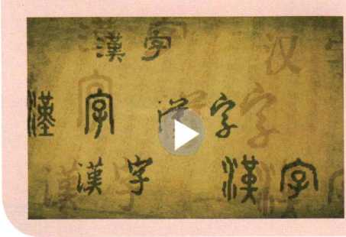

Chinese Characters

The Chinese writing system has evolved from ancient times. Learning Chinese characters can connect us with people from long ago. Written Chinese has also been adapted so it can be used by future generations.

**BEFORE YOU WATCH**

Complete the sentences with the words below.

/ \

carved classics era origins radicals

k ——-—

\ Ancient Chinese people symbols onto turtle shells or bones of animals.

1. Many of today's characters have their in the observations of ancient Chinese people.
2. About 80 percent of Chinese characters are made up of smaller parts, called .
3. If you can read Chinese characters, you can read Chinese from thousands of years ago.
4. Chinese characters have been adapted into digital form in the modern ・

**WHILE YOU WATCH**

Choose the correct answers.

1. How many tales or legends about the origin of Chinese characters are mentioned in the video?

A Three. B Four. C Five.

1. Today, written Chinese is the system of writing in the world.

A most complicated B oldest continuously used C hardest

1. The character *jia* probably originated from the idea that .

A animals should live in family homes B a good family home has plenty of food

C ancient homes always kept pigs

1. China's unified writing system forms a strong bridge linking .

A China with the rest of the world B Asia, Africa, and Europe

C the present and the past

1. Written Chinese spreads wherever it goes.

A Chinese culture B Chinese classics C tales and legends

**AFTER YOU WATCH**

Work in groups. Discuss the questions.

1. Why do you think written Chinese has survived for so long?
2. Why do you think an increasing number of international students become interested in learning the Chinese language?

**WORKBOOK**

**UNIT1**

TEENAGE LIFE

Using Words and Expressions /////////////

1. Look at the words below. Cross out the one that does not belong to this group and think of more words to add to this group.

teenage freshman literature

outgoing greenhouse wildlife

online cheerleader extra-curricular

Use the words below to make compound words and then explain their meanings.give a(n) in class. Nearly half of the teenagers think that their are too busy They wish they had not up for so many courses and extra-curricular activities. The older teenagers say that they that freshmen wait until the second term before they join a team or club. What todays teenagers the most? Not surprisingly; listening to music and playing computer games are common favourites. Watching videos is popular； too, and 21 percent say that they reading.

|  |  |  |
| --- | --- | --- |
| air | line | 3 Some words can be used as a verb and as a noun. Find these words |
| country | man | in the sentences and explain their |
| hand | side | meanings. |
| bed | | » made |  |
| home | room | volunteer challenge focus graduate schedule |
| under | sick |

2 Complete the passage with the correct forms of the words below.

online

sign

debate

attract

youth

speech

schedule

prefer

recommend

What are teenagers into and what turns them off? A(n) questionnaire asked 1,000 senior high school students about their likes and dislikes. According to the results, taking exams and speaking in front of others are among the least popular activities for todays . Many students like to interesting topics with their classmates but feel awkward or uncomfortable when they have to

1. Oscar challenged me to a game of chess and I accepted the challenge.
2. Some experts worry that parents schedule too many extra-curricular activities for their kids. The kids have a busy schedule every day and do not get enough sleep.
3. OK, listen up； please! We need a volunteer to help organise the school dance on Saturday Who wants to volunteer?
4. The focus of todays meeting is how to stay safe at school. Please focus on this problem.
5. My cousin Jim is a Isinghua University graduate. After graduating； he now works as a designer.

Can you find other similar words from the unit?

Using Structures

Complete the sentences with the correct forms of the phrases below.

be suitable for be concerned about be responsible for be addicted to be attracted to

1. Sheila is the coach of the school badminton team； she training the players.
2. This course seems difficult and (not) freshman students.
3. Many teenagers today online games； but they should manage their time so that they wont those games.
4. You dont have to getting low grades at the end of the term if you try your best now
5. Decide whether the underlined parts are noun/adjective/adverb phrases and state their functions.
6. The students will do group discussions, timed writing； and research in the advanced literature course.
7. Its raining quite heavily. He wont be back very soon.
8. What you learn at school plays a very important part in shaping your behaviour in society
9. Just sign up for one activity for the joy of trying something new
10. Strangely enough, she didnt seem to like ballet very much.
11. Read the poem aloud and see how the underlined parts work in the poem.

5 Translate the English sentences into Chinese.

1. Some behaviours of my generation are considered strange by my parents， generation.
2. We will try our best to give you a detailed schedule soon.
3. Recently, there has been a strong movement around the country encouraging people to quit smoking.
4. 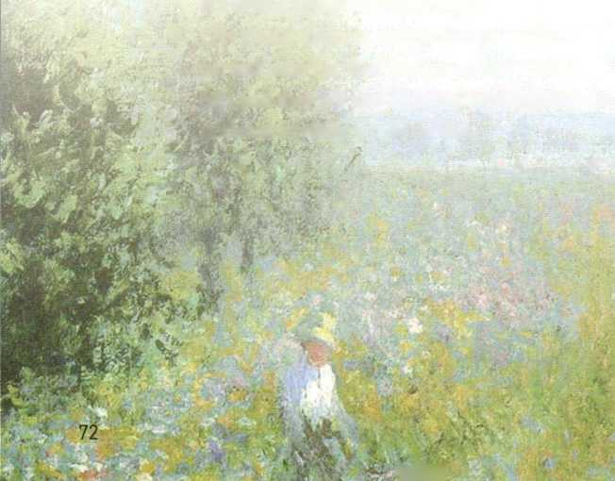Adventure travel has become more and

more popular； not only among the youth

*洋警

but even among the middle-aged.

5 Obviously students are required to ask their parents whether they can go on the school trip, and they are also responsible for giving notice in advance if they cannot.

Nothing so rare

As a day in June,

The air so fine

And the blossoms all blue.

The weather just perfect,

The skies never gray

The bugs always buzzing

And the trees seem to sway

The sun beats so warmly On the tenderness of my skin, And the birds... they fly, Far away in the wind.

June is the month

That carries a tune.

Its beautifiil melody

Floats like a balloon.

by Danielle OwensThe words in some of the sentences are not in the correct order. Put them in the correct order.

EXAMPLE

I'm very interested in Chinese modern literature. —*

*Tm very interested in modem Chinese literature.*

1. What a beautiful old French painting!
2. We can find a public reading quiet room.
3. They plan to build a new volunteer centre in town.
4. She owns a white small cute cat.
5. Don't worry. He will do the job enough well.

Choose the phrases below to replace the underlined parts.

quite silly

well enough some of the very bad too many very kind

a very difficult test really angry really great not such a big deal

A: Oh! What a day!

B: Why? What happened?

A: We had an impossible quiz in chemistry class. I thought I'd prepared very well but couldnt answer a single question. I felt like a fool!

B: Sorry to hear that. But its just a quiz. I'm sure you got a —w questions right. Its not the end of the world.

A: Oh； its terrible! My mum will be cross. Shes told me a thousand times I need to become a better student.

B: She wont. She knows you tried your best. Dont worry Its nothing!

A: Yeah, I guess youre right. I just wish I'd done better.

B: Why don't we study together next time?

A: That would be wonderful! Youre the best!

1. Complete the passage by translating the Chinese in brackets into English. What do you think of Chinese tea culture?

Move *over,* mochaccino一Chinese tea culture is coming! If （一群来自杭州的高中生）get their way, the world will （很快）be drinking Chinese tea instead of coffee. The students created a project to make Chinese tea and tea culture more popular at home and abroad. They gave speeches on the history and traditions of Chinese tea and organised （很多令人激 动的活动）.In （其中 一些活动中〉people could taste （各种不同类 型 的茶）and even try picking tea leaves.

The students also used the Internet to make teenagers （更加感兴 ft ） in tea culture. The project was so successful that the students won second prize in （ 一■次大型的国 际性的）competition. Best of all, they learnt to work as a team and use their creativity

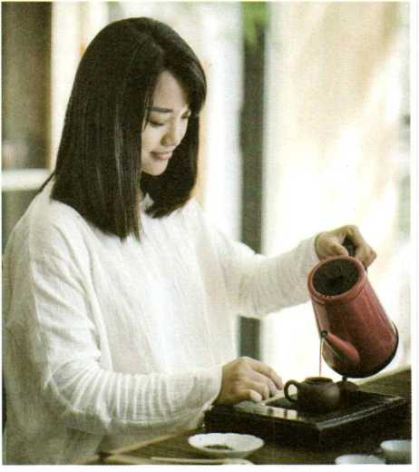

Reading

W＞》1 Skim the text. Write down the main idea of the text.

**THE FACE-DOWN GENERATION**



If you*re reading this, you were probably born in the 2000s. The oh-ohs. The 21st century. That would make you young, creative, connected, global, and no doubt smart. Maybe good­looking, too. Right? But what do other people think about your generation?

Some adults worry that you*re more interested in the screen in front of you than the world around you. They think of you as the uface- down generation" because you use your phone so much and they wonder how you will deal

with school, friends, and family. Are today*s teenagers too busy texting and taking selfies to become successful in real life一- r UIRU, as you would say?

Other adults worry that today's youth are spoilt (宠坏的)and don't want to face the challenges of adult life. Many children born in the 1990s and 2000s were raised by "helicopter parentsM who were always there to guide and help them with a busy schedule filled with homework and extra-curricular activities such as dancing, drawing, or sports. With parents who do everything for them, today*s youth seem to prefer to live like teenagers even when they are in their 20s or 30s.

Does the face-down generation need a heads-up? Well, probably not. The fact is that many of today's teenagers are better educated and more creative than past generations. They also seem to be enthusiastic (热情的)and willing to become leaders. More young people than ever volunteer to help their communities. There are also brave young people such as Malala \busafzai, the teenager who won the 2014 Nobel Peace Prize for pushing girls* rights to go to school.

So if you're one of the oh-ohs, there's reason to be hopeful about the future. Things are looking up for the face-down generation. Chances are that you will do GR8 (great) and LOL (laugh out loud).

1. Read the text carefully and answer the questions.
2. Was the writer born in the 2000s? How do you know?
3. Read the last sentence in Paragraph 2. How does the writer answer the question? How would you answer the question?
4. What is a “helicopter parent”？
5. What does the writer think about the younger generation? Do you agree?

Writing /////////////

"Talking Teens" provides advice for parents. Read the parents' questions. Choose one of the questions or one from your parents", and then write a letter of advice.

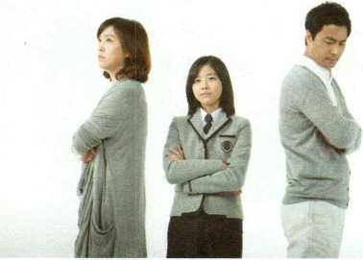

Dear Talking Teens,

I have a daughter who has just started senior high school. She wants to choose her own courses and decide everything by herself. In the past, she would always ask me for advice, but now she talks to her friends instead. Why doesn't she want my advice any more?

Best regards,

Confused Mum

Dear Talking Teens,

My son will turn 15 next week. I want to give him something special, but I have no idea what to buy. It used to be easy to know what he liked. Now it seems Like we don't have the same taste any more. Please help!

Sincerely,

Loving Father

Dear Talking Teens,

My daughter wants to study abroad but I think she is too young. She is only 14. Besides, it would cost a lot of money to send her to a school in another country. I think she should finish senior high school first, and then maybe study abroad when she*s in university. What do you think?

Best wishes,

Mum in Yunnan

Dear Talking Teens,

My son is 16 and wants to get a girlfriend. I think he is too young and should focus on school instead. He says that his friends have girlfriends and that I am being too old-fashioned. Is he right?

Yours truly,

Old-school Dad

* Expanding Your World

TEENAGE LIFE AROUND THE WORLD

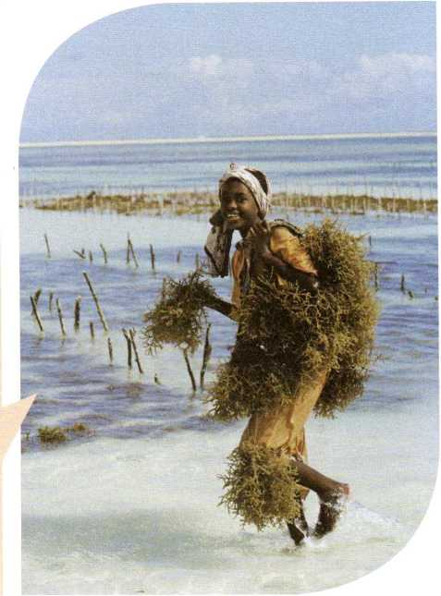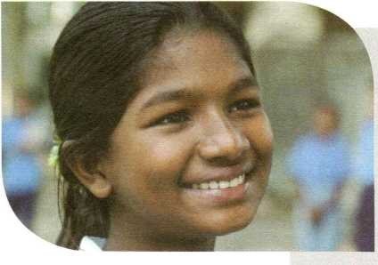Hi there! My name is Asha and I'm from Tanzania. Like most teenagers, I start my day early and end it late. After school, I study at a night school to prepare for the university entrance exam. When I have time off, I prefer to be outdoors. I love nature and animals. Tm quite upset about how we treat the environment, so I do my best to help. I volunteer to plant trees and I'm a member of our schooPs Nature Club.

Asha, Tanzania

Samika, Bangladesh

Hi! I'm Samika and I'm 15. I wish I were a student, but I'm not. I had to leave school when I was 13 so that I could get a job and help my family. I work in a garment factory. Ifs unbelievably hard work and the days are so long. Although everyone works hard, we still find time to play and laugh together. At times like these, the world feels like a wonderful place.



Frieder, Germany

Hi, Frieder here. So, I'm 16 and I go to a high school in Munich. I'm not crazy about school—listening to a teacher isn't my thing—but I know I have to get an education. It's very difficult for young people to find a job in Europe, so I worry a lot about the future. Oh, and I'm a gaming nerd. I love Internet games so much that I have started a gaming club at my school. Maybe ril see you online—my screen name is FastFreddy.

Using Words and Expressions

1. Make compound words and explain what they mean. Then use them to complete the sentences below.

|  |  |  |  |  |
| --- | --- | --- | --- | --- |
| guide |  | night |  |  |
| high |  | forest |  |  |
| pass |  | port |  |  |
| water | + | land | —> |  |
| sight |  | book |  |  |
| over |  | way |  |  |
| Ice |  | seeing |  |  |
| rain |  | fall |  |  |

1. A（n） is a book which gives information to visitors so they can know more about the place they are visiting.
2. A（n） is flowing water that drops from a high to a low place； often from a great height.
3. A（n） is an important public road that connects cities and towns.
4. is the activity of visiting interesting and/or beautiful places； usually as a tourist.
5. A（n） is a small book given by your government to prove that you are a citizen （公民）of your country
6. means during or for the night.
7. A（n） is a large forest； usually in a hot place, that gets a lot of rain.
8. ______ is a country that is beautiful and green； although its name sounds like it is cold and icy



1. Complete the passage with the words and phrases below.

amazing check in unique other than economy sights view destinations

One of the most relaxing ways to travel is a cruise. A cruise neednt be expensive! Cruise ships have lots of class rooms and lots of free activities. the ticket, you dont have to pay for anything you dont want. You can enjoy food in the ships many dining rooms and have a wonderful ocean every day You can experience local cultures when the ship stops at different seaside . Of course； if the ship stays at a city for several days, you can even at a local hotel for a few nights； so you can see more of the local .

1. Complete the poster with the correct forms of the words from this unit.

Popular tourist destinations include the Zhongshan Walking Street； famous for its food and shopping； and the Island Ring Road； where tourists can cycle on the 43-km bike p that runs along the seaside.

Other famous s are the Nanputuo Temple and the Xiamen Botanical Garden （植物园〉which is m u

of more than 20 areas filled with beautiful plants. Hulishan Fortress； built in the Qing Dynasty, is also worth a visit. It helped s stop any enemies from t c o the city

A must-see for visitors is Gulangyu Island； with its n streets, beautiful beaches, and unusual a . It has a piano museum with over 200 pianos. Visitors can enjoy a wonderful v of the island from Dragon Head Hill.

1. Use the words and phrases in brackets to translate the Chinese into English.

A: Do you have any plans for the holiday?

B: "Yes! My parents and I are going to drive out to the countryside and stay in a farmhouse.

A: Why aren't you going to (游览一个著名的旅游胜 地)？ (tourist destination)

B: Well, all of us really want to relax and enjoy some peace and quiet. (我们打算每天去山 里远足，欣赏美景).(hike,admire,view)

A: That sounds nice. How did you hear about this kind of holiday?

B: (我爸爸 看到了 一份乡村度假的宣传册).(brochure, countryside) So he decided to call and see whether we could book a farmhouse. (我迫不及待想 要出发了 ). (cant wait to)

1. Try to expand the mind map with as many words and phrases as you can think of.

**Preparing for a trip**

amazing sights

choose a  
destination

go online to look at travel websites

collect

information

Using Structures

1. Use the present continuous tense of the verbs in brackets to complete the sentences.
2. He (apply for) a credit card next Tuesday
3. He (not； visit) the Eiffel Tower next week since he (attend) a meeting in Seoul.
4. I (not； pack) until the

day after tomorrow

1. I dont know if she (check in) tonight or tomorrow
2. (you； check out) of the hotel tomorrow?
3. How long (you, stay) here?
4. Combine the words and phrases to make sentences using the present continuous tense.
5. they/rent/a car/this weekend

1. he/go hiking/with us/this Sunday/?

1. where/you/go/for the Spring Festival/ ?

1. what time/the flight/take off/?

1. 1/pick up/package/from the post office/ after lunch

1. 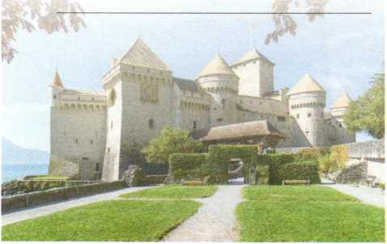I/book/tickets/for the castle tour/tomorrow

book transport

make travel  
arrangements

1. Decide whether *will do* or the present continuous tense is better and fill in the blanks.
2. I (always； love) you.
3. My parents and I (visit) the Architecture Museum this weekend.
4. I think you (find) this guidebookuseful.
5. We (take) a trip to Hubei next month to see my grandmother.
6. (you； contact) the travel agent this Friday?
7. If you ask him； I'm sure he (give) you a ride to the airport.
8. Tick the sentences expressing future plans and change *will do* into the present continuous tense. Then complete the email.

]The cruise will leave on 23 March and return on 1 April.

] We will take a cruise to Thailand!

]I know you will want to read more about the tour.

二 I will also send you the brochure soon.

Dear Dad,

1. hope you and Mum are well! Mia and I want to invite you to join us for our spring holiday.

We found a great package tour for the end of March.

Mia is especially excited about the trip. She loves warm weather! I really hope you can come with us.

You can find more information online.

Let me know what you think!

Love,

Paul

1. Choose one of the two itineraries below. Write a few sentences to describe your travel plans, using the present continuous tense.

Hangzhou, China

**Mon** 9:00 a.m.: flight to Hangzhou afternoon: check in at the hotel

**Tue** West Lake

**Wed** Grand Canal (大运河)

**Thur** Wuzhen: experience the beauty of the ancient water town

**Fri** morning: Botanical Garden afternoon: National Silk Museum

**Sat** morning: go shopping afternoon: pack

**Sun** leave for home

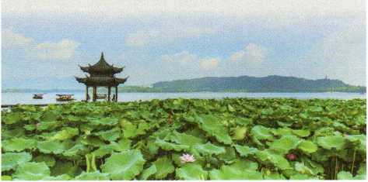

Auckland, New Zealand

**Mon** 1:50 a.m.: flight to Auckland

late afternoon: check in at the hotel **Tue** fe Papa (National Museum of New

Zealand)

**Wed** take a cable car•(缆车)up to the

Botanical Gardens

**Thur** morning: go shopping

afternoon: visit the Sky Tower

**Fri** take a road trip into the mountains

**Sat** return to the city

**Sun** leave for home



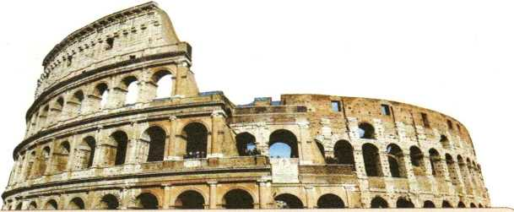

Reading —

1 Read the editorial below.

What is its main idea?

**BEA GOOD TOURIST**

Tourism can be both good and bad. Yes, it brings in money for the local economy and creates lots of jobs for locals, but it may also bring some problems.

One growing problem is tourists who want to prove that they have visited a destination. Tourists have used paint, rocks, or even keys to write on the Luxor Temple in Egypt, the Colosseum in Rome, Stonehenge in the UK, memorial stones at the bottom of Qomolangma, and many, many other places. Thousands of tourist sites are being destroyed by tourists who "'love them to death". I have three words for people like this: please stop it. If you want to leave a mark on the world, do it by changing someone's life with kindness and love. Pass kindness along to future generations, not destruction (破坏).

Another big problem in some places has been tourists disturbing (打扰)the local people and life. Some tourists wander around and take pictures of local people without asking for their permission. For example, Chiang Mai University in Thailand and Yonsei University in South Korea have great numbers of tourists visiting their campuses and walking through their libraries and other public areas, taking pictures of students, and disturbing their studies. Another example is Sanlitun, a neighbourhood in Beijing, China. Some tourists love to party there late into the night, making it difficult for locals to sleep. I have three words for tourists like this: please be considerate. Have fun in a way that does not disturb others.

The number of problems from tourists is endless: walking in large groups without considering others who need to walk by, crossing roads without thinking of local traffic laws, and many more. The only way to solve the problem of the terrible tourist is to make sure that you are not one! Be the best, kindest, most polite tourist possible. Remember, whenever you step outside your country's borders, you are representing (代表)your country to the rest of the world.

1. Scan the text for answers to the questions.
2. What kind of mark does the writer suggest that tourists should make?
3. What does the writer say is the only way to solve the problem of the terrible tourist?
4. Look at the sentences. Which are facts (F) and which are opinions (0)?

()1 Tourists have used paint, rocks, or even keys to write on some famous sites.

()2 If you want to leave a mark on the world, do it by changing someone's life with kindness and love.

()3 Some tourists wander around and take pictures of local people.

()4 Be the best, kindest, most polite tourist possible.

1. Do you agree with the writers suggestions for tourists? What other suggestions do you have?

Writing 務

1 Look at the pictures below. Write down what the tourists are doing wrong in each picture and think about the consequences.

2 What are some other wrong or foolish things that tourists do? What are some good things that tourists should do?

3 Organise your ideas using one of the outlines below or your own.

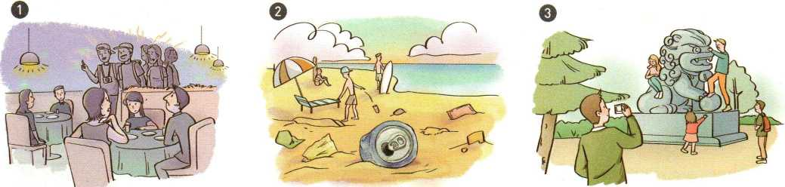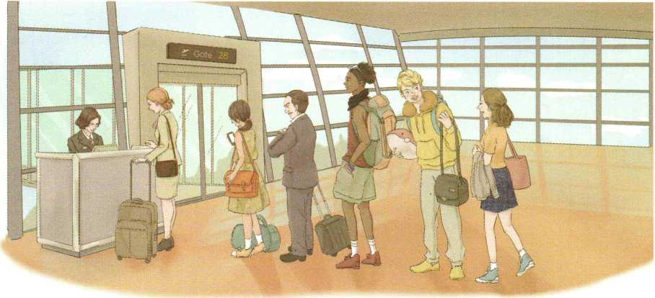

Outline 1

1. Introduction
2. Dos and don'ts: First...
3. Dos and don'ts: Second ...
4. Dos and donls: Third ...
5. Conclusion

Outline 2

1. Introduction
2. Bea good tourist by...
3. Be a good tourist by ...
4. Be a good tourist by ...
5. Conclusion

Your Outline

1. Write a passage to express your opinions on how to be a good tourist.

* Expanding Your World ft

Dear Sir^

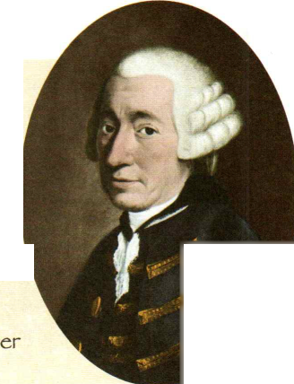Pisa is a fine old city. The houses are well-built； the streets open, straight, and well-paved； the shops well-furnished； and the markets welksupplied. There are some beautiful palaces. The churches are built with taste and well decorated. There is a stone wharf on each 】 side of the Arno River （阿尔诺河）,which runs through the city, and there are three bridges over it. The number of people there *is* rath small. This gives the place an air of wonderful quietness, which is very pleasant.

■

Of course, I visited the beautiful leaning tower, which is eight floors high, each having a round of columns, rising one above another. It leans so far on one side that if you dropped a stone from the top, which is 188 feet high, it would fall feet From the base of the tower. I would have never dreamt that this would have happened for ant） other reason than an accident； but some people have said that it was done on purpose bg the architect! Anyone with eyes can see that the columns on one side have sunk rather far. These leaning towers are not uncommon in Italy； there is one in Bologna （博洛尼亚）*）*another in Venice （威尼斯）） a third between Vtenice and rbrrara （费拉拉），and a fourth at Kavenna （拉韦纳）.

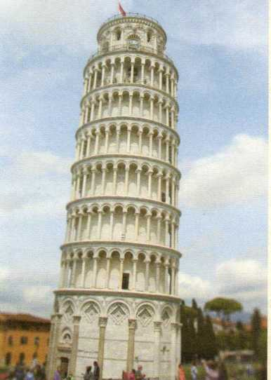A most interesting person ljou might meet in Italy is the Improvisatore； this *is* what theg call certain people who have the surprising ability to make up poems on any subject ljou surest. Mr Corvesi, my landlord^ has a son who *is* amazingli） good at this. When a subject is given, his brother picks up his violin to play along as he begins to make up poems with wonderful speed and skill. He will, at a minuted warning, recite two or three hundred beautifully written verses, with compliments to the listeners! The Italians are so fond of poetry that mantj of them have memorised the best parts of their great poets； these are the sources from which the Improvisatori take their rhcjmes^「hgthms, and expressions.

Pisa today

Tobias Smollett

Using Words and Expressions *////////////z*

| An athlete is | a large sports area with rows of seats all round it. |
| --- | --- |
| An event is | a large room with things for doing physical exercise. |
| A stadium is | someone who competes in a sport. |
| A gym is | a thing that happens； especially something important. |

work out give up fall apart lose heart

1 Match the two parts to make definitions. 1983. She became the first Chinese world champion in and field.

1. The became a modern Olympic event in 1896 though the distance was not standardised until 1921.
2. Complete the sentences with the correct forms of the phrases below.

at home and abroad come along even though learn from ones failures

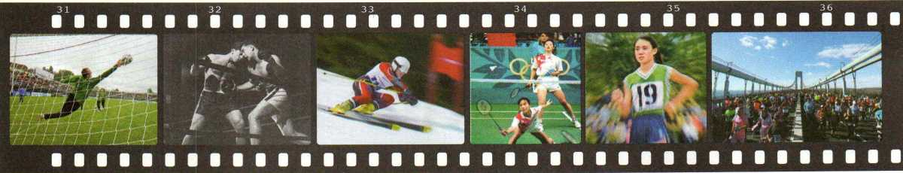

1. Which sports record is stated in each sentence? Fill in the blanks to find out.

skiing marathon track

boxing badminton soccer

1. The first ever FIFA World Cup goal was scored by Lucien Laurent； a French player, at the 1930 World Cup.
2. The greatest number of rounds in a match was 276 when Jack Jones beat Patsy Tunney in Cheshire； England； 1825.
3. The longest time spent non-stop is 202 hr 1 min by Nick Willey in Australia in 2005. He skied over 1J50 km in the process.
4. The first Chinese Olympic gold medals in were won by Ge Fei and Gujun in Atlanta in 1996.
5. Xu Tongjiu won the gold medal in a 10-km walking race in the Norway World Cup in
6. Do not . You should work harder to solve the problem.
7. It is a shame that their friendship finally

and they became

enemies.

1. we will certainly fail at times； learning from the mistakes we make will be invaluable.
2. Even in the middle of his busiest schedule； he three times a week to keep fit.
3. As much as we value our successes； we need

to .

1. Ping-pong has now become an international sport； it is played .
2. I hope you can come to our party after the final game； and please feel free to invite a friend if you like.
3. If you could choose to remember only six words in your life； remember these： "Nevei; ever . Keep trying.”
4. Write down as many phrases as you can using *make or out.* Then make sentences with them.

it

a difference

make,

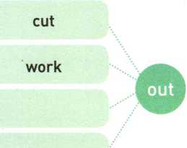

1. Read the passage and answer the questions. Do you agree with the writer?

What is the difference between a good athlete and a great one? What is the difference between a player of a sport and a master of a sport? A sports psychologist (心理学家)suggests there are four things that all great athletes have in common. First, all great athletes love competition. They are not afraid to compete with other people. Second is their self-confidence; they are positive about themselves and their abilities. Great athletes can also deal with stress well. They are able to cut out things from their lives that add to their stress, such as unhealthy food or bad friendships. Finally, all great athletes have the mental strength to focus on what is most important. They will not let themselves be distracted (使 分心)from their goal. Great athletes set an example to all of us not only in how to play sports well but also in how to live life well.

1. What do all great athletes have in common?
2. How do all great athletes feel about themselves and their abilities?
3. What are all great athletes able to do to help handle (处理)stress?
4. What makes it possible for all great athletes to focus on what is most important?
5. Translate the sentences into English using the words and phrases in brackets.

1有些女孩子进行不健康的节食，因为她 们想保持苗条的身材。(go on unhealthy diets； slim)

2足球运动员在比赛中不应该假装摔倒， 这是一种作弊行为。(pretend；cheat)

3美式足球和世界上其他地方的足球没有 可比性，因为它们是两种截然不同的运 动。(compare... with/to)

4安娜喜欢打网球，而不是羽毛球。(prefer； rather than； badminton)

5吉姆偶尔会买几本体育杂志。(nowand then)

Using Structures /////////////

1 Read the conversation aloud and pay attention to the tones of the tag questions.

A: Were all so busy, but we cant just sit around and study all the time； can we?

B: *No,* we cant. Sometimes I just have to get up and do a few jumping jacks.

A: Jumping jacks? Those are a kind of exercise； arent they?

B: Yes, they are! You jump and bring your hands together above your head and move your feet apart. Then you jump again； bringing your hands to your side and your feet together. I'm sure youve done them before； havent you?

A: I know what you mean now They are also called star jumps； arent they? Why dont we do a few now?

B: Sure.

2 Add tag questions to the statements.

1. Lets go and work out in the gym丿

?

1. Vbu dont take part in a marathon when youre ill； ?
2. Turn off the *TV, ?*
3. Shes doing all she can for us in times of stress, so we must back her up；

?

1. Henry thinks you are cheating your friends,

?

1. Andys never been anything but a friendly 鲫 ?
2. Emily had to cut out sugar from her diet as her doctor suggested； ?
3. There's going to be a talk on wellness and fitness next week； ?
4. Complete the conversation with appropriate tag questions.

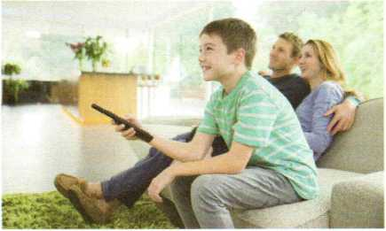

Tom: Mum； I can have one more burger； ?

Mum: No； you cant. Youve already had two! Youre going to get sick ... Oh, whats that noise?

Dad: It isnt a storm coming； ? Tom: *Yes,* it is! But it s on TV!

Dad丿 come and see； ? Dad: What movie are you watching? Tom: *The Day after Tomorrow.* Mum: Lets watch it together; ?

Family time!

Dad: Good idea!

1. Complete the questionnaire for Chris. Then fill in the blanks below and write an ending to the conversation, using tag questions where necessary.

**PRIME GYM**

**Be your best**

Name: Chris Chang

Age: 17

Gender: Male

1. How long have you been working out at the gym?

© Never. O 1-6 months. O Over 6 months.

1. How many hours do you (plan to) spend at the gym each week?

O 2 hours. O 4 hours. O 6 hours.

1. What do you like to do at the gym?

O Running. O Weight training. O \t)ga.

1. Why do you go to the gym?

O lb keep fit. O *To* build muscle. O For fun.

A: Hi Chris! My name is Steve. Im a trainer here at the gym. So youve just filled out our questionnaire； ?

B: yes. It s nice to meet you, Steve.

A: It s good to meet you, too! OK, let me take a look at your answers. Hmm ... So youve never worked out in a gym before； ?

B: No)I haven't, Steve. Embarrassing (让人尴 尬的);but true.

A: Oh, don't be embarrassed! Its never too late to start. But I have to ask ... Ybu think working out for ... hours a week is enough； ?

Reading *IIMIIIMIIIII*

1 What do you know about the sports below? Match them with their descriptions.

1. Skiing ... ・ was originally a sport only in cold northern countries.
2. Skating ... • is named after the shape of the sleds （雪橇）used in the 1890s.
3. The skeleton ...・ can involve speed and graceful figures.

♦》2 Read the text and check your answers.

**COOL COLD SPORTS**

The Winter Olympic Games are not just an opportunity for athletes to win medals and honour for their countries. Every four years, the Games also offer audiences a chance to get to know more about winter sports from around the world. The Winter Olympics may not have the large crowds and huge stars of its summer sibling, but they share the same Olympic spirit.

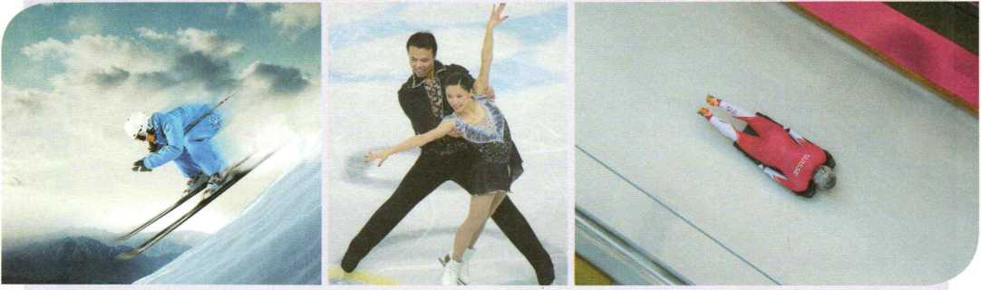

Skaters compete with each other in speed races or in figure- skating events. The figure-skaters are generally considered to be the stars of the Winter Olympic Games. These ice princes and princesses are so graceful that ifs easy to forget that they are actually highly skilled athletes.

One of the most popular sports of the Winter Olympic Games is skiing. Skiers compete in the downhill and slalom （回转赛），and in the short and long cross-country ski races. Skiing was originally a sport played only in cold northern countries, but now athletes from all over the world compete in this sport, even those from countries without any snow!

The skeleton is one of the strangest- named sports of the Olympics. The skeleton is named after the shape of the metal sleds used in the 1890s, when the sport first started. The skeleton is a downhill sled race, usually on ice. This sport looks a little like the luge （无舵雪 橇），where a person sits on the back of the sled with his or her feet forward, but the skeleton is a lot more exciting and dangerous than that. In the skeleton, a person lies on his or her stomach on the sled, with his or her head pointing downhill!

1. Read the text again and answer the questions.
2. What is the "summer sibling" of the Winter Olympics? Why do you think the writer uses that phrase?
3. How does the writer describe figure-skaters?
4. Which of these three Winter Olympics events do you find the most interesting? Why?

Write a letter to the International Olympic Committee (IOC) to propose a new sport or event that you think should be added to the Olympics. Use the outline below to help you.

* The name of the sport or event
* Where it comes from and a short history about it
* Why you think it should be an Olympic sport or event



Sender's  
name  
and address

Li Hua

Room 301, Building 5 Postage stamp area

Jingyuan Road, Chaoyang District

Beijing, China, 10020

IOC Headquarters

Route de Vidy 9 1007

Lausanne, Switzerland A?；：-

name and address VIA AIR MAIL

(Address of the sender)

(Title of the recipient)

(Address of the recipient)

(Date)

Dear Sir/Madam,

My name is , and Im a student in > China writing to you to a&k whether :

This sport comes from . It first started in

(think should be included as an Olympic sport because

Yours faithfully,

* Expanding Your World *刪刪*

**HOT TICKETS**

What makes a sports event a winner? Exciting action? Tick. Athletes competing to win honour and glory for their club or motherland? Tick. History and tradition? Tick. Delicious snacks? Tick, Most people think global events such as the Olympic Games and the World Cup are the most exciting, but there is some serious competition. Here's a look at some of the hottest tickets in sports.

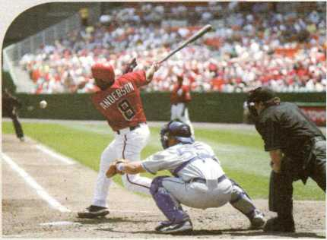**The World Series** (baseball, USA)

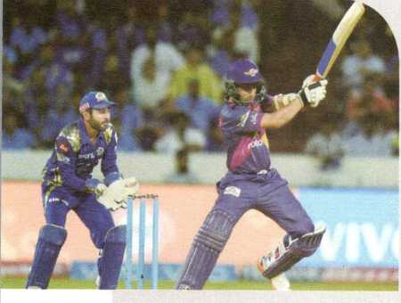The World Series is the final championship of the American baseball leagues. The seven-game series is played in October or November and attracts a great number of fans. Baseball is one of America's favourite sports and has many traditions, such as the "seventh-inning stretch (七局伸展操)".The song “Take Me Out to the Ball Game” is played so that everyone can get up after sitting for a long time. The break is also a good time fbr a snack. Hot peanuts are a hit with hungry baseball fans, but the hot dog is the real winner!

**Indian Premier League** [cricket, India)

Cricket is from England but has become as Indian as saris and curry. The Indian Premier League has the largest audience of all cricket leagues in the world and is the sixth most-watched sports league in the world. Cricket is a unique sport and may seem a little confusing at first, but once you start learning the rules, you'll love it. The most popular cricket snacks are finger foods like biscuits and cucumber sandwiches.

**Wimbledon** (tennis, England)

Wimbledon is a treat for all tennis fans. The tournament started in 1877 and many of the rules are the same today. For example, the players may only wear white clothes. The event, however, is quite colourful since fans often dress up for the games and wear amazing hats. And when it comes to snacks, ifs "game, set, and match,, at Wimbledon. Where else can you enjoy champagne and strawberries as you cheer fbr the champion?

Using Words and Expressions

1 Match each word with its definition.

electricity volcano flood

landslide drought shelter

1. : a long period of time with little or no rain
2. : the falling of a lot of earth and rocks down a mountain
3. : a large amount of water overflowing and causing a lot of damage
4. : a form of power fbr lighting, heating； machines； etc.
5. : a mountain from which gas； ash； and hot rocks sometimes burst out
6. : a place built to give protection； especially from danger or bad weather

2 Circle the verbs in the puzzle. Then complete the sentences with the correct forms of the verbs.

|  |  |  |  |  |  |  |  |  |  |  |  |  |
| --- | --- | --- | --- | --- | --- | --- | --- | --- | --- | --- | --- | --- |
| 0 | U | P | C | H | F | M | 0 | B | G | J | N | r |
| R | U | A | R | 旦 | M | C | R | A | C | K | Z | U |
| E | L | B | A | W | T | F | S | P | H | *X* | W | R |
| S | E | N | S | I | W | A | S | M | V | D | S | E |
| C | Y | M | H | T | N | S | U | R | V | I | V | E |
| U | I | S | M | 0 | L | H | F | I | S | Y | D | G |
| E | E | V | A | E | H | 0 | F | W | T | R | A | P |
| T | S | U | P | P | L | Y | E | T | C | E | C | A |
| 金 | T | R | I | K | E | A | R | K | K | H | H |  |

snowstorm last night.

1. The child was from the mins by a young volunteer after the earthquake.
2. I was shocked when I saw on TV that so many people were in the burning buildings.
3. The Red Cross Society of China is the disaster-hit area with doctors and medical supplies.
4. Complete the passage with the correct forms of the words below.

death destroy survive

crash shelter disaster

Earthquakes are a form of natural . They are so powerful that they can cause tall buildings to to the ground in just a few seconds. In fact； most of the in an earthquake are caused by falling houses or buildings. New research data from earthquake zones is helping architects to design safer buildings that will not be during an earthquake. Instead of being fixed in place like most ordinary buildings, the new buildings they have designed can move. Other researchers have designed small round houses that will not fall down when there is a quake. Because the houses are round； they can strong winds and floods, and are good during a disaster.

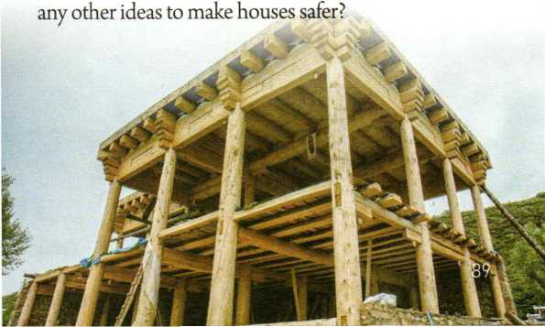

The photo below shows a special earthquake- proof house in Sichuan, China. Do you have

1. He made a stupid decision and now he is for it.
2. My brother a bone in his arm when he fell off his bike.
3. A truck went out of control and into the back of a bus.
4. An earthquake can suddenly, but there may sometimes be warning signs.
5. Few sheep and cows the
6. Translate the sentences into English using the words and phrases in brackets.

**1**志愿者给被困在村子里的人送去了食物 和其他补给品。(trap, deliver, supply)

**2**多年以后，他在乡下过着平蓄的生 活，似乎灾难从未发生过。(calm, as i£ disaster)

**3**在震区，因为没有栖身之所，人们只好 露宿户 外。(quake-hit area, in the open air, shelter)

**4**这个援助项目将对非洲女童的教育产生 巨大影响。(aid, effect)

**5**虽然洪水没有影响我们的学校，但是却  
冲毁了低地的许多房屋。(affect, ruin)

**6**幸运的是，志愿者手上有一些船只， 可以帮助人们转移到安全的地方。(on hand)

* 5 Gile, a girl in Bangladesh, is talking about floods in her country. Write her story with the help of the notes below.

Using Structures /////////////

1 Fill in the blanks with *that, which, who, whose,* or *whom.*

1. A disaster is a very bad accident or a sudden event usually causes great damage and can ruin many peoples lives.
2. The woman wanted to find and thank the firefighter rescued her from the fire.
3. A typhoon is an extremely strong wind often happens in the Western Pacific Ocean.
4. The children parents could not be found were looked after by neighbours and friends.
5. A tsunami is a very large wave is often caused by an earthquake under the sea.
6. People to much is given are people of much will be expected.

Gile frightened a flood sweep over her village

neighbours sweep away > huge waves

Gile's house destroy her family safe now live a shelter

Bangladesh often affected disasters like flooding

Gile think people better prepared protect flooding

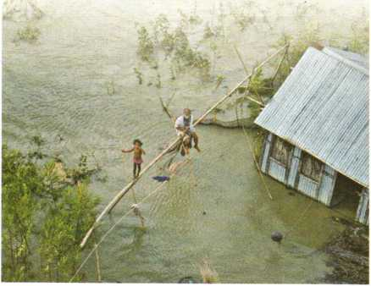

1. Use a restrictive relative clause to combine each pair of sentences.

EXAMPLE

The baby was crying. The baby was rescued from the building, (who)

*The baby who was rescued from the building was crying.*

OR

*The baby who* was *crying* was *rescued fivm the building.*

1. The CCTV reporter is interviewing a woman. The womans family survived the earthquake, (whose)

1. The soldier will remember the rescue worker. The soldier worked with the rescue worker during the quake, (with whom)

1. The rescue workers had to walk slowly through the bricks. The bricks covered the ground, (that/which)

1. My family will always be thankful for the people. We received aid from the people, (from whom)

1. The people lost everything in the quake. We need to help them prepare for the coming winter, (who)
2. Add more information to the passage by using restrictive relative clauses that answer the questions in brackets. You may use a library or the Internet to help you.

EXAMPLE

Who should be warned? —>

*people who might be in danger*

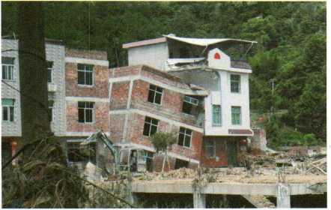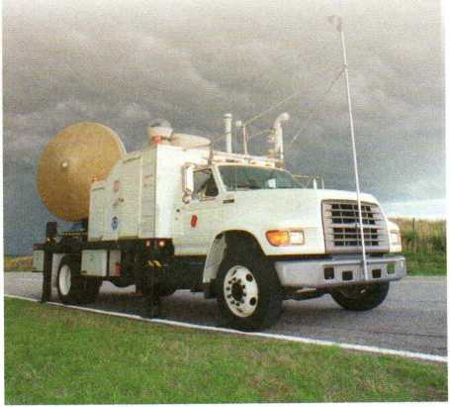

3 Complete the passage with *that, which, who, whose, ovprep + whom.*

For people love the sun； summer is a time of fun. But for people families were destroyed by the super typhoon hit East China in July 2016； that summer was a time of great sadness. The floods and landslides caused by the typhoon killed 161 people； left 61 missing； and forced the evacuation of hundreds of thousands of people. The victims the typhoon brought death or great loss were in several provinces along the Yangtze River. In the months have passed since then； much has been done to make things better and help the thousands of people homes were destroyed； although the sadness will never leave those summer now marks the death of a loved one.

Tornadoes are strong winds (What kind of winds are they?). It is not easy to know where they will go, so it can be difficult to warn people (Who should be warned?). In order to learn more about how tornadoes form and move, some brave researchers (What is their job?) do what most of us would not. They chase (追赶)storms in order to collect more detailed information first hand. Of course, the researchers have special equipment (What kind of equipment?), but they need to get close enough to use it and still keep safe from the danger.

Reading and Writing *IIMMIMIIII*

1. Read the text quickly. Who is the eyewitness? What event is the eyewitness describing?

THE STORY OF AN EYEWITNESS （Adapted）

Jack London

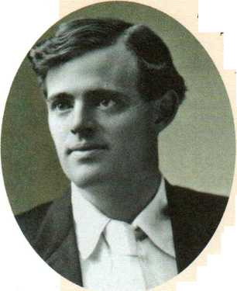

of thousands of dollars5

worth of walls and

chimneys （烟囱）.But the fire that followed burned

*San Francisco, May 5, 1906.*

The earthquake that hit San

Francisco on April 18 shook down hundreds

up hundreds of millions of dollars9 worth of buildings and homes. Never before in

history has a city been so completely destroyed. San Francisco is gone. The factories, the great stores and newspaper buildings, the hotels, and the great houses of the rich are all gone.

On Wednesday morning at a quarter past five came the earthquake. A moment later, the disaster was a fact. South of Market Street, in the working-class neighbourhoods and in the factories, fires started. Within an hour of the first quake, the smoke could be seen 100 miles away. The sun was red in the dark sky. There was no stopping the fires. The firefighters to whom the task was given did their best but there was no way to organise or communicate. The railway tracks were now useless and there was no water in water pipes. All of the ways man had made to keep the city safe were gone in the 30 seconds the earth moved.

By Wednesday afternoon, half the heart of the city was gone. At that time, I watched the disaster from a ship on the bay （海 湾）. Out at sea it was calm. No wind came up. Yet from every direction~east, west, north, and south—strong winds blew upon the unlucky city and those whose homes had once stood in its green hills.

Wednesday night saw the destruction of the very heart of the city. Man himself had to make ruins of some of the city's best buildings so that they would not be a danger to those in the streets. Tens of thousands who had lost their homes left the city to look for shelter from the fires. Some were dressed only in blankets and carried the things that they had been able to rescue from the fires. But there were no fights and no pushing or shoving. Somehow this worst of disasters brought out the best in the survivors. Never in all of San Francisco's history were her people so kind as on this night of terror.

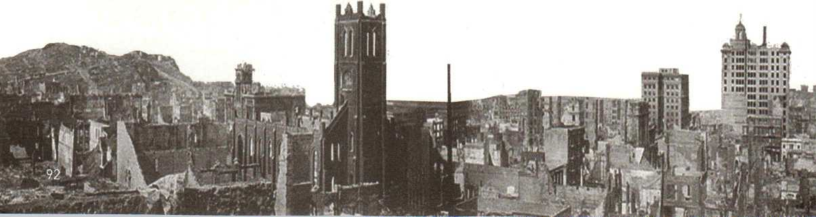

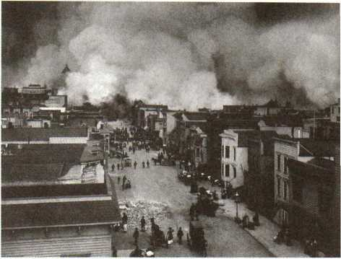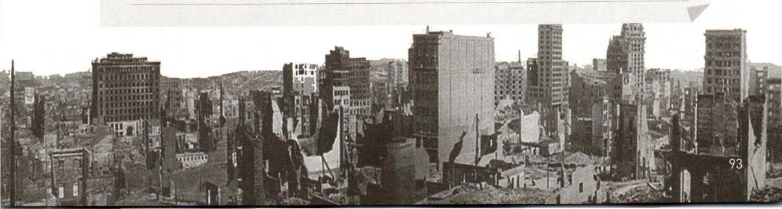

1. Read the text again and answer the questions.
2. Which was more destructive, the earthquake or the fire? Why?
3. Why couldn't the firefighters put out the fires when they first started?
4. Where was the writer? Did he suffer from the fire?
5. How long did it take for half of the city centre to burn? Why did the fire spread so fast?
6. How did the people of San Francisco behave during the disaster?
7. What do the underlined sentences mean? Rewrite each sentence in your own words.

10. Find answers to the questions from the text.

What was the first disaster?

When and where did it happen?

What was the second disaster?

What damage did it cause?

How did people behave?

Who described the event?

1. Use your answers to the above questions to write a summary of the text.

* Expanding Your World *1咖1 刪III*

**CHINA TO THE RESCUE!**

The China International Search and Rescue Team （OSAR） was formed in 2001 and is now made up of several hundred rescue workers and about 20 sniffer dogs. The team brings help and hope to those whose lives are changed by a storm, flood, earthquake, or any other natural disaster.

After long and careful training, the team went on its first international rescue missions in 2003. That year, the Chinese team helped save lives after earthquakes in Algeria （阿尔及利亚） and Iran （伊朗 \ It was the first time that a Chinese team had worked outside China, and the team won high praise for their bravery and skill.

Since then, the CISAR has completed many missions. The list of people to whom help has been given is long. The team treated more than 3,000 people who were injured in the 2006 earthquake in Indonesia, helped 2,500 wounded people after the earthquake that hit Haiti （海 地）in 2010, and spent several months giving aid to over 25,000 victims of the 2010 floods in Pakistan （巴基斯坦）.

Rescue workers are trained to find people, treat injuries, and hand out food, water, and other supplies. They have to be able to do work that is difficult under conditions which can be very dangerous. After a disaster, there is usually no electricity or water, and there may be diseases and accidents. Rescue workers get to save lives, but they must also bury the dead. That means they have to be strong in both body and mind.

Rescue workers must have big hearts, too. It takes a lot of love and courage to risk one's own life to save someone else's. The members of the CISAR have plenty of both and are always ready to go wherever help is needed.

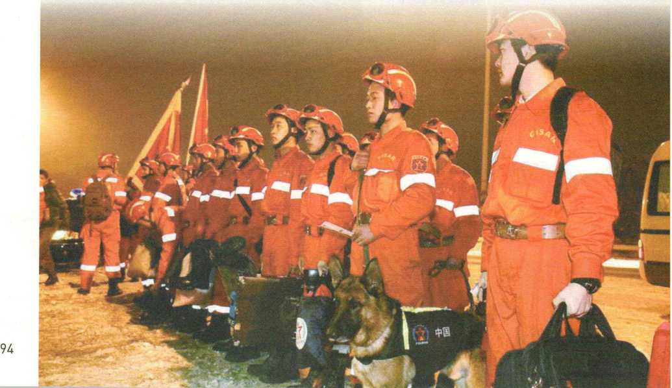

Using Words and Expressions

1. Read the definitions of each word below. Then choose the correct one for each sentence.
2. major
3. *adj.* more important than other things

of the same kind

1. *n.* the most important subject that a

student studies in university

* Sugar is a major cause ofhealth problems.[
* His major is the French language.[ ]

1. base
2. *n.* the main part of something
3. v. to be in the main place where a

company does its business

* The company is based in Guangzhou.[

® This dish has a milk base.[

1. character
2. *n.* the qualities of a person or place that

make it different from others

1. *n.* a letter, number； or other mark used in

writing

1. *n.* a person in a story or film

* Old Korean and Japanese characters are related to Chinese characters.[ ]
* Work hard to be known as a person of good character.[]
* The story is about two main characters； a

little boy and his mother [ ]

1. affair
2. *n.* a situation or matter that is being

considered

1. *n.* an event

* The meeting was a long and boring affair.[ ]
* Hu Ming manages student union affairs.[ ]

1. equal
2. *adj.* the same as something else
3. *n.* someone of the same importance
4. v. to be exactly the same

* He treats all his students as equals.[ 糠 All work is of equal value.[
* Two plus four equals six.[

1. Fill in the blanks with the correct forms of the phrases below. Use a dictionary to help you if there are words you do not know.

ups and downs (be) related to as if no matter struggle for

1. Money and fame are not happiness. Ime happiness lies in being satisfied with your life and being grateful for all the things you have received.
2. how much moneyyou can earn and how successful you become in the future； you should always remember where you are from and keep your family and friends close to your heart
3. Life is always full of . Be brave and do not complain when you experience hard times. Just be strong and make the best of things. You will get over tough times sooner than you think.
4. Studying is not easy for me at all. However； I fully understand it is something worth putting effort into. I am not good scores in exams； but rather； a chance for a better future.
5. Be comfortable with who you are. Be happy

and laugh every day Dance nobody is watching. Sing

no one is listening.

1. Complete the advertisement with the correct forms of the words below.

classic equal demand native despite gap system struggle



Have you ever tried to learn Chinese but failed； your best efforts? Do you

with remembering vocabulary or lose heart over the writing ? Have you studied for the HSK （汉语水平考试）but still feel there is a large to close before you can hope to pass? Do you want to read the great Chinese from early Chinese dynasties? High Point Chinese Language School has the answers to all of these questions! We welcome students from everywhere, because we believe everybody should have a（n） opportunity to learn Chinese! We have classes for all levels and interests. But sign up soon； as all of our teachers are Chinese speakers and are in great !

1. Translate the underlined parts in the conversation into Chinese.

**A:** Hey I'm going to sign up fbr a Chinese calligraphy class at that new language school. Do you want to join me?

**B:** You know, I'm learning Chinese at my school, and to be honest, my teacher's method is really boring. Im not sure I want to take another Chinese class.

**A:** I think learning calligraphy will help you feel better about Chinese! Calligraphy is regarded as an art fbrm Many people enjoy it

**B:** I guess it would be good to learn! After all there're over a billion people who speak and read Chinese. OK； Til find some time in my schedule and try the class.

Using Structures /////////////

1. Underline the clauses in the sentences and decide whether they are restrictive relative clauses or object clauses.
2. The reason why he found German so difficult was because of its grammar.
3. **A:** Have you decided where we should go

for our holiday yet?

**B:** After learning for two years； I really want to visit a country where French is spoken.

1. According to an old story, there was once a time when the whole world spoke only one language.
2. This passage introduces how Chinese characters have changed over time.
3. Fill in the blanks with the correct relative pronouns or adverbs. Add a preposition where necessary.

Japanese uses three writing systems’ including kanji_ originated （起源*）*in China.

Nineteen fifty-three was the year  *Xinhua Zidian,* or the New *Chinese Dictionary^* first came out.

Bones symbols were carved, known as “oracle bones'； have contributed a lot to our understanding of Chinas past.

There are many reasons English is so widely used around the world in the fields of science； business, and more.

Sign language is of great importance for people are deaf or have poor



1. Complete the passage with the correct relative pronouns or adverbs below.

that when where (in) which who why

The United Nations (UN) is an organisation aims to promote international cooperation. It was founded in 1945 and has about 190 member states. This is the reason the UN has a huge number of translators and interpreters, since international meetings in the UN are attended by people speak so many different languages. Translators are people usually work with written language, while interpreters work with spoken language. Meetings only two languages are used may need only one interpreter; while larger events leaders from many countries gather may need over 70 interpreters.

1. Match the sentence parts with the times, places, and reasons. Then make complete sentences with restrictive relative clauses.

when/prep + which

**A** Lu Xun was bom

**B** I have my debating class

**1** (A) 1881

Eighteen oightg-on。th。养ar when Lu Xun born.

**2()** Sunday

where/prep + which

**C** the oldest written European language has been found

**D** language is processed

**3 (** ) the left part of the brain

**4()** modem Turkey

There are two main ways that an interpreter can provide spoken translation. First is the method requires the speaker to stop every few sentences； so the interpreter can translate those sentences for the audience. Hie second method is the one the interpreter listens and translates at the same time. This second method is more difficult； but the place the interpreter is located is not so important. The interpreter can be in a completely different location from the speaker, listen through headphones； and translate for an

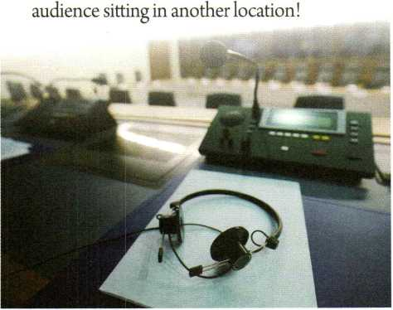

why

**E** some students like to do volunteer work

**F** people often choose to learn a foreign language

1. **(** ) caring about others

**6()** spending some time abroad

1. Think about one of your favour代e memories, and then write a short paragraph about it. Use the expressions below to help you.

One of my favourite memories is of the time when...

The place where it happened was ...

That was the day when ...

The reason why...

Reading *IIIIWMII冊*

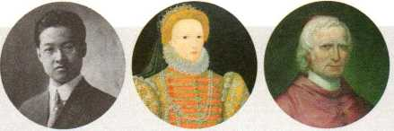■》1 Look at the pictures below. Do you know who they are? Can you think of any similarities among these people? Read the text and check your answers.

**POLYGLOTS:**

**WHAT ARE THEY AND WHO CAN BE ONE?**

Some polyglots, who can speak quite a few languages, may seem especially talented. Zhao Yuanren, a Chinese American linguist, could speak seven languages and more than 30 dialects. England's Queen Elizabeth I could speak about 10 languages. A famous Italian named Guiseppe Mezzofanti was reported to have been able to communicate in 30 to 40 languages. Polyglots are indeed amazing, but American teenager Tim Doner is living proof that anyone can try to be one.

As a child, Tim studied French and Latin at school, but he found it difficult to be interested in just words and grammar rules. When he was 13, Tim started listening to Hebrew rap music. One day, he looked up the words in a dictionary and realised he could put them together to make sentences! He started looking for people who spoke Hebrew so he could practise, and then, he decided to sign up for a summer Arabic class. One evening, just for fun, he posted a video of himself speaking Arabic and another of him speaking Hebrew. Hebrew and Arabic speakers wrote nice comments on his videos and gave him advice. Tim loved it. He could actually communicate with people! After that, Tim started looking for new languages to learn, and posting more videos of himself speaking new languages, including Chinese. Tim also began to use many other methods to make learning fun.

Tim wishes everyone would learn more than one language and not just as a school subject. “Knowing a language is a lot more than knowing a couple of words out of a dictionary/5 Tim says. Languages are for communicating with people, learning about their culture, and understanding how different people think. "Open up your mind to the fact that language represents a cultural world view,” says Tim. "Ydu can translate words easily, but you can't quite translate meaning.M Or, as Nelson Mandela said, “If you talk to a man in a language he understands, that goes to his head. If you talk to him in his language, that goes to his heart.n

1. Scan the text for answers to the questions.
2. How did Tim Doner first become interested in learning languages?
3. Do you think that Tim Doner would say that polyglots are "especially talented,^? Explain.
4. Underline the ways that Tim Doner used to learn foreign languages. Which ones did he find successful? Have you ever used any of the methods in your language learning?

Writing

1. Discuss in groups： What is wrong or inappropriate in the pictures below? What similar experiences have you had or heard of?

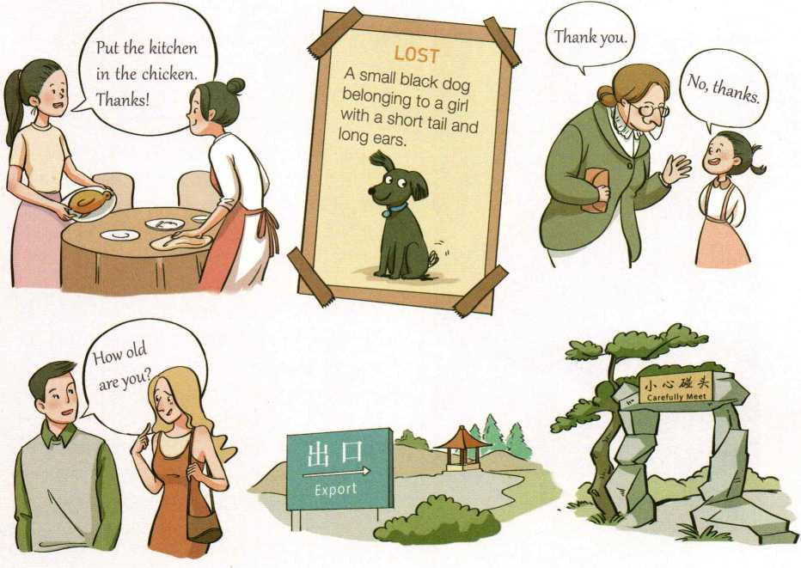

2 Write a short description of your experiences in learning English. You can refer to the outline below.

Introduction

How I felt when I started learning English

©

Funny experiences/ mistakes in learning English

Learning methods that I use to learn English

0 「

Problems that I still have in learning English

Conclusion

How I hope to improve my English in the future

* Expanding Your World

**THE BOOK THAT KEEPS ON GROWING**

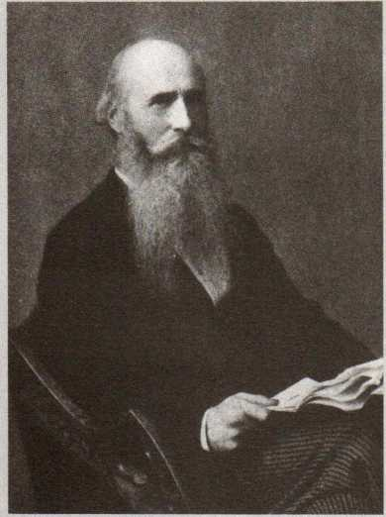

It is one of the most famous books in the world; yet it has no story and no interesting characters, no exciting beginning and no satisfying ending. And yet this book keeps being printed—and it keeps growing! At its last printing, it was 20 volumes, with nearly 22,000 pages. This strangely popular book is one of the most famous dictionaries in the English- speaking world, the *Oxford English Dictionary.*

The *Oxford English Dictionary,* or *OED* for short, began in 1857 as just an idea of a group of people who thought the world needed an English-language dictionary to show the history of English words from 1150 CE to the present. It wasn't until the late 1870s, however, when James Murray joined the project that it began to

grow. Murray planned for a dictionary of about 6,400 pages in four volumes, completed in 10 years.

James Murray (1837-1915) did most of his work in a small metal building called the Scriptorium. That small building, hot in summer and cold in winter, was the place where Murray and his assistants collected millions of pieces of paper, each one with a word and an example sentence or phrase written on it. Murray and his assistants worked hard, but after five years they had only reached the word ant!

It was not until 1928 that the dictionary was declared complete and published: 10 volumes with over 400,000 words and phrases. James Murray did not live to see the completion of his life's work; he passed away in 1915, over a decade before the *OED* came out.

As soon as the dictionary was published, however, the editors started to update it! In 1933, the *Oxford English Dictionary* was reprinted in 12 volumes. Between 1972 and 1986, four more volumes were added with new technical and scientific vocabulary and words from other English-speaking countries, such as Canada, the USA, Australia, New Zealand, and South Africa. In 1989, the entire dictionary was reprinted in 20 volumes! Three years later, all 20 volumes were put onto CD-ROM, and the entire dictionary is available online today.

With about 600,000 words and three million quotations from over 1,000 years of English, the *OED* not only is a record of where the English language has come from but has also become an important part of the history of English-speaking cultures around the world.

Appendices 附录

**Notes**注释

**I** Unit 1

1. Going from junior high school to senior high school is a really big challenge.从初中 过渡到高中真是一项巨大的挑战。

going from junior high school to senior high school在句中作主语。英语中，当动词或动词短语用作 主语时，可以使用动词-Sg形式。如：

Seeing is believing.［谚】百闻不如一见。

Reading outside school is necessary and important in learning English,课外阅读对于英语学习既必 要又重要。

【思考】本单元使用动词-们g形式作主语的句子还有哪些？你能找出它们并理解其意义吗？

1. The school adviser helped me choose the suitable ones： maths, English, chemistry, world history, and Chinese.学校的指导老师帮我选择了适合我的课程：数学、英语、化学、世 界史和中文。

美国高中学制多为四年，采取学分制，不分文理科，一般修完18~23个学分可以获得高中毕业证 书。高中课程设置分基础必修和选修两类。基础必修课程通常包括英语、数学、自然科学（如生物、化 学、物理、地理）、社会科学（如历史、经济学、心理学）。选修课程内容丰富，有视觉艺术（如绘画、摄 影）、行为艺术（如合唱、戏剧、舞蹈、电影）、职业课程（如木工、汽车修理）、计算机、商业、体育、新 闻、外语、家庭和消费者科学、健康等。

1. My adviser recommended that I should sign up for advanced literature because I like English and I'm good at it.我的指导老师建议我选修高级文学，因为我喜欢英语而且成绩不错。

recommend意为“建议；推荐”，其后常用that从句表示所推荐或建议的内容，从句谓语常用 u（ should ）+动词原形"。如：

We highly recommend that students （should） read some real-life materials from the English-speaking countries.我们强烈建议学生读一些来自英语国家的真实生活读物。

I recommend that you （should） see your doctor,我建议你去看看医生。

recommend后面除了可以接that引导的宾语从句，也可以接名词或代词。如：

I recommended the novel to my pen pal.我把这本小说推荐给了我的笔友。

【思考】你还知道哪些表达“建议；推荐”的动词？请写出来并查阅词典，看看它们是否具有与 recommend类似的用法。

sign up （for sth）是一个短语动词，意思是 add your name to a list for something because you want to take part in it,尤其指报名参加课程学习。如：

I have decided to sign up for evening classes this term.我决定这个学期报名上夜校。

My sister is thinking of signing up for a yoga club.我姐姐正考虑报名加入瑜伽俱乐部。

1. Every Wednesday, we work at a soup kitchen and hand out food to homeless people in the community.每周三，我们会在食品救济站里干活，把食物分发给社区里的无家可归書。

soup kitchen是为救济贫民、灾民而设的食品施舍场所，这里通常有志愿者团体承办的、向救济 对象免费发放或低于市价出售食品的活动。英语中，与soup kitchen具有类似功能的场所，还有meal centre^ food kitchen 等。

I Unit 2

1. the Eiffel Tower埃菲尔铁塔

埃菲尔铁塔位于法国巴黎塞纳河南岸的马尔斯广场，高300多米，是一座巨大的钢结构建筑。铁塔 最初是为1889年巴黎世博会搭建的临时建筑。该建筑在设计竞标和建设过程中备受争议，但铁塔建成 后却深受法国人的喜爱。铁塔以其设计者居斯塔夫•埃菲尔的姓氏命名。如今它不仅是巴黎城市的地 标、法国文化的象征，也是吸引世界各地游客前来观光的旅游景点。人们可以乘坐电梯或走楼梯登至塔 顶，铁塔上还设有餐厅和观景台。

1. Neuschwanstein Castle 新天鹅堡

新天鹅堡位于德国巴伐利亚西南部，靠近奥地利边界。新天鹅堡建于1869年，是巴伐利亚国王路德 维希二世(Ludwig II)耗巨资建造的一座私人行宫。新天鹅堡外形独特，是许多童话城堡的灵感源泉， 美国加州迪士尼乐园中的睡美人城堡就是以此为原型设计建造。

1. Peru秘鲁

全称秘鲁共和国(Republic# Peru),国土面积100多万平方千米，拉美第四大国家。秘鲁位于南 美洲西部，濒临太平洋，首都利马(Lima ),人口约3,000多万，官方语言为西班牙语。秘鲁是印加文明 的发源地，旅游资源丰富。境内有库斯科古城、马丘比丘、的的喀喀湖等世界遗产。

库斯科(Cusc。或Cuzco),位于秘鲁境内安第斯山脉的山谷中，是库斯科省首府。库斯科是古印 加帝国的首都，是当时的政治、经济、文化及宗教中心。古城区内的建筑具有典型的古印加石建筑风 格，许多石板街道蜿蜒于建筑的石墙之间，游人行走其中犹如在石廊中穿行。除此以外，城内还有许多 西班牙殖民时代的建筑。

马丘比丘(Machu Picchu),秘鲁著名的印加帝国古城遗迹，位于库斯科西北方。马丘比丘大约建 于公元15世纪。全城分为两大部分：梯田和城区。城区内有广场、庙宇和居住区等。古城建筑风格独 特，全用巨石建成，打磨光滑且形状规则的石墙之间接缝严密，毫无灰浆痕迹。遗迹于1911年被考古 学家发现，并借用附近的山名将其称作“马丘比丘”。这一遗迹被认为是历史悠久的安第斯文化的集中 代表。

的的喀喀湖(Lake Titicaca),位于玻利维亚和秘鲁交界的科亚奥高原上，属两国共有。该湖是南 美洲第三大湖，某些地方水深超过270米，享有“高原明珠”的美誉，也是著名的游览胜地。湖中有很 多岛屿，一些岛屿上还有印第安文明遗址。

乌鲁斯人(theUros,也作Uru),是生活在的的喀喀湖上的古老民族。他们长年生活在湖中的浮岛 上，主要以捕鱼和出售手工编织的芦苇工艺装饰品为生。

1. the Andes Mountains 安第斯山脉

安第斯山脉纵贯南美洲西岸，是世界海平面以上最长的山系，拥有不少海拔6,000米以上且山顶终 年积雪的高峰。安第斯山脉有“南美洲脊梁”之称，植被和矿产资源丰富。

1. the Amazon rainforest亚马孙热带雨林

亚马孙热带雨林位于南美洲的亚马孙盆地。雨林总面积的三分之二位于巴西境内，其余覆盖了玻利 维亚、秘鲁、厄瓜多尔、哥伦比亚及委内瑞拉等地区，是全球面积最大、物种最多的热带雨林。亚马孙 雨林占世界雨林总面积的一半，占全球森林面积的20%0如今大约10%的亚马孙雨林已遭破坏；砍伐、 采矿等还威胁着亚马孙热带雨林地区的土著居民文化。

1. the Inca Empire 印加帝国

印加帝国是南美洲古代印第安人建立的。帝国以首都库斯科为中心向外扩张，鼎盛时期版图几乎涵 盖了整个南美洲西部。印加帝国于16世纪因西班牙殖民者入侵而被颠覆瓦解。印加文明是南美洲古代 印第安人文明，它与玛雅文明、阿兹特克文明并称为“印第安三大古老文明”。

【思考】你还知道其他有关古印加文化的情况吗？如果你感兴趣，可以通过网络或者百科全书搜寻 更多详细的资料。

1. You can then spend three days exploring the rainforest with a local guide and enjoying the plants and animals unique to the rainforest.在接下来的三天里，您可以在当 地导游的陪同下，深入雨林进行探索，欣赏雨林特有的动植物。

unique to the rainforest是形容词短语，用作定语，修饰the plants and animalso英语中，形容词短 语用作定语可以位于被修饰词之后。如：

a book interesting to me —本我觉得有趣的书

the student worried about the exams 担心考试的学生

形容词unique与介词to搭配,构成（be） unique to sb/sth结构，表示"（某人、地或事物）独具的、 特有的”。如：

This flower is unique to the area.这种花是这一地区独有的。

1. Especially amazing is the Incas' dry stone method of building.特别令人惊叹的是印加人 的干式石头搭砌的建造方法。

这是一^倒装结构，因语篇衔接和语义需要而使用，表语especially amazing前置是为了突出和强 调。正常语序的句子为“The Incas' dry stone method of building is especially amazing."。如:

Higher up was an old castle where a king once lived,再往高处去就是一座旧城堡，一位国王曾在此 居住。

1. Inca builders cut stones to exact sizes so that nothing was needed to hold walls together other than the perfect fit of the stones.印加的建筑工人将石头切割成精确的尺寸， 仅仅凭着石头间的完美契合，即可稳固墙体。

other than在句中是"除了"之意，用法较为正式，常用于否定语气之后。此处，other than的作用 相当于介词。如：

There is nobody here other than the teacher,这里除老师外再无别人了。

The form cannot be signed by anyone other than yourself.该表除了你本人，别人不能代签。 【思考】你能想出几个与other than意义相近的单词或短语吗？

**I** Unit 3

1. Would you like to go to the soccer game?你想去看足球比赛吗？

soccer足球，英式英语中用football表示。现代足球是世界上开展最广泛、影响最大的运动项目。 在北美地区，尤其是美国，soccer和football是两种完全不同的运动。美式英语中soccer指英式足球， football则是美式足球，即美式橄榄球，是一种运动员必须穿戴规定服装和护具的强对抗性运动。在英 国，人们把橄榄球运动称作rugby football （简称rugby ）,把美式橄榄球称作American football0

1. e-sports电子竞技

全称electronic sports,也译作“电子体育”。电子竞技运动是利用电子设备作为运动器械进行的、 人与人之间的智力对抗运动。2003年11月18日，中国国家体育总局正式批准将电子竞技列为第99个正 式体育竞赛项，2011年将其改批为第78个正式体育竞赛项。2017年10月国际奥委会同意将其视为一项 “运动”。

【思考】你对电子竞技如何客观评价？

1. One of the best players had been injured, and the team captain had to leave because of heart problems.最优秀的队员中有一人受伤了，而且队长也因心脏问题离队。

had been injured是过去完成时的被动语态。过去完成时态指先于过去某动作发生前完成的动作， 即“过去的过去"，用“had +过去分词"表示。在这里，had been injured与后半句the team captain had to leave…形成参照，指这名优秀队员受伤在前，队长因心脏问题离队在后。如：

By the time I rushed to the train station, the train had already left.当我赶到火车站时，火车已经开走了*。*

She had finished her homework before she started to read the novel.她看小说之前就已经完成了 作业。

［思考】现在完成时和过去完成时在形式上有何区别？其表达的意义有什么不同？

captain的基本词义是“队伍或团体的领导者（the leader of a group of people ）",在不同的语境中 有不同的中文翻译。在体育运动队中可译作“队长”；在航空飞行领域则是“机长”；在航海舰船上为 “舰长；船长”；在军队中则是“上尉；上校”等。captain还可以指在某一领域内有能力和影响力的人 物。如：

a captain of food industry 食品工业巨头

1. The Boys and Girls Club which he started in Chicago has been helping young people since 1996.他（乔丹）在芝加哥所创建的“男孩女孩俱乐部”从**1996**年至今一直在帮助年轻人。

本句主句时态为现在完成进行时，这一时态主要用于表示过去开始并一直延续的动作，可能刚刚停 止，也可能还在进行。如：

How long have you been waiting here?您在这儿等了 多久了？

He has been running since 4:00 p.m., but doesn't want to stop at all.他从下午四点开始跑，丝毫不 愿停下来。

1. I tried no-fat, low-fat, 5：2, only bananas, no bananas—I almost went bananas, too.

我尝试了无脂肪、低脂肪、**5:2**饮食法、只吃香蕉、不吃香蕉——我也几近疯狂。

作者采用幽默的方式陈述了自己所试过的各种节食疗法。其中5:2读作five to two,指the 5:2 diet, 即“一周有五天正常饮食，两天（不连续）以减肥为目的控制饮食”。

go bananas是非正式用法，用来表示“发疯；疯狂”，在本文中是双关语，一方面比喻作者几乎 要变成了香蕉，另一方面说明自己被节食疗法搞得几近疯狂。go用作系动词，多表示趋向消极意味的 “变得；变成”。如：

The jelly's gone mouldy.果酱发霉了。

My grandma's hair is going grey,我奶奶的头发日渐花白。

1. I want to be able to do 30 push-ups.我希望能做 **30** 个俯卧撑。

push-up是由短语动词push up转化而来的名词。这是一种构词方式，用连字符或者连写的方式将 短语动词转化为名词。这种结构的名词具备名词的基本特征，如可数和不可数、单复数等。类似的名词 还有sit-up（仰卧起坐）、clean-up（大扫除）、check-up（体检，亦作checkup ）等。遇到这些词语时, 可以先猜测词义，然后查阅词典进行核实。

［思考】你能说出下面句子中的lift-off和take-off的意思吗？

The rocket lift-off is set for 4:35 p.m., depending on the weather.

Our plane is on the runway, ready for take-off.

**I** Unit 4

1. It seemed as if the world were coming to an end!仿佛世界末日即将来临！

as if是一个连词结构，用来引导从句，意为“好像；似乎；仿佛”。从句根据说话人所陈述内容的 真实性或可能性，可用陈述语气或虚拟语气。如：

The pot is smoking. It looks as if the food is overcooked.锅在冒烟，看样子食物都煮过头啦。

He talks as if he knows everything,他说话的口气好像是知道了一切。

She was sitting there as if nothing had happened.她坐在那儿，若无其事的样子。

come to an end此处与the world搭配，表示“世界末日来临"的意思。come to还常常与decisions conclusion, agreement等词汇搭配，表示“达成；得到”等意思。如：

They finally came to an agreement after a long discussion,他们在长时间讨论之后终于达成了一 致意见。

1. Nearly one third of the whole nation felt it!全国几乎三分之一的地方均有震感。

one third表示“三分之一”。英语中分数词由基数词和序数词构成，分子用基数词(one, two,...), 分母用序数词(first, second, ...)o当分子大于一时，分母用复数。如：

12 3 5

—one fifth — two thirds — three fourths 2 — two and five sixths

□ J 4 o

If an apple is cut into six equal slices, each slice is called one sixth. If you eat two slices, you eat two sixths or one third,如果一个苹果被平分为六块，每块就是六分之一。如果你吃掉两块，就是吃掉 了六分之二或三分之一。

1. Everywhere survivors looked, there was nothing but ruins.幸存者目及之处无一不是废 墟。

everywhere在句中作连词用，引导状语从句。如：

Everywhere we go, we hear people predicting the election results,无论我们走到哪里，都听见人们 在预测选举结果。

Everywhere they appeared, they were welcomed with applause and flowers.他们不论在哪里出现， 都会得到掌声和鲜花的欢迎。

1. ... the army sent 150,000 soldiers to Tangshan to dig out those who were trapped and to bury the dead.……部队派出了 **15**万名士兵奔赴唐山，将受困群众从废墟中挖出，并掩埋死者。

the dead意为“死者；逝者”。“the +形容词转化而来的名词”表达具有该形容词语义特征或状态 的“人”或“物”，为集合概念。这类名词无复数词尾，通常当作复数词使用。如：

The old sometimes help the young to enrich their social experiences.长者有时帮助年轻人丰富社会 阅历。

For the disabled, life can sometimes be difficult. We should care for them in every way possible.对 残疾人来说，生活有时会有困难。不管什么时候，我们都要尽可能地关心他们。

【思考】你还能举出类似the dead、the young、the old的例子吗？

1. In Sri Lanka, some 1,600 kilometres west of the quake centre, the number of deaths stood at 2,498 ...在斯里兰卡，震中以西约**1,600**千米处，死亡人数高达**2,498 A**……

stand at sth表示“达特定水平(或数量、高度等)”。如：

It is said that the highest death toll caused by a lightning strike stands at 91, when a plane was struck and crashed into the Amazon rainforest in 1971.据说，被雷电击中造成死亡的最高纪录为91人。 那是1971年，一架飞机被击中并坠毁于亚马孙雨林。

Unit 5

1. It dates back several thousand years to the use of *longgu* …它可以追溯到数千年前使用龙 骨的时期……

date back常和to搭配，意为“追溯到 ”,相当于date fromo如：

His family history dates back to the 1700s.他的家族历史可以追溯到18世纪。

*longgu龙骨,*英文为oracle bones,此处指我国上古时期（主要指商朝后期）镌刻在龟甲、兽骨上 向神灵、祖先叩问吉凶、解疑释惑时所记载下来的卜辞符号。这些符号统称为“甲骨文”。甲骨文已经 是一种相当成熟的文字，使用了象形、会意、形声、假借等造字方法。1899年，甲骨文被我国清代学者 王懿荣发现，至今发掘的甲骨文片已达16万片以上。甲骨文记录了商朝大量历史事件，是研究中国早 期历史的宝贵资料。

1. Even today, no matter where Chinese people live or what dialect they speak, they can all still communicate in writing.即使在今天，不论住在哪里，也不论说何种方言，中国人羸仍能 通过书写（文字）进行交流。

no matter （what/how/where/when/whether） ...是一个引导让步状语从句的连词结构，意为“无论 （什么、怎样、哪里、何时、是否等）……”，可置于句首、句中和句尾。如：

No matter how fast the rabbit ran, it could not escape the big grey wolf,无论这兔子跑多快，都无法 逃过那大灰狼。

Any person, no matter who they are, must go through an identity check,任何人，无论是谁，都要 接受身份检查。

I'll leave anyway, no matter what you say,不管你说什么，我都要离开。

1. Chinese calligraphy 中国书法

书法是使书写优美的艺术。中国书法具有独特的艺术价值和悠久的历史，早在两千多年前就发展为 一种艺术形式。书法字体多样，最为知名的有楷书、行书、草书、隶书、篆书等。中国古代有许多著名 的书法家，如：王羲之、赵孟頫、柳公权、颜真卿、欧阳询、黄庭坚等，这些书法家的作品是我国书法 艺术宝库中的瑰宝。除了作为一门艺术独立存在，优秀的书法还能装饰书籍和画稿，美化建筑物和其他 艺术品。研习书法不仅能够学习中国传统文化艺术，还能培养美感、陶冶性情、修身养性。

1. As China plays a greater role in global affairs, an increasing number of international students are beginning to appreciate China s culture and history through this amazing language.随着中国在全球事务中扮演着更为重要的角色，越来越多的国际学生开始通过汉语这一奇 妙的语言了解和欣赏中国的文化和历史。

a number of意为“很多；好些”，这时number还可被large、small、good、growing等形容词修 饰。increasing在句中修饰number,表示“不断增加；持续增多”。如：

A good number of my classmates agree with me.我班上的不少同学都赞同我（的意见）o

Though she is quite a popular writer, only a small number of her works can be found in public libraries.尽管她是一位十分知名的作家，但公共图书馆中能够找到的她的作品却不多。

【思考】在第四单元我们学过另外一个短语the number ofQ你能说出the number of与a number of 的用法有何不同吗？请查阅工具书，找出更多的例句并说明它们的不同。

1. I can never quite get the main idea. Any advice?我从来就没能完全搞懂过大意。有什么建 议吗？

这是英语口语中的常用表达，句中never quite get sth意指说话人往往能听懂部分词句，但不敢保 证完全听明白了。这种表达的另一种近似说法为can't always quite get stho如：

I'm afraid I can't always quite get what he says. He has a strong accent, you know,我担心自己总是 不能完全听懂他说的话。你知道的，他口音很重。

“Any advice?"是一个省略句，其完整形式是“Have you got any advice?"或"Do you have any advice?" o这里的网络留言是非正式文体，所以作者使用了 口语中常见的省略句形式。

【思考】除了 "Sounds great!" "How nice!" "Any questions?"等表达以外，你知道口语中还有哪 些省略形式的表达？

1. ... so I only need a few words to bridge the gap between us. 因此我只需说几个字，就 能消除我们之间的距离。

句中bridge作动词，表示“减小、消除两者间的隔阂、鸿沟或分歧”。如：

The differences between two cultures can always be bridged if the people of these areas continue to communicate.只要两种文化地域的人们不断交流沟通，两种文化间的差异总是可以缩小的。

Sometimes it is really hard to bridge the generation gap.有时候要消除代沟确实非常困难。

**Grammar** 语法

**I Phrases**短语⑴

短语或词组（Phrases ）是具有一定意义但不构成句子或从句的一组词。

1名词短语（Noun Phrase ）：指以一个名词为中心构成的短语，在句中的功能相当于名词。

2形容词短语（Adjective Phrase ）：指以一个形容词为中心构成的短语，在句中的功能相当于形容词。

3副词短语（Adverb Phrase ）：指以一个副词为中心构成的短语，在句中的功能相当于副词。

|  |  |  |  |
| --- | --- | --- | --- |
| 短语类型 | 组成 | 功能 | 例子 |
| 名词短语 | （限定词）+ （形容 | 在句中当作名词用， | a beautiful campus |
| (Noun Phrase) | 词、形容词短语、 描述性名词）+名 | 一般用作主语、宾 语、表语或宾语补 | some school clubs |
|  | 词+ （介词短语） | 语。 | a beautiful campus of my school |
| 形容词短语 | （副词）+形容词+ | 在句中当作形容词 | very suitable |
| (Adjective Phrase) | （介词短语） | 用，可以修饰名词 或代词，还可以用 | really very confusing |
|  |  | 作表语或者宾语补 | strong enough |
|  |  | 语。 | good for nothing |
| 副词短语 | （副词）+副词 | 在句中当作副词用， | very quickly |
| (Adverb Phrase) |  | 可以修饰动词、形 | quite well |
|  |  | 容词或副词。 | far too fast |

much more creatively

说明：

1在“组成”中，括号里的成分是可选项。

2在名词短语的“组成”中，限定词包括冠词（a/an/the ）、指示代词（this、that、these、those等）、 物主代词（my、your、his、her、our、their 等）和不定代词（some、no、neither x both等）。

3副词enough在修饰形容词或者副词构成形容词短语或者副词短语时，一般放在所修饰的形容词或者副 词后面O

**II Tenses** 时态（D

现在进行时（The Present Continuous Tense）表示将来

初中阶段学习过be going to do和will/shall do的形式表示将来意义。英语中还可以用现在进行时（be doing ）表示计划安排好要采取的行动或要做的事情。如：

What **are** you **doing** for the National Day holiday?你国庆假期打算做什么？

Sam **is taking** advanced literature next term,萨姆下学期要选修高级文学。

We **are spending** the Spring Festival in Sanya. My parents have booked the air tickets.我们打算在三亚 过春节。我爸妈已经订好机票了。

在使用现在进行时表示将来的句子中，除非上下文意思清楚，通常都需要时间状语。如：

**Are** you **meeting** your coach this weekend?这个周末你要和教练见面吗？

We **are having** a few guests over tomorrow,明天有几位客人要来。

be doing表示将来与be going to do和will do的比较

1. be doing, be going to do都可以表示即将要做的事情。前者更强调事先计划好的安排、确定要做的事情； 后者表示说话者的打算和意图，还可表示根据当前情况作出的预言。试体会下面两个句子的不同含义： A： Hey, your room is really a mess ...嗨,你的房间真是一团糟

B!: I know. I'm cleaning it this afternoon,知道啦，我打算今天下午就打扫。

B2： I know. I'm going to clean it,知道啦，我会打扫的。

1. be doing与will do表示即将发生的事情时，will更强调个人意愿和瞬间的决定。试体会下面句子中两者 的用法：

A： Oh, it's 8:20. I'm going to be late for my class. I'm giving my students a very important test this morning.噢，8:20啦，我上课要迟到了。今天早上我要给学生一场重要考试呢。

B： Honey, don't worry. I'll drive you to your school right away,亲爱的，别担心。我马上开车送你去学校。

**III Tag Questions**附加疑问句

附加疑问句，又称反意疑问句，主要用于口语，其作用是说话人向对方验证自己的陈述或者判断，也 可以用于祈使句表示请求或者建议。

1附加疑问句的组成

附加疑问句包括陈述部分和附加疑问部分。附加疑问部分一般由助动词、be动词或情态动词和表示主 语的代词构成。

|  |  |
| --- | --- |
| 组成 | 例句 |
| 肯定式陈述部分+否定附加疑问部分  否定式陈述部分+肯定附加疑问部分  含有否定词的陈述部分+肯定附加疑问部分  祈使句+附加疑问部分 | Ydu often play badminton, don't you?  You're going to the gym with me, aren't you?  Ifs not a real sport, is it?  They can't finish it by Friday, can they?  Nobody saw him walk into the room, did they?  You've never been to Paris, have you?  Come along with me, will you?/can you?/won't you?/can,t you?  Don,t make any noise, will you? |

2附加疑问句的回答

附加疑问句的答语与一般疑问句类似，注意其与汉语表达习惯的差异。如：

(1) A： The 29th Olympic Games were held in Beijing, weren't they?

B： *Yes,* they were. (Yes, thafs right.)

⑵ A： Michael Jordan started to play basketball in college, didn't he?

B： No, he didn't. He first played in a team at senior high school.

1. A： David has been to a boxing match, hasn't he?

B： No, he hasn't. He always watches boxing on TV.

1. A： You can,t cook, can you?你不会做饭，是吗？

B： Yes, I can. Tm good at cooking.不，我会。我做饭很好。

3附加疑问部分的读法

陈述部分一般用降调，而附加疑问部分既可用升调也可用降调，但含义有所不同。通常情况下，用升 调时，多表示疑问或请求；用降调时，多表示求证或希望对方同意。如：

The school team have won the gold medal, *J* haven*t they?

The school team have won the gold medal,、haven51 they?

**IV Restrictive Relative Clauses** 限制性定语从句（i）（2）

在复合句中，修饰名词或代词的从句叫作定语从句。

1关系代词和关系副词

定语从句通常由关系代词或关系副词引导，说明事物的具体信息，从句位于被修饰词之后。如：

The man **who lives next to us** is a police officer.住在我们隔壁的那位男士是一位警官。

A drone is an aircraft without a pilot **that is operated by remote control.**无人机是一种无飞行员、被遥 控操作的飞机。

We will start at the point **where we left off last time.**我们从上次结束的地方开始吧。

上面例句中的man x aircraft和point都是被定语从句修饰的词，叫作先行词。其后的黑体部分是定语从句, 其中who和that叫作关系代词，where叫作关系副词。引导定语从句的词通常有关系代词that、which、 who （宾格 whom,所有格 whose ）；关系副词 where、when、why 等。

2关系代词that、which、who （宾格whom ）引导的定语从句

关系代词 例句

This is a book *that interests a large number of people.*（作主语） 指物

Is there anything *{that） I can do for you?*（作宾语）

that

在从句中作主语 或宾语

He *that would eat the fruit* must climb the tree.（作主语） 指人

He is a man （that） *you can safely trust.*（作兵语）

which

在从句中作主语 或宾语

The bus *which has just left* was the last one today.（作主语） 指物

The fish （wh/ch） / *bought this morning* were not fresh.（作宾语）

The expert *who visited our class yesterday* is from Canada.（作主语）

who, whom 在从句中分别作 主语或宾语

匕 Is he the boy *who always wins maths competitions?*（作主语） 指人

The one *lyvho/whom）* we *are talking about* is a scientist.（作宾语）

This is the teacher *to whom I referred.（*作宾语）

说明：

关系代词that、

hich、who （宾格whom）在从句中作宾语时，特别是在口语或非正式的书面表达中, 常常省略。

3关系代词whose引导的定语从句

关系代词whose引导的定语从句先行词既可以是人，也可以是物。whose在从句中作定语。如：

She is the girl *whose brother is studying abroad.*

The room *whose window faces south is mine.*

I talked with the man *whose house was destroyed in the flood.*

He has written a book *whose name I've forgotten.*

4关系副词when、where、why引导的定语从句

定语从句可以由关系副词when、wherex why等引导，关系副词在从句中作状语。当when、where引 导定语从句时，其对应的先行词分别是表示时间的名词和表示地点的名词。

关系副词 例句

|  |  |
| --- | --- |
| when 在从句中作 时间状语 | The first of October, 1949, is the day *when ( = on which) the People's Republic of China was founded.*  Ill never forget the time *when ( = during which)* ive *visited Xifan.*  Do you remember the day *when ( = on which) we first met?* |
| where 在从句中作 地点状语 | This is the place *where ( = at/in which )* we *first met.*  The hotel *where (= at/in which)* we *stayed* was very clean.  I recently went back to the town *where ( = in which) my father was born.*  I'd like to live in a country *where ( = in which) there is plenty of sunshine.* |
| why 在从句中作 原因状语 | Thafs the reason *why (=for which ) he missed his bus.*  I didn,t get a pay rise, but this wasn't the reason *why ( = for which) 1 left.* |

**Words and Expressions in Each Unit**

各单元生词和习惯用语

注：黑体部分为课标词和短语；白体部分为非课标词；专有名词在每单元词表后面单独列出。

Welcome Unit

exchange /iks'tjeinds/

交换；交流

w.交换；交流；交易；兑换 lecture/'lektJNr）/讲座；讲课；教训

*vi.*（开）讲座；讲课

*vt.*训斥 registration /lred3i'streifn/

".登记；注册；挂号

register /'red3ista（r）/ *vt. & vi.*登记；注册 sex /seks/ *n.*性别

female /'fi：meil/*adj.*女（性）的；雌的

”.雌性动（植）物；女子 male /meil/ *adj.*男（性）的；雄的

".雄性动（植）物；男子 nationality 0缶Rn&loti/”.国籍；民族 nation /'neijn/ *n.*国家；民族;国民 designer /di'zaina（r）/ *n.*设计者 design /di'zain/ *n.*设计；设计方案

".设计；筹划 campus /'ksmpas/ *n.*校园；校区 formal /'foiml/ *adj.*正式的；正规的 anxious /'aegkjas/ *adj.*焦虑的；不安的 annoyed /a'noid/ *adj.*恼怒的；生气的 annoy/o'noi/w.使恼怒；打扰 frightened /'fraitnd/ *adj.*惊吓的；害怕的 p.m. /,pi:'em/ *abbr.*（源自拉丁语）下午；午后 a.m. /.en'em/ *abbr.*

（源自拉丁语）上午；午前；午夜至正午 senior /'si:nia（r）/ *adj.*级别（或地位）高的

*n.*较年长的人

senior high school （美国）髙中 at last终于；最终

outgoing /'autgauig/ *adj.*爱交际的；外向的 impression /im'prej'n/ *n.*印象；感想

impress /im'pres/

讨.使钦佩；给……留下深刻的好印象

*vi.*留下印象；引人注目

make an impression 留下好印象 what if要是……会怎么样呢？ guy/gai/机小伙子；男人；家伙 concentrate /'konsntreit/

*vi.* & w.集中（注意力）；聚精会神 concentrate on集中精力于 experiment /ik'sperimant/ *n.*实验；试验 leave ... alone不打扰；不惊动 awkward /'o:kwad/ *adj.*令人尴尬的；难对付的 junior/'d3u:nia（r）/

*adj.*地位（或职位、级别）低下的 *n.*职位较低者；（体育运动中）青少年 junior high school （美国）初级中学 explore /ik'splo:（r）/ *vt. & vi.*探索；勘探 confident /'konfidant/ *adj.*自信的；有把握的 confidence /'knnfidans/ *n.*信心；信任 forward /'forwad/

*adv.* （also forwards）向前；前进

a".向前的；前进的

look forward to 盼望；期待 take notes记笔记

flash /flsf/ *n.*光；信号

vi.闪耀；闪光；发出信号 m使闪耀；发出（信号）

flash card教学卡片；识字卡 organise *[NAmE* -ize） /'oiganaiz/

w.组织；筹备；安排；组建

讨.组建；成立

organisation （A^mf-ization）

/^igsnai'zeijn/ *n.*组织；团体；机构 goal/goul/目标；球门；射门 Strategy /'strastadsi/ *n.*策略；策划 partner/'pa:tna（r）/n.同伴；配偶；合伙人 improve /im'pruiv/ *vi. & vt.*改进；改善 curious /'kjuarias/ *adj.*好奇的；求知欲强的 company /'kAmpani/ *n.*公司；商行；陪伴 personality /.paisa'naelati/ *n.*性格；个性 Style /stall/ *n.*方式；作风

revise /n'vaiz/ *vt. & vi.*修改；修订；复习

**I** Unit 1

teenage /'timeids/

*adj.*十几岁的（指13至19岁）；青少年的 teenager /'ti：neid39（r）/

*n.* （13至19岁之间的）青少年 ballet /'bselei/ *n.*芭蕾舞 volunteer /lvD19nltis（r）/ *n.*志愿者 debate /di'beit/n.辩论；争论

W. &vi.辩论；争论 prefer /pn'f3：（r）/ *vt.*较喜欢

prefer ... to ...喜欢……多于…… content /'kontent/ *n.*内容；［pl.］目录；

（书、讲话、节目等的）主题 movement/'mu：vmont/〃.动作；运动；活动 greenhouse/'grimhaus/〃.温室；暖房 clean up打扫（或清除）干净 Suitable /'suitsbl/ *adj.*合适的；适用的

suitable for对 适合的

actually /'asktjuoli/ *adv.*事实上；的确 challenge Ajaelmdj/ 挑战；艰巨任务

w.怀疑；向……挑战

title /'taitl/n.（书、诗歌等的）*名称;*

标题；职称；头衔 topic/'tnpik/n.话题；标题 freshman /'frejman/ *n.* （ *especially NAmE*）

（中学）九年级学生；（大学）一年级新生 confusing /kan'Qu:zig/ *adj.*难以理解的；不清楚的 confuse /ksn'Quiz/ *vt.*使糊涂；使迷惑 confused /ksn'Quizd/ *adj.*糊涂的；迷惑的 fluent/'flunnt/。勿•.（尤指外语）流利的；熟练的 graduate /'grasdgueit/ *vi. & vt.*毕业；获得学位 /'graedgust/ *n.*毕业生 recommend /.reka'mend/ *Vt.*建议；推荐；介绍 sign up （for sth）报名（参加课程） advanced /sd'vamst/

。勿•.高级的；高等的；先进的 advance /od'vains/ *n.*前进；发展

*VI.*刖进；发展

w.发展；促进 literature /'litratj9（r）/ *n.*文学；文学作品

extra-curricular/.ekstrako'nkjuls/

旳.课外的；课程以外的 extra /'ekstrs/ *adj.*额外的；附加的 obviously /'obvissli/ *adv.*显然；明显地 quit /kwit/ *vi. & vt.* （ quit, quit）

停止；戒掉；离开（工作职位、学校等） responsible /rfsponssbl/ *adj.*负责的；有责任的 responsibility /n^pDnsa'bilati/ *n.*责任；义务 be responsible for 对……负责 solution /ss'luijn/ *n.*解决办法；答案 Schedule /'Jedjuzl; *NAmE* 'sked3U：l/

儿工作计划；日程安排

*vt.*安排；预定

editor /'edita（r）/ *n.*主编；编辑；编者 plate /pleit/ *n.*盘子；碟子 adventure /9d'ventj9（r）/ *n.*冒险；奇遇 youth /ju:0/n.青年时期；青春 survival /sa'vaivl/ *n.*生存；幸存；幸存事物 expert /*eksp3：t/ *n.*专家；行家

Q力.熟练的；内行的；专家的 behaviour/bi'heivjXr）/〃.行为；举止 generation /再。。。'®］*!!/ 一代（人） attract /a'tr^kt/ *vt.*吸引；引起……的注意（或兴趣）

be attracted to 喜爱

focus /Tsukas/

*vi. & Vt.*集中（精力、注意力等）；（使）调节焦距 *n.*中心；重点；焦点

focus on集中；特别关注

addicted /o'diktid/ *adj*.有瘾的；上瘾的；入迷的 addict /'aedikt/n.对 入迷的人;吸毒成瘾的人

addicted to对 很入迷

adult /'aedAlt/ *n.*成年人

。由.成年的；成熟的

Chicago /JVkccg。。/芝加哥（美国城市）

Seoul /soul/首尔（韩国首都）

**I** Unit 2

Castle /'ka:sl/ *n.*城堡；堡垒 apply /s'plai/ *vi. & vt.*申请；请求

w.应用；涂（油漆、乳剂）

apply for 申请

visa /'vizzo/ *n.*签证 rent /rent/ *vt.*租用;出租 租用；租金为

*n.*租金

pack /paek/ vi. & *vt.*收拾(行李)

*vt.*包装

机(商品的)纸包；纸袋；大包 amazing /a'meizii)/ *adj.*令人惊奇的；令人惊喜的 amazed /a'meizd/ *adj.*惊奇的；惊喜的 arrangement /a'reindsmant/ *n.*安排；筹备 extremely /ik'stri：mli/ *adv.*极其；非常 source /so:s/n.来源；出处 narrow /'naerau/ *adj.*狭窄的

VI. & *vt.*(使)变窄 flat /flaet/ *adj.*平坦的；扁平的 心公寓；单元房 powerful /'pauafl/

a#.强有力的；有权势的；有影响力的 empire /'empaio(r)/ ".帝国 emperor /'empg(r)/ *n.*皇帝 Site /salt/ *n.*地点;位置；现场 take control of 控制;接管 official /a'fip/ *adj.*官方的；正式的；公务的

".官员；要员 recognise *[NAmE* -ize) /'rekagnaiz/

*vt.*辨别出；承认；认可 type /taip/ *n.*类型；种类

*vi. &* W.打字 flight /flait/n.空中航行；航班；航程 accommodation /a'koma^eifn/

”.住处；停留处；膳宿 unique/ju'ni:k/ *adj.*唯一的；独特的；特有的 path /pa:0/ *n.*小路；路线；道路 destination /,desti'neijn/ *n.*目的地；终点 other than除……以外 admire /ad'maia(r)/ *vt.*钦佩；赞赏 architecture /'a：kitektj'a(r)/

".建筑设计；建筑学

architect /'aikitekt/ *n.*建筑设计师 brochure /'brauf9(r); *NAmE* brou'fur/

*n.*资料(或广告)手册 package/'p&kid3/包裹；包装盒

*Vt.*将……包装好

package tour包价旅游

contact /'konteekt/ *vt.*联络；联系

".联系；接触

civilisation *[NAmE* -ization) /(Sivalai'zeijn/

".文明；文明世界 make up构成；形成

soldier/’sould33（r）/士兵；军人 transport /'traenspoit/ *n.* （ *especially BrE*） usually transportation ）交通运输系统 w.运输；运送

hike /haik/ *vi.*徒步旅行

*vt.*去 远足

".远足；徒步旅行 economy /I'konami/ *n.*经济；节约

economic /jika'nomik/ a#.经济（上）的；经济学的 Credit /'kredit/ *n.*借款；信用；称赞；学分

credit card 信用卡

detail/'di:teil/n.细节；详情；细微之处 check in （在旅馆、机场等）登记 check out结账离开（旅馆等） request /n'kwest/n.（正式或礼貌的）要求；请求 讨.（正式或礼貌地）要求；请求 view /vju:/ *n.*视野；景色；看法 sight /salt/ *n.*景象；视野；视力 Statue /'staetfu:/ *n.*雕塑；雕像

BCE /.bi: si: 'i:/ （ = before the Common Era ） 公元前 tomb /tu:m/ *n.*坟墓

unearth/An‘3：0/vr.挖掘；发掘 comment /'koment/ *n.*议论；评论 *vi. & vt.*发表意见；评论

the Eiffel Tower /,aifl'tau9（r）/ 埃菲尔铁塔 Neuschwanstein /noi'lvainjiain/ Castle 新天鹅堡

Iceland /'aisland/ 冰岛（国家名）

Disneyland /'diznileend/ 迪士尼乐园

Peru /pa'ru:/秘鲁（国家名） the Andes /'aendi：z/ Mountains 安第斯山脉 the Amazon /'aemazn/ rainforest 亚马孙雨林 the Inca /'irjka/ Empire 印加帝国 Machu Picchu /.maitjui'piiktju:/ 马丘比丘 Spain /spein/西班牙（国家名）

Spanish /'spaemj-/ *n.*西班牙语；西班牙人 *adj.*西班牙的 Cusco /'kuskau/库斯科（秘鲁城市） Lake Titicaca /,titi'ka：ka/ 的的喀喀湖 the Uros /'ju：rouz/ 乌鲁斯人 the Terracotta /^era'kota/ Army 兵马俑

**I** Unit 3

fitness /'fitnss/n.健康；健壮；适合

soccer /'sDkg(r)/ *n.*足球；足球运动

Stadium /'steidiam/ *n. (pl.* stadiums or stadia ) 体育场；运动场

boxing /'boksig/ *n.*拳击(运动) badminton /'baedminton/ *n.*羽毛球运动 marathon /'maeraean/ *n.*马拉松赛跑 event /I'vent/ *n.*比赛项目；大事；公开活动 come along跟随；到达；进步；赶快 ski /ski:/ *adj.*滑雪的

*vi.*滑雪

host/houst/讨.主办；主持

71.主人；东道主；节目主持人 track /trsk/ *n.*跑道；足迹；铁路轨道

W. &讨.追踪；跟踪

track and field 田径

gym /dgim/ *n.*健身房；体育馆

gymnastics /d3im'n&stiks/".体操(训练) work out锻炼；计算出；解决

sweat /swet/ *vt.*使出汗；出汗弄湿

w•.出汗；流汗

".汗水；出汗

make代获得成功；准时到达

legend /'ledgand/ ”.传奇故事(或人物)；传说 athlete /'aeOliit/ *n.*运动员；运动健儿

master /'ma:sta(r)/ *n.*高手；主人

讨.精通；掌握

set an example树立榜样

honour/'ona(r)/ *n.*荣誉;尊敬；荣幸 glory /'glo:ri/ *n.*荣誉；光荣；赞美 medal /'medl/ *n.*奖章；勋章 championship /'tf^mpianjip/

n.锦标赛；冠军赛；冠军称号

champion /'tjaempian/n.冠军；优胜者 determination /dilt3：mi'neij'n/ *n.*决心；决定 apart /a'pa：t/ *adv.*分离；分开；成碎片

fall apart破裂；破碎；崩溃

injure /'md3a(r)/ *vt.*使受伤；损害

injured /'indgod/ *adj.*受伤的；有伤的 injury/'ind33ri/71.伤害；损伤

captain /'k^ptin/ *n.*(运动队)队长；船长；机长 lose heart丧失信心；泄气

graceful/'greisfl/a".优美的；优雅的 Strength /strer)e/ *n.*力量；体力 failure /'feilja(r)/ *n.*失败；失败的人(或事物) give up放弃；投降 compete/k3m'pi:t/vi.竞争；对抗 make sense有道理；合乎情理；表述清楚 pretend /pn'tend/ *vi. &* 讨.假装；装扮

pretend to do sth假装做某事

even if/though 即使；虽然

million /'miljan/ *num.*—百万 cheat /tfi：t/ *vi.*作弊；舞弊

*vt.*欺骗；蒙骗

".欺骗手段；骗子

audience /'o:dians/n.观众；听众 positive /'pozativ/

。勿•.积极的；正面的；乐观的；肯定的

slim/slim/ *adj.*苗条的；单薄的

diet /'daiat/ *n.*规定饮食；曰常饮食

*vi.*节食

make a difference有作用或影响

rather /'ra:da(r)/ *adv.*相当；有点儿

rather than 而不是

push-up /'puj\p/ *n. ( especially NAmE* )俯卧撑 cut... out停止做(或使用、食用)；剪下 now and then有时；偶尔

compare ... with/to ...与 比较

jog /dgog/ *vi.*慢跑

*n.*慢跑

Stress /stres/n.压力；紧张；重音

讨.强调；重读；使焦虑不安

*vi.*焦虑不安 error /'era(r)/ *n.*错误；差错

**I** Unit 4

disaster /di'za:sto(r)/ *n.*灾难；灾害 tornado /toi'neidau/ *n. (pl.* -oes or-os)龙卷风； drought /draut/n.旱灾；久旱 landslide /'laendslaid/

(landfall)(山地或悬崖的)崩塌；滑坡 slide /slaid/ *vi. & vt.*(使)滑行；滑动 tsunami /tsu:'na:mi/ *n.*海啸 flood /flAd/ *n.*洪水；大量

商.淹没；大量涌入 使灌满水；淹没

volcanic eruption /vol'kasnik frApJn/ 火山喷发

magnitude/'maegmtjuid/ m.(地)震级；重大 rescue /'reskju：/ *n. & vt.*营救；救援 damage/dasmidg/w.损害；破坏

儿损坏；损失 destroy /di'stroi/ *vt.*摧毁；毁灭 evacuate /i'vaekjueit/ *vt.*疏散；撤出

*Vi.*撤离

helicopter /'helikDpta（r）/ *n.*直升机 death /de0/ *n.*死；死亡

affect /a'fekt/ *Vt.*影响；（疾病）侵袭；深深打动 shelter /'felta（r）/ *n.*避难处;居所；庇护

保护；掩蔽

*Vi.*躲避（风雨或危险） crack /kraek/ *n.*裂纹；裂缝

*vi. & vt.*（使）破裂 as if似乎；好像;仿佛 ruin /'ru:m/ *n.&vt.*破坏；毁坏 in ruins严重受损；破败不堪 percent /pa'sent/ *n.*百分之

*adj. & adv.*每一百中 brick /bnk/ *n.*砖；砖块 metal /'metl/ *n.*金属 shock /Jok/ *n.*震惊；令人震惊的事；休克

（使）震惊；

in shock震惊；吃惊

electricity /ijek'tnsati/ *n.*电；电能 trap /trasp/ *vt.*使落入险境；使陷入圈套

”.险境；陷阱

bury/'beri/ *vt.*埋葬；安葬 breathe /bri：d/ *vi. & vt.*呼吸 revive /ri'vaiv/ *vt. & vi.*复活；（使）苏醒 reviva I /n'vaivl/ *n.*振兴；复苏

effort /'efat/M.努力；艰难的尝试；尽力 unify /'juinifai/ *vi. & vt.*统一；（使）成一体 wisdom /'wizdam/n.智慧；才智 context /'kontekst/ *n.* ±下文；语境；背景 suffer /'sAfa/ *vt.*遭受；蒙受

*vi.*（因疾病、痛苦、悲伤等）受苦 volcano /vol'keinau/ *n.* （*pl.* -oes or -os ）火山 erupt /I'rApt/

*vi. & Vt.*（火山）爆发；（岩浆、烟等）喷出 supply /sa'plai/ zi.供应（量）；补给；［PL］补给品 W.供应；供给

typhoon /tai'fu:n/ *n.*台风

in the open air露天；在户外 hurricane /'hAnkan/ *n.*（尤指西大西洋的）飓风 survive /sa'vaiv/ *vi.*生存；存活

W.幸存；艰难度过 power /'paua（r）/ *n.*电力供应；能量；力量；控制力 tap /taep/ *vi.* & vt轻叩；轻敲；轻拍

*n.*水龙头；轻叩；轻敲 pipe /paip/ *n.*管子；管道 whistle /'wisl/ *vi.*吹口哨；发出笛声

*vt.*吹口哨

”.哨子（声）；呼啸声 emergency /i'm3：d39nsi/ *n.*突发事件；紧急情况 calm */ka:m/ adj*.镇静的；沉着的

讨.使平静；使镇静 aid/eid/n.援助；帮助；救援物资

*vi. & vt.* （*formal*）帮助；援助

kit /kit/ *n.*成套工具；成套设备

first aid kit 急救箱

on hand现有（尤指帮助） crash /krsej/ *vt. & vi.*碰撞；撞击

*n.*撞车；碰撞

sweep /swi:p/ *vt. & vi.* （ swept, swept）打扫；清扫 sweep away消灭；彻底消除

wave /weiv/ *n.*海浪；波浪

m.&讨.挥手；招手

strike /straik/

说.& 讨.（struck, struck/stricken ）侵袭；突击；击打 *n.*罢工；罢课；袭击

deliver/di'liva（r）/ vt *& vi.*递送；传达

*vt.*发表

summary /'sAmari/ *n.*总结；概括；概要 effect Zi'fekt/ *n.*影响；结果；效果 length /leg9/n.K；长度

Ecuador/'ekwad3：（r）/ 厄瓜多尔（国家名） Memphis /'memfis/孟菲斯（美国城市） Alberta /'aelbaita/艾伯塔省（加拿大省份） Colombo /ka'lAmbau/科伦坡（斯里兰卡首都） Sri Lanka /,sn 'laegka/斯里兰卡（国家名） Indonesia /jndo'nig。/印度尼西亚（国家名） Thailand /'tailaend/ 泰国（国家名） Malaysia /ma'leiga/马来西亚（国家名） Sumatra /su'ma：tro/ Island

苏门答腊岛

Chandra Theeravit /'tjamdra '9i：raevit/

钱德拉•特拉维

Unit 5

billion /'biljan/ *n.*十亿

native /'neitiv/ *adj*.出生地的；本地的；土著的

〃.本地人 attitude /'setitjuid; *NAmE* 'aetituid/

〃.态度；看法 reference /'refrans/n.指称关系；参考

refer /n'f3：（r）/ *vi.*提到；参考；查阅

w.查询；叫……求助于 refer to指的是；描述；提到；查阅 system /'sistom/ *n,*体系；制度；系统 despite /di'spait/prep.即使；尽管 ups and downs浮沉；兴衰；荣辱 factor /'fsekt0（r）/ *n.*因素；要素 based /beist/ *adj.*以（某事*）*为基础的； 以……为重要部分（或特征）的

base /beis/ *vt.*以 为据点；以 为基础

〃.底部；根据

date back （to..J追溯到 bone /boon/ 〃.骨头；骨（质） shell /Jel/ *n.*壳；壳状物 symbol/'simbl/n.符号；象征 carve /ka：v/ *vt. & vi.*雕刻 dynasty /'dmasti; *NAmE* 'dai-/ *n.*王朝；朝代 variety /va'raisti/

〃.（植物、语言等的）变体；异体；多样化 major /'meid39（r）/ *adj*.主要的；重要的；大的

〃.主修课程；主修学生 讶.主修；专门研究 no matter where, who, what, etc.

不论……；不管……

dialect /'daislekt/ *n.*地方话;方言 means /mi:nz/ *n.*方式；方法；途径 classic /'klaesik/ *adj.*传统的；最优秀的；典型的 经典作品；名著

regard /n'gaid/n.尊重;关注

讨.把……视为；看待 character /2 缶的 kto（r）/

〃.文字；符号；角色；品质；特点 Calligraphy /ka'ligrofi/ *n.*书法；书法艺术 global /'glaubl/ *adj.*全球的；全世界的 affair/s'fe^o/n.公共事务；事件；关系 appreciate /s'priijieit/ *vt.*欣赏；重视；感激；领会

*vi.*增值 specific/spo'sifik/。靖.特定的；明确的；具体的 CE «si: *i:/ （ = Common Era ）公元 Struggle /'strAgl/ *n. & vi.*斗争；奋斗；搏斗 tongue/tA./儿舌头；语言 point of view观点；看法 semester /sFmesto（r）/ *n.*学期 gas /gaes/ *n.*汽油；气体；燃气 petrol /'petrol/ *n.* （*NAmE* gas ）汽油 subway/'sAbwei/n. （Brf underground ）地铁 apartment /o'pcutmont/

*n.* （ *especially NAmE* ）公寓套房 pants /paents/ *n.* [pl.] （*BrE*）内裤；短裤；

（*especially NAmE*）裤子 beg /beg/ *vt.*恳求；祈求;哀求 equal /'iikwol/ *n.*同等的人；相等物

&宓.相同的；同样的 gap /gaep/ *n.*间隔；开口；差距 demand /di'mamd/ *n.*要求；需求 强烈要求；需要

*vi.*查问 vocabulary /va'ksebjalsri; *NAmE* -leri/ *n.*词汇 description /di'skripjn/n.描写（文字）；形容 relate /n'leit/ *vt.*联系；讲述

relate to与 相关；涉及；谈到

Korean /ka'riisn/ *n.*朝鲜（或韩国）语； 朝鲜（或韩国）人 *adj.*朝鲜（或韩国）的 Danish /'demij/ *n.*丹麦语；丹麦人 *adj.*丹麦的

Denmark /'denmaik/ 丹麦（国家名） Arabic /'^rsbik/ *n.*阿拉伯语

。由.阿拉伯语的；阿拉伯文学的 FIFA /'fiifs/ *abbr.*（源自法语）国际足联； 国际足球联合会

**Vocabulary**

词汇表

注：黑体部分为课标词和短语；白体部分为非课标词；带 符号的词汇为专有名词。

**IA**

accommodation /a'koma.deij'n/ m住处；停留处；膳宿

actually /'sektjuali/ *adv.*事实上；的确 addict /'aedikt/

兀对……入迷的人；吸毒成瘾的人

(2)

⑴

apiplyfor申请 ⑵

appreciate/o'prijieit/w.欣赏；重视；感激；领会 *vi.*增值 (5)

Arabic /'aerabik/ *n.*阿拉伯语

a勿.阿拉伯语的；阿拉伯文学的(5)

(2)

addicted /a'diktid/ *adj.* W瘾的；上瘾的；入迷的⑴ addicted to对 很入迷

admire /od'mai0(r)/ *vt.*钦佩；赞赏 adult /'®dAlt/ *n.*成年人

*adj.*成年的；成熟的 advance /ad'vams/ *n.*前进；发展

*VI.*刖进；发展

W.发展；促进

advanced /ad'va：nst/

。勿••高级的；高等的；先进的 adventure /ad'yentfaCr)/ 〃.冒险；奇遇 affair/9'fea(r)/n.公共事务；事件；关系 affect /a'fekt/ *vt.*影响；(疾病)侵袭；深深打动 aid */eid/ n.*援助；帮助；救援物资

*vi. & vt. (formal*)帮助；援助

Alberta /Wlb3：t。/艾伯塔省(加拿大省份) a.m. ^en'em/ *abbr.*

(源自拉丁语)上午；午前；午夜至正午 amazed /s'meizd/ *adj.*惊奇的；惊喜的 amazing /s'meizirj/

。力.令人惊奇的；令人惊喜的 annoy /a'noi/ *vt.*使恼怒；打扰

annoyed/o'noid/1力.恼怒的；生气的 anxious /'asgkjas/ *adj*.焦虑的；不安的 apart /s'pa:t/ *adv.*分离；分开；成碎片 apartment /s'paitmant/

*n. ( especially NAmE*)公寓套房 apply /s'plai/ *vi. & vt.*申请；请求

w.应用；涂(油漆、乳剂)

⑴

⑴

(5)

(4)

(w)

(2)

(2)

(w)

(W)

(W)

⑶

(5)

architect /'aikitekt/ *n.*建筑设计师 architecture /'aikitektf9(r)/

m建筑设计；建筑学 arrangement /9lremd3mant/ *n.*安排；筹备 as if似乎；好像；仿佛 at last终于；最终 athlete /'ae01i:t/ *n.*运动员；运动健儿 attitude /'setitjuid; *NAmE* 'aetitu:d/

*n.*态度；看法

⑵

⑵ ⑷ (w)

⑶

(5)

attract /s'traekt/ *vt.*吸引;引起……的注意(或兴趣)(1) be attracted to 喜爱

audience/bdions/观众；听众 awkward /bkwod/ *adj.*令人尴尬的；难对付的

badminton /'basdmmtsn/ *n.*羽毛球运动 ballet /'baelei/ *n.*芭蕾舞

base /beis/ *vt.*以 为据点;以 为基础

〃.底部；根据

based /beist/ *adj.*以(某事)为基础的； 以……为重要部分(或特征)的

⑴

⑶

(w)

(3)

⑴

(5)

(5) BCE /.bi: si: 'i:/ ( = before the Common Era )公元前(2) beg /beg/ *vt.*恳求；祈求；哀求 behaviour /bi'heivja(r)/ *n.*行为；举止 billion /'biljan/ *n.*十亿 bone /baun/ *n.*骨头；骨(质) boxing /'boksig/ *n.*拳击(运动) breathe /bri：3/ *vi. & vt.*呼吸 brick /bnk/ *n.*砖；砖块

(5)

⑴

(5)

(5)

(3)

⑷

⑷



(W(5Q

\)z

4 2 3 5  
zl\ z(x z(\ /(\

brochure /’broujXr）; *NAmE*brou'Jur/

资料（或广告）手册 （2）

bury /'beri/ *vt.*埋葬；安葬 ⑷

|C

calligraphy/ko'ligrofi/〃.书法；书法艺术 （5）

Calm *Ika-.ml adj.*镇静的；沉着的

使平静；使镇静 （4）

campus/'ksmpas/n.校园；校区 （w）

captain/’kseptin/".（运动队）队长；船长；机长 ⑶ ca rve /ka:v/ *vt. & vi.*雕刻 （5）

castle /'kaisl/ *n.*城堡；堡垒 （2）

CE «si: 'i:/ （ = Common Era ）公元 （5）

challenge /'tfeehndg/ *n.*挑战；艰巨任务

讨.怀疑；向……挑战 （1）

champion /'tfaempian/n.冠军；优胜者 （3）

championship /'tfsempianj'ip/

〃.锦标赛；冠军赛；冠军称号 （3）

Chandra Theeravit /'tjaindra '0i：rasvit/ 钱德拉•特拉维 （4）

character /'kaeraktaCr）/

n.文字；符号；角色；品质；特点 （5）

cheat /tji：t/ *vi.*作弊；舞弊

vf.欺骗；蒙骗

".欺骗手段；骗子 （3）

check in （在旅馆、机场等）登记 （2）

check out结账离开（旅馆等） （2）

Chicago /ji'kaigau/芝加哥（美国城市） ⑴

civilisation *（NAmE* -ization） /^ivalafzeijn/

文明；文明世界 （2）

classic /'klassik/ *adj.*传统的；最优秀的；典型的

".经典作品；名著 （5）

clean up打扫（或清除）干净 （1）

Colombo /ka'lAmbau/科伦坡（斯里兰卡首都）（4） come along跟随；到达；进步；赶快 （3）

comment /'koment/ *n.*议论；评论

讨.&讨.发表意见；评论 （2）

company/'kAmponi/公司；商行；陪伴 （w）

compare ... with/to ...与 比较 （3）

compete/k°m'pi:t/vi.竞争；对抗 （3）

concentrate /'konsntreit/

*vi.* & W.集中（注意力）；聚精会神 （w）

concentrate on 集中精力于 （w）

confidence /'konfidans/ *n.*信心；信任 （w）

confident /'konfidant/ *adj.*自信的；有把握的（w） confuse/kon'gu:z/讨.使糊涂；使迷惑 ⑴

Confused /kan'Quizd/ *adj*.糊涂的；迷惑的 ⑴ confusing /kan'iju:zig/

旳•.难以理解的；不清楚的 （1）

contact /'kontaekt/ *vt.*联络；联系

".联系；接触 （2）

content /'kontent/ *n.*

内容；［pL］目录；（书、讲话、节目等的）主题 ⑴ context /'kontekst/ *n.* ±下文；语境；背景 （4） crack /krask/n.裂纹；裂缝

*vi. & vt.* （使）破裂 ⑷

crash /kraef/ *vi. & vt.*碰撞；撞击

*n.*撞车；碰撞 （4）

credit /'kredit/ *n.*借款；信用；称赞；学分 （2）

credit card 信用卡 （2）

Curious /'kjuarias/ *adj.*好奇的；求知欲强的 （w）

CUSCO /'kuskau/库斯科（秘鲁城市） （2）

cut ... out停止做（或使用、食用）；剪下 （3）

**ID**

damage/'dasmidg/w.损害；破坏

机损坏；损失 （4）

△ Danish /'demij'/ *n.*丹麦语；丹麦人

*adj.*丹麦的 （5）

Denmark /'denma:k/ 丹麦（国家名） （5）

date back （to …）追溯到 （5）

death /de0/ *n.*死；死亡 （4）

debate /di'beit/ *n.*辩论；争论

w.&讶.辩论；争论 （1）

deliver/di'liv9（r）/ *vt. & vi.*递送；传达

*vt.*发表 （4）

demand /di'mamd/ *n.*要求；需求

W.强烈要求；需要

*vi.*查问 （5）

description /di'skripjn/n.描写(文字);形容(5) design /di'zam/ *n.*设计；设计方案

订.设计；筹划

designer /di'zaina(r)/ *n.*设计者 despite /di'spait/prep.即使；尽管 destination /.desti'neijn/w.目的地；终点 destroy /di'stroi/ *vt.*摧毁；毁灭 detail /'diiteil/ *n.*细节；详情；细微之处 determination /di.taimi'neifn/ *n.*决心；决定 dialect /'daislekt/ *n.*地方话；方言 diet /'daiat/ *n.*规定饮食；日常饮食

*vi.*节食 (3)

disaster /di'za:sta(r)/ *n.*灾难；灾害 ⑷

Disneyland /'diznilaend/ 迪士尼乐园 (2)

drought /draut/n.旱灾；久旱 ⑷

dynasty /'dinasti; *NAmE* 'dai-/ *n.*王朝；朝代 （5）

**IE**

economic /[kdnDmik/

。由.经济（上）的；经济学的 （2）

economy/FkDnomi/经济；节约 （2）

Ecuador /'ekw9do：（r）/ 厄瓜多尔（国家名）（4） editor /'edit9（r）/ *n.*主编；编辑；编者 （1）

effect /I'fekt/ *n.*影响；结果；效果 （4）

effort /'efst/ *n.*努力；艰难的尝试；尽力 （4）

electricity /i.lek'trisati/ *n.*电；电能 emergency /i'maidgansi/ *n.*突发事件；紧急情况 emperor /'empara(r)/ *n.*皇帝 empire /'empaia(r)/ *n.*帝国 equal /'i：kwal/ *n.*同等的人；相等物

*adj.*相同的；同样的

error /'era(r)/ *n.*错误；差错

erupt Zi'rApt/

*Vi. & Vt.*(火山)爆发；(岩浆、烟等)喷出 evacuate /i'v£ekjueit/ *vt.*疏散；撤出

*Vi.*撤离

even if/though 即使；虽然

event /I'vent/ 比赛项目；大事；公开活动 exchange /iks'tfemds/

如.交换；交流

交换；交流；交易；兑换 （W）

\7 \7 ^7 \7 \7

4 4 2 2 5 3  
/(\ ZI\ /V z(\ zl\ zlx

experiment /ik'spenmant/ *n.*实验；试验 （w） expert /'eksp3：t/ n,专家；行家

祝/.熟练的；内行的；专家的 （1） explore /ik'splo:（r）/ *vt. & vi.*探索；勘探 （W） extra /'ekstra/ *adj*.额外的；附加的 （1）

extra-curricular/.ekstraka'nkjula/

a宓.课外的；课程以外的 ⑴

extremely /ik'stri:mli/ *adv.*极其；非常 （2）

**IF**

factor/'faekta（r）/ *n.*因素；要素 （5）

failure /'feilja（r）/ *n.*失败；失败的人（或事物）（3） fall apart破裂；破碎；崩溃 ⑶

female /'finneil/ *adj.*女（性）的；雌的

雌性动（植）物；女子 （W）

male /meil/ *adj.*男（性）的；雄的

〃.雄性动（植）物；男子 （W）

fitness /Titnas/ *n.*健康；健壮；适合 ⑶

FIFA *abbr.*（源自法语）国际足联；

国际足球联合会 （3）

flash/fl缶J7 光；信号

闪耀；闪光；发出信号

使闪耀；发出（信号） （W）

flash card教学卡片；识字卡 （w）

flat /flast/ *adj*.平坦的；扁平的

〃.公寓；单元房 （2）

flight /flait/ *n.*空中航行；航班；航程 （2）

flood /flAd/ *n.*洪水；大量

讨.淹没；大量涌入

讨.使灌满水；淹没 （4）

fluent /'fluent/ *adj.*（尤指外语）流利的；熟练的（1） f0CUS /'fsukas/

*Vi.&vt.*集中（精力、注意力等）；（使）调节焦距

*n.*中心；重点；焦点 （1）

focus on集中；特别关注 （1）

formal /'fo:ml/ *adj.*正式的；正规的 （w）

forward /'foiwsd/

*adv.* （also forwards）向前；前进

旳.向前的；前进的 （w）

look forward to 盼望；期待 （w）

freshman /'frejman/ *n.* （ *especially NAmE* ）

（中学）九年级学生；（大学）一年级新生 （1）

frightened /'fraitnd/ *adj.*惊吓的；害怕的 （w）

**IG**

gap /gsep/ *n.*间隔；开口；差距 （5）

gas /gaes/ *n.*汽油；气体；燃气 （5）

generation /|d3enQ'reij*n/ *n.*—代（人） （1）

give up放弃；投降 ⑶

global /'glsubl/ *adj*.全球的；全世界的 （5）

glory /'gloiri/ *n.*荣誉；光荣；赞美 ⑶

goal /gsul/ *n.*目标；球门；射门 （w）

graceful /'greisfl/ *adj.*优美的；优雅的 （3）

graduate /'graed3ueit/ *vi. & vt.*毕业；获得学位

/'graed3U0t/ *n.*毕业生 （1）

greenhouse/'gri：nhaus/温室；暖房 （i）

guy/gai/〃.小伙子；男人；家伙 （w）

gym /dgim/ *n.*健身房；体育馆 （3）

gymnastics /dsim'naestiks/ *n.*体操（训练）（3）

|H

helicopter /'helikDpto(r)/ *n.*直升机 (4)

hike /haik/ *vi.*徒步旅行

*vt.*去 远足

".远足；徒步旅行 honour/'ona（r）/n,荣誉；尊敬；荣幸 host /haust/ *vt.*主办；主持

legend /'iedgand/ *n.*传奇故事（或人物）；传说（3） length/le功/”.长；长度 ⑷

⑵ literature /'litratf9（r）/ *n.*文学；文学作品 ⑴

⑶ lose heart丧失信心；泄气 ⑶

〃.主人；东道主；节目主持人 （3） hurricane /'hAnkan/ *n.*（尤指西大西洋的）飓风（4）

**II**

Iceland /'aisland/ 冰岛（国家名） ⑵

impress /im'pres/

讨.使钦佩；给……留下深刻的好印象

vi.留下印象；引人注目 （W）

impression /im'prejn/ *n.*印象；感想 （w）

make an impression 留下好印象 （w）

improve /im'pru:v/ *vi. & vt.*改进；改善 ⑴

in the open air露天；在户外 ⑷

Indonesia /jnda'ni^a/印度尼西亚（国家名）⑷ injure /'md39（r）/ vt.使受伤；损害 ⑶

injured /'mdgad/ *adj.*受伤的；有伤的 （3）

injury /'mdgari/ *n.*伤害；损伤 （3）

**IJ**

jog /djog/ *vi.*慢跑

*n.*慢跑 （3）

junior /'d3u:ni9（r）/

*adj.*地位（或职位、级别）低下的

*n.*职位较低者；（体育运动中）青少年 （w）

junior high school （美国）初级中学 （w）

**IK**

kit /kit/ *n.*成套工具；成套设备 ⑷

first aid kit急救箱 ⑷

Korean /ka'ri:an/

*n.*朝鲜（或韩国）语；朝鲜（或韩国）人

*adj.*朝鲜（或韩国）的 （5）

**IL**

Lake Titicaca /,titi'ka：ka/ 的的喀喀湖 ⑵

Landslide /'laendslaid/

*n.* （*also* landfall）（山地或悬崖的）崩塌；滑坡（4） leave ... alone不打扰；不惊动 （w）

lecture /'lektfa（r）/ *n.*讲座；讲课；教训

讨.（开）讲座；讲课

*vt.*训斥 （w）

M

Machu Picchu /^aitjui'piiktju：/ 马丘比丘（2） rnagnitude/'masgmtjuid/ *n.*（地）震级；重大 （4） major /'meid39（r）/ *adj*.主要的；重要的；大的

".主修课程；主修学生

讨.主修；专门研究 （5）

make a difference有作用或影响 （3）

make it获得成功；准时到达 （3）

make sense有道理；合乎情理；表述清楚 （3）

make up构成；形成 ⑵

Malaysia /ma'ieisa/ 马来西亚（国家名） （4）

marathon /'masraQan/ *n.*马拉松赛跑 ⑶

master /'ma:sta（r）/ *n.*高手；主人

讨.精通；掌握 （3）

means/mi：nz/方式；方法；途径 （5）

medal/'medl/n.奖章；勋章 ⑶

Memphis /'memfis/孟菲斯（美国城市） （4）

metal /'metl/ *n.*金属 （4）

million /'miljan/ *num.—百万* （3）

movement/'mu：vmont/动作；运动；活动 （1）

**IN**

narrow */'merau/ adj.*狭窄的

*vi. &vt.*（使）变窄 （2）

nation /'neifn/ *n.*国家；民族；国民 （w）

nationality /.naeja'naelati/ *n.*国籍；民族 （w） native /'neitiv/ *adj.*出生地的;本地的;土著的

*n.*本地人 （5）

Neuschwanstein /noi'Jvarnjtain/ Castle 新天鹅堡 （2）

no matter where, who, what, etc.

不论……；不管…… （5）

now and then 有时；偶尔 （3）

**IO**

obviously /'obviasli/ *adv.*显然；明显地 （1） official /s'fifl/ *adj.* 方的；正式的;公务的

〃.官员；要员 （2）

on hand现有（尤指帮助） ⑷

organise *[NAmE* -ize） /'oigsnaiz/

w.组织；筹备；安排；组建

祈.组建；成立 （W）

organisation *{NAmE*-ization）

/^igsnai'zeijn/ *n.*组织；团体；机构 （w）

other than 除 以外 （2）

outgoing /'autgauig/ *adj.*爱交际的；外向的 （w）

**IP**

pack /paek/ vi. *& vt.*收拾（行李）

*vt.*包装

儿（商品的）纸包；纸袋；大包 （2）

package/ipaekidg/m 包裹；包装盒

*vt.*将……包装好 （2）

package tour 包价旅游 （2）

pants /pasnts/ *n.* [pl.] （*BrE*）内裤；短裤；

（*especially NAmE* ）裤子 （5）

partner/'pa:tna（r）/«-同伴；配偶；合伙人 （w）

path /pa:9/儿小路；路线；道路 （2）

percent /ps'sent/ *n.*百分之

*adj. & adv.*每一百中 （4）

personality ^psiss'nashti/ *n.*性格；个性 （w）

△ Peru /po'ru：/ 秘鲁（国家名） （2）

petrol /'petrol/ *n.* （*NAmE* gas ）汽油 （5）

pipe /paip/ *n.*管子；管道 （4）

plate /pleit/ *n.*盘子；碟子 ⑴

p.m. /（Pil'em/ *abbr.*（源自拉丁语）下午；午后 （w）

point of view 观点；看法 （5）

positive /'pozstiv/

。由.积极的；正面的；乐观的；肯定的 （3）

power /'pau9（r）/ *n.*电力供应；能量；力量；控制力（4） powerful /'pausfl/

。勿•强有力的；有权势的；有影响力的 （2）

prefer /pn'f3：（r）/ *vt.*较喜欢 ⑴

prefer ... to ...喜欢••…多于•… （1）

pretend /pri'tend/ *vi.* & w.假装；装扮 （3）

pretend to do sth 假装做某事 （3）

push-up /'pujAp/ *n.* （ *especially NAmE* ）俯卧撑（3）

**IQ**

quit /kwit/ *vi. & vt.* （ quit, quit）

停止；戒掉；离开（工作职位、学校等）

**IR**

rather /'ra：d9（r）/ 口如 相当；有点儿 ⑶

rather than而不是 ⑶

recognise *[NAmE* -ize） /'rekagnaiz/

*Vt.*辨别出；承认；认可 （2）

recommend /.rek^'mend/ *vt.*建议；推荐；介绍（1） refer /n'f3i（r）/ *vi.*提到；参考；查阅

订.查询；叫 求助于 （5）

refer to指的是；描述；提到；查阅 （5）

reference /'refrsns/n.指称关系；参考 （5）

regard /n'ga：d/n.尊重；关注

w.把 视为；看待 （5）

register /'red3ist9（r）/ *vt. & vi.*登记；注册 （w）

registration /.redsi'streij'n/

m登记；注册；挂号 （w）

relate /n'leit/ vt 联系；讲述 （5）

relate to与 相关；涉及；谈到 （5）

rent /rent/讨.租用；出租

*vi.*租用；租金为

*n.*租金 （2）

request /n'kwest/ *n.*（正式或礼貌的）要求；请求

W.（正式或礼貌地）要求；请求（2） rescue /'reskju：/«. & vr.营救；救援 （4）

responsible /ri'sponssbl/ *adj.* ft责的；有责任的（1） responsibility/r^sponss'bihti/n.责任；义务（1） be responsible for 对 负责 （1）

revise /n'vaiz/ *vt. & vi.*修改；修订；复习 （w） revive /ri'vaiv/ *vt. & vi.*复活；（使）苏醒 ⑷ revivaI /n'vaivl/ *n.*振兴；复苏 ⑷

ruin /'ruiin/ *n.&vt.*破坏；毁坏 （4）

in ruins严重受损；破败不堪 （4）

**IS**

Schedule /'fedjuil; *NAmE* 'sked3U：l/

〃.工作计划；日程安排

w.安排；预定 ⑴

semester /si'mest9（r）/ *n.*学期 （5）

senior /'si:ni9（r）/ *adj.*级别（或地位）高的

*n.*较年长的人 （w）

senior high school （美国）高中 （w）

Seoul /soul/首尔（韩国首都） ⑴

set an example树立榜样 ⑶

sex /seks/ *n.*性别 （w）

shell/Jel/n.壳；壳状物 （5）

shelter/'Jelta（r）/n.避难处；居所；庇护

W.保护；掩蔽

*Vi.*躲避（风雨或危险） （4）

shock /fnk/ *n.*震惊；令人震惊的事；休克

*vt.*（使）震惊； ⑷

in shock震惊；吃惊 ⑷

sight /salt/ *n.*景象；视野；视力 （2）

sign up （for sth）报名（参加课程） ⑴

Site /salt/ *n.*地点；位置；现场 （2）

ski /ski:/ a力.滑雪的

*vi.*滑雪 （3）

slide /slaid/ *vi. & vt.*（使）滑行；滑动 （4）

slim /slim/ *adj.*苗条的；单薄的 （3）

SOCCer /'sDka（r）/ *n.*足球；足球运动 （3）

soldier/‘S0uld30（r）/〃. 士兵；军人 （2）

solution /sa'lu:Jn/ *n.*解决办法；答案 （1）

source /so:s/n.来源；出处 （2）

Spain /spern/西班牙（国家名） （2）

Spanish /'spaenif/ *n.*西班牙语；西班牙人

a勿'.西班牙的 （2）

specific /spa'sifik/ *adj.*特定的；明确的；具体的（5）

Sri Lanka /,sn 'laegka/斯里兰卡（国家名）（4） Stadium /'steidiam/ *n.* （*pl.* stadiums or stadia ）

体育场；运动场 （3）

Statue /'staetju:/ *n.*雕塑；雕像 （2）

Strategy/'straetodgi/策略；策划 （w）

Strength /strerjO/ *n.*力量；体力 （3）

stress /stres/ *n.*压力；紧张；重音

讨.强调；重读；使焦虑不安

*vi.*焦虑不安 （3）

Strike /straik/

*vi. & vt.* （ struck, struck/stricken ）侵袭；突击；击打

".罢工；罢课；袭击 （4）

Struggle /'strAgl/ *n. & vi.*斗争；奋斗；搏斗 （5）

style /stall/ *n.*方式；作风 （w）

subway /'sAbwei/ *n.* （BrEunderground ）地铁（5） suffer /'sAfa/ *vt.*遭受；蒙受

*Vi.*（因疾病、痛苦、悲伤等）受苦 ⑷

suitable /'su:tabl/ *adj*.合适的；适用的 （1）

suitable for对 适合的 ⑴

Sumatra /su'maitrs/ Island 苏门答腊岛 （4）

summary /'sAmari/ *n.*总结；概括；概要 （4） supply /sa'plai/ 〃.供应（量）；补给；［pL］补给品

总供应；供给 （4）

survival /sa'vaivl/ *n.*生存；幸存；幸存事物 ⑴

Survive /sa'vaiv/ *vi.*生存；存活

幸存；艰难度过 ⑷

sweat /swet/ *vt.*使出汗；出汗弄湿

Vi.出汗；流汗

".汗水；出汗 （3）

Sweep /swi:p/ *vt. & vi.* （ swept, swept）打扫；清扫（4） sweep away消灭；彻底消除 ⑷

symbol/'simbl/n.符号；象征 （5）

system /'sistam/ *n.*体系；制度；系统 （5）

**IT**

take control of控制；接管 ⑵

take notes 记笔记 （w）

tap /tep/ vi. & *vt.*轻叩；轻敲；轻拍

〃.水龙头；轻叩；轻敲 （4）

teenage /'timeids/

*adj.*十几岁的（指13至19岁）；青少年的 （1）

teenager /'timeids^Cr）/

*n.* （ 13至19岁之间的）青少年 ⑴

Thailand /'tailasnd/ 泰国（国家名*）* （4）

the Amazon /'aemazn/ rainforest

亚马孙雨林 （2）

the Andes /坯ndi：z/ Mountains 安第斯山脉（2） the Eiffel Tower〈aifTtauMr）/ 埃菲尔铁塔（2） the Inca /'igko/ Empire 印加帝国 （2）

the Terracotta /^ers'kota/ Army 兵马俑 （2） the Uros /'juirsuz/ 乌鲁斯人 （2）

title /'taitl/

*n.*（书、诗歌等的）名称；标题；职称；头衔 （1） tomb /tu:m/ *n.*坟墓 （2）

tongue /tAg/n.舌头；语言 （5）

topic /'topik/n.话题；标题 （1）

tornado /toi'neidsu/

*n.* （*pl.* -oes or -OS ）龙卷风；旋风 （4）

track /trask/ *n.*跑道；足迹；铁路轨道

*vt. & vi.*追踪；跟踪 （3）

track and field 田径 （3）

transport /'trasnspet/ *n.* （ *especially BrE*）

（*NAmE* usually transportation ）交通运输系统

w.运输；运送 （2）

trap /traep/ w.使落入险境；使陷入圈套

〃.险境；陷阱 （4）

tsunami /tsu:'na:mi/ *n.*海啸 （4）

|  |  |  |
| --- | --- | --- |
| type /taip/ *n.*类型；种类  *vi. &* w.打字 | volcano /vol'keinau/ *n.* (pZ.-oes or-os )火山 | (4)  (1) |
| (2) volunteer /lvD19nltia(r)/ *n.*志愿者 |
| typhoon /tai'fuin/ *n.*台风 | ⑷ |  |
| |U  unearth /An'3：0/vr.挖掘；发掘 | 1 w  wave /weiv/ *n.*海浪；波浪  ⑵ 讶.&w.挥手；招手 | (4) |
| unify /'juimfai/ *vt.*统一；（使）成一体 | (4) wisdom /'wizdom/ *n.*智慧；才智 | (4) |
| unique /ju'niik/ *adj.*唯一的；独特的；特有的 | （2） what if要是……会怎么样呢？ | (w) |
| up sand downs浮沉；兴衰；荣辱 | （5） whistle /*wisl/ *vi.*吹口哨；发出笛声 |  |
| **IV** | *vt.*吹口哨  哨子（声）；呼啸声 | ⑷ |
| work out锻炼；计算出；解决 | (3) |
| variety /volaioti/  儿（植物、语言等的）变体；异体；多样化 | (5) | Y |  |
| view /vju:/ *n.*视野；景色；看法 | (2) |  |
| visa /'virzs/ *n.*签证 | （2） youth /ju:0/n.青年时期；青春 | ⑴ |
| vocabulary /vs'ksebjshri; *NAmE* -leri/ *n.*词汇 | (5) |  |
| volcanic eruption /vol'ksemk I'rApJn/ 火山喷发 | (4) |  |



Irregular Verbs

**Irregular Verbs**不规则动词

|  |  |  |
| --- | --- | --- |
| **Verb** | **Past tense** | **Past participle** |
| be (am, is, are) | was, were | been |
| bear | bore | born, borne |
| beat | beat | beaten |
| become | became | become |
| begin | began | begun |
| blow | blew | blown |
| break | broke | broken |
| bring | brought | brought |
| build | built | built |
| burn | burnt/burned | burnt/burned |
| buy | bought | bought |
| catch | caught | caught |
| choose | chose | chosen |
| come | came | come |
| cost | cost | cost |
| cut | cut | cut |
| deal | dealt | dealt |
| dig | dug | dug |
| do (does) | did | done |
| draw | drew | drawn |
| dream | dreamt/dreamed | dreamt/dreamed |
| drink | drank | drunk |
| drive | drove | driven |
| eat | ate | eaten |
| fall | fell | fallen |
| feed | fed | fed |
| feel | felt | felt |
| fight | fought | fought |
| find | found | found |
| fly | flew | flown |
| forget | forgot | forgotten |
| get | got | got/gotten |

|  |  |  |
| --- | --- | --- |
| **Verb** | **Past tense** | **Past participle** |
| give | gave | given |
| go | went | gone |
| grow | grew | grown |
| hang | hung | hung |
| have (has) | had | had |
| hear | heard | heard |
| hide | hid | hidden |
| hit | hit | hit |
| hold | held | held |
| hurt | hurt | hurt |
| keep | kept | kept |
| know | knew | known |
| lay | laid | laid |
| lead | led | led |
| learn | learnt/learned | learnt/learned |
| leave | left | left |
| lend | lent | lent |
| let | let | let |
| lie (躺) | lay | lain |
| light | lit/lighted | lit/lighted |
| lose | lost | lost |
| make | made | made |
| mean | meant | meant |
| meet | met | met |
| mistake | mistook | mistaken |
| overcome | overcame | overcome |
| oversleep | overslept | overslept |
| pay | paid | paid |
| put | put | put |
| quit | quit | quit |
| read /ri:d/ | read /red/ | read /red/ |
| ride | rode | ridden |

|  |  |  |
| --- | --- | --- |
| **Verb** | **Past tense** | **Past participle** |
| ring | rang | rung |
| rise | rose | risen |
| run | ran | run |
| say | said | said |
| see | saw | seen |
| sell | sold | sold |
| send | sent | sent |
| set | set | set |
| shake | shook | shaken |
| shine | shone | shone |
| show | showed | shown |
| shut | shut | shut |
| sing | sang | sung |
| sit | sat | sat |
| sleep | slept | slept |
| smell | smelt/smelled | smelt/smelled |
| speak | spoke | spoken |
| speed | sped/speeded | sped/speeded |
| spell | spelt/spelled | spelt/spelled |

|  |  |  |
| --- | --- | --- |
| **Verb** | **Past tense** | **Past participle** |
| spend | spent | spent |
| spread | spread | spread |
| stand | stood | stood |
| steal | stole | stolen |
| stick | stuck | stuck |
| strike | struck | struck/stricken |
| sweep | swept | swept |
| swim | swam | swum |
| take | took | taken |
| teach | taught | taught |
| tell | told | told |
| think | thought | thought |
| throw | threw | thrown |
| understand | understood | understood |
| wake | woke | woken |
| wear | wore | worn |
| win | won | won |
| write | wrote | written |

本册教科书是人民教育岀版社课程教材研究所英语课程教材研究开发中心与美国圣智 学习集团合作，依据教育部《普通高中英语课程标准（2017年版）》编写的，经国家教材 委员会2019年审查通过。

本册教科书的编写，集中反映了我国十余年来普通高中课程改革的成果，吸取了 2004 年版《普通高中课程标准实验教科书 英语》的编写经验，凝聚了参与课改实验的教育专 家、学科专家、教材编写专家、教研人员和一线教师，以及教材设计装帧专家的集体智慧。 本册教科书的执笔者还有 Jacqueline Eu、Edward Yoshioka、Ravin Daswani s Simon McCue x 熊金霞、马晓蕾、郭砚冰。为本册书提供整体设计的是吕旻、胡白珂，绘制插图的是怡彩 艺术设计。为本册书摄影或提供图片的还有张朝平、王伟、周盈科、王英和邱玲。

我们感谢2004年版《普通高中课程标准实验教科书 英语》的副主编龚亚夫和编写 人员Dodie Brooks. Rick Sjoquist、肖菲等。我们感谢为本册书提供专业支持的中国地震 局监测预报司、北京师范大学王宁教授。我们感谢所有对教科书的编写、出版、试教等提 供过帮助与支持的同仁和社会各界朋友。

本册教科书出版之前，我们通过多种渠道与教科书选用作品（包括照片、画作）的作 者进行了联系，得到了他们的大力支持。对此，我们表示衷心的感谢！

我们真诚地希望广大教师、学生及家长在使用本册教科书的过程中提出宝贵意见。我 们将集思广益，不断修订，使教科书趋于完善。

联系方式

电话：010-58758866

电子由日箱:[jcfk@pep.com.cn](mailto:jcfk@pep.com.cn)

人民教育出版社课程教材研究所  
英语课程教材研究开发中心

2019年4月

谨向为本书提供照片的单位和人士致谢

全景网（P3 —张图，P13 —张图，P14 —张图，P16 —张图,

P17 —张图，P76两张图）；

东方IC图片网（P5 —张图，P8两张图,

P11 —张图，P17 —

张图，P19 —张图，P27 —张图，P35 —张图,

P37 —张图，P41 一

张图，P42—张图，P52三张图，P74—张图,

P75 —张图,P76 —

张图，P79 —张图，P83三张图，P94—张图）;

National Geographic Creative (Pl 一 张图，P11 —张图，P23

一张图，P88 —张图）；

iStock （P26两张图，P27 —张图，P48两张图）；

Getty Images ( P26 —张图，P48 两张图，P49 —张图，P50 —

张图，P54 —张图，P100 —张图）。

出于自用和兴趣，收集了相关系列的课本和文档。

非常重要声明：我们收集的文档全部都来源于网络，所有版权 都归相关出版社，如果冒犯你的权益，我们会进行相关处理。请广 大使用者在使用过程中务必注意这一点。

我们努力收集相关的教材，练习，教案及相关文档，只为自己 提供便利，可能也为你提供方便。

如果想查询更多资料可咨询我们。

